**M30-2 Set Theory Assignment Name: __________________**

**Class Statistics**

1. **Brothers and Sisters**
   * Universal Set 
   * Set 
   * Set 

Complete the Venn Diagram based on our class information.

Answer the following questions:

1. How many students have a sister? _______
2. How many students have only a sister? _____
3. How many students do not have a brother? ______
4. How many students have a brother and a sister? ______
5. How many students have a brother or a sister? ______
6. How many students have no brothers or sisters? ______
7. **Seventeen or Eighteen**
   * Universal Set 
   * Set 
   * Set 

Complete the Venn Diagram based on our class information.

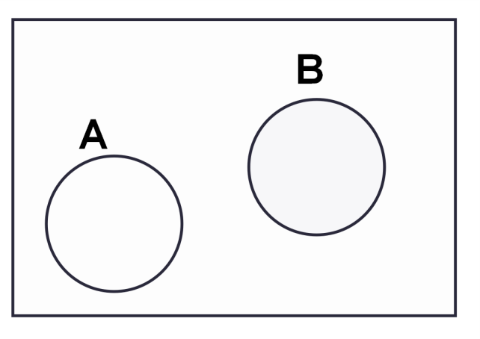

Answer the following questions:

1. How many students are 17? _______
2. How many students are not 17? ______
3. How many students are 17 and 18? ______
4. How many students are 17 or 18? ______
5. How many students are not 17 or 18? ______
6. **Camping?**
   * Universal Set 
   * Set 

Complete the Venn Diagram based on our class information.

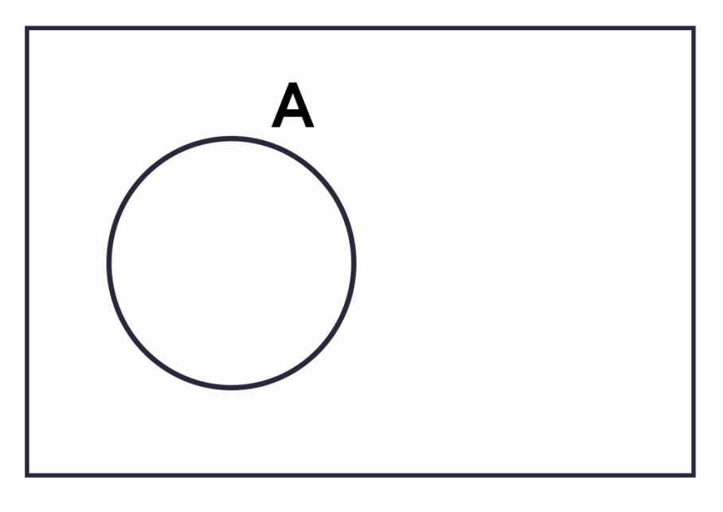

Answer the following questions:

1. How many students are camping this summer? _______
2. How many students are not camping this summer? ______
3. What do you notice about the solution to a) and b) and the Universal Set?
4. **Right Handed & Blonde**
   * Universal Set 
   * Set 
   * Set 

Complete the Venn Diagram based on our class information.

Answer the following questions:

1. How many students are blonde? _______
2. How many students are not blonde? ______
3. How many students are blonde and right handed? ______
4. How many students are blonde or right handed? ______
5. How many students are not blonde or right handed? ______
6. How many students are not blonde and right handed? ______