Names:

Block:
Clinometer Project
Names:

Goal: Students will use the trigonometric ratios (Sine, Cosine, and Tangent) to measure the real life height of various objects.

How: Students will work with one partner; however they both will have to turn in individual projects.
Step One Create a clinometer by following these steps.
    - Cut out the photocopied protractor.
SOHCAHTOA
    - Glue it to your piece of cardboard.
    - Cut out the cardboard so that it is the shape of your protractor

    - Cut a 4-inch piece of string, tape it to the middle of the protractor by your mark. It is important that you tape your string before you tape your straw.
    - Tape your straw to the top flat end of your protractor.
    - At the end of the string, tape a couple pennies to it.
Your clinometer should look like this:
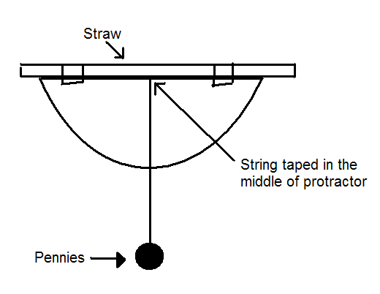
Step Two Measure the height of the wall using sine, cosine, tangent, and your clinometer.
- In order to measure the height of the wall, complete the Clinometer Worksheet that is attached to this project sheet.
- After you measure the height of the wall, you will measure two more objects at school (that are over 10 ft. tall)

Step Three Create a story/cartoon/comic that shows how you used trigonometry to solve the problem that you did at school and at home.
    - Create a unique, interesting story.
      - Example:
        - You had to figure out how tall your house was so that you could see if you could jump over it.
      - Draw/create pictures. Make this colorful and creative. Have fun with it!
      - Make sure to show all of your calculations and diagrams of how you made each calculation
      - Write big and neat.
Turn in: By November 10, you and your partner will turn in…..
- 1 clinometer
- 1 clinometer worksheet
- 2 stories
    - One story per person about the objects/buildings that were measured at school
    - with math evidence
    - good pictures/images on how you found out the height of objects/buildings using a clinometer
  - 1 scoring rubric.

CLINOMETER WORKSHEET WORKSHEET

This worksheet will guide you through the steps necessary to use your clinometer to measure the height of any object. Answer the questions in complete sentences and in great detail.

  - Before you use the clinometer, you must understand how it works. In this project, everything you measure will be standing vertical to the ground. You will hold the straw of the clinometer to your eye and aim the straw so that you can see the very top of the object you are measuring (in the picture below it is the wall), the string line will naturally fall straight down (this is called plumb). Below is a diagram of how this will work.

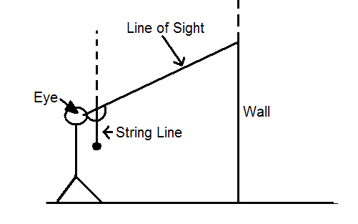

  - What do you notice about the relationship between the string line the line of the wall?

  - The picture below shows a close up version of the string line, clinometer, and line of the wall. What do you notice about the relationship between angle A and angle B?

  - What does this mean for the values of angles B and A using the knowledge you have of the relationship between the string line and line of the wall (question 2)?
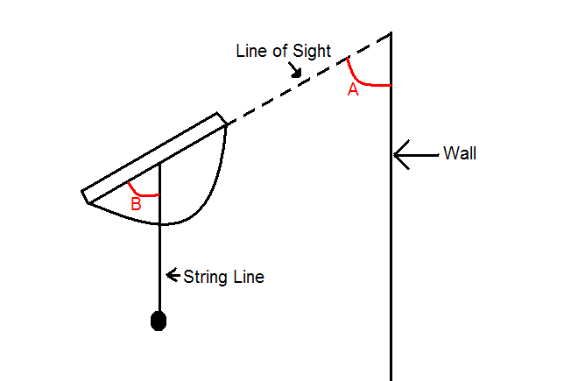

  - Now that we have established that angles B and A will be ______________ (FILL IN THE BLANK).We can create a right triangle between your eye and the object you are measuring. For the case of measuring the height of a wall the triangle will look like this:

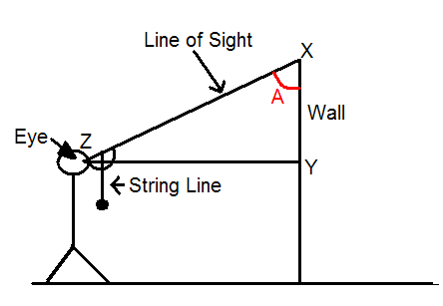

    - Line XZ is the line of sight (the line you will form by aiming the straw at the top corner of the wall)
    - Line XY is the wall or the object you are measuring.
    - Line ZY is the horizontal distance you are standing away from what you are measuring.

  - There is one side of the triangle that you can measure. Which side would it be? (XZ, XY, or ZY)

  - You can determine the measure of angle A from angle B (angle B will show on your clinometer – see question 4) and from question 6 above you can measure side __________. With this information you can use one of your trig functions to find a measurement for side XY – the vertical distance of the height of the object to the height of your eye.

  - On triangle XZY (taken from the picture) below label the known angle, the known side, and the unknown side you will be solving for.

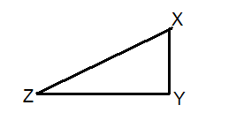

  - With this information, what trig function (cos, sin, or tan) will you use to solve for side XY. Write an equation using A to represent your known angle, B to represent your known side, and x to represent the unknown side XY.

  - The final step is once you know the length of XY, adding to XY the additional height. The height from your eye to the bottom of the ground.

  - Using the steps outlined above measure the height of one of your classroom walls. As you know now, you will need to measure the distance you stand from the wall, and the distance from your eye to the ground. Then you will aim the clinometer at the top corner of the wall and measure angle B (see question 4).

  - After you have this information complete the sketch below by putting in the correct distances and angles.

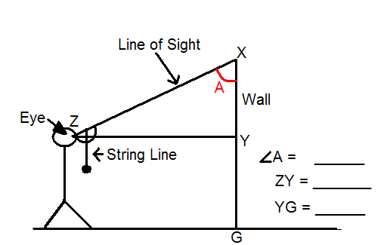

  - Using your measurements use the correct trig function (see question 9) and solve for the distance of side XY, and then for the height of the wall (XG). Show all your work.

  - At home you will measure the height of your house, or a tree, or any other tall object (should be more than 10 ft). You will use this problem for the story portion of this assignment. Along with a colorful, clear sketch of your work and clearly showing all of the math work you used to measure the height, you will create a creative story to explain why you measured this height. Do this on a separate piece of paper and be sure to add color and creativity. This is due on November 10, 2010.

- Your score is combined with your partners

Clinometer Project Scoring Rubric
Name: Stories:

Has…. | Max Points | Received | Comments
Accurate math on 1 story | 7
Completed and Accurate worksheet | 6
Creative story | 2
Colorful, Good Pictures | 2
Clinometer | 1
Late (-5 points a day) | -10
EXC: Powerpoint | 5
TOTAL | 18

Name: Stories:

Has…. | Max Points | Received | Comments
Accurate math on 1story | 7
Completed and Accurate worksheet | 6
Creative story | 2
Colorful, Good Pictures | 2
Clinometer | 1
Late (-5 points a day) | -10
EXC: Powerpoint | 5
TOTAL | 18

GRAND TOTAL:
(Your score plus your partners)
Grading Scale
A 34-38 Excellent team work. Definitely go into business together. The next Google company?
B 30-33 Good team work. Possible future business together?
C 26-29 Average team work. I would not recommend going into business together. You guys would go bankrupt.
D 22-25 Below average team work. Next time, I would find another partner.
F 20-23 No team work. Run away! (and not for bad breathe I hope).
On-time

