**M30-2 Introduction to Sinusoidal Functions Name: __________________**

**Ferris Wheel #1**

A Ferris Wheel has a diameter of 100 meters. It takes 20 minutes to go around the Ferris wheel once. The lowest point, where you enter the Ferris wheel is 0 meters above the ground.

a) Complete the table of values below showing the height of the Ferris Wheel over time, starting at the lowest point.

|  |  |  |  |  |  |  |  |  |  |
| --- | --- | --- | --- | --- | --- | --- | --- | --- | --- |
| Time (min) | 0 | 5 | 10 | 15 | 20 | 25 | 30 | 35 | 40 |
| Height (m) |  |  |  |  |  |  |  |  |  |

b) Sketch a scatterplot of the height of the Ferris Wheel over time, based on the table of values.

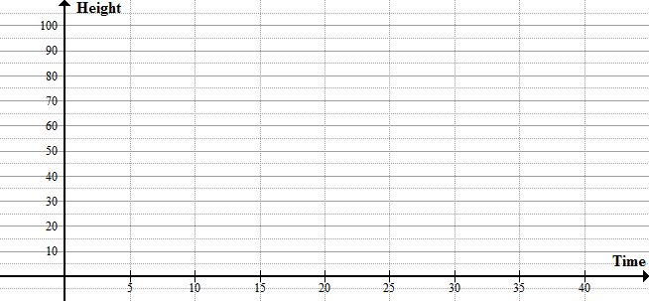

c) Use regression to calculate a sinusoidal function that best models this data.

STAT – CALC – C: SinReg  **Make sure calculator is in Radian Mode!**

Write the regression equation below and sketch the line of best fit on the scatter plot above.

|  |  |
| --- | --- |
| **From Graph / Description:** | **From Equation:** |
| radius = | a = |
| average/middle height = | d = |
| time to go around once = |  |

d) Complete the table below:

**Ferris Wheel #2**

A Ferris Wheel has a low point of 5 meters above the ground and its highest point is 85 meters above the ground. It takes 16 minutes to go around the Ferris wheel once.

a) Complete the table of values below showing the height of the Ferris Wheel over time, starting at the lowest point.

|  |  |  |  |  |  |  |  |  |  |
| --- | --- | --- | --- | --- | --- | --- | --- | --- | --- |
| Time (min) | 0 | 4 | 8 | 12 | 16 | 20 | 24 | 28 | 32 |
| Height (m) |  |  |  |  |  |  |  |  |  |

b) Sketch a scatterplot of the height of the Ferris Wheel over time, based on the table of values.



c) Use regression to calculate a sinusoidal function that best models this data.

STAT – CALC – C: SinReg  **Make sure calculator is in Radian Mode!**

Write the regression equation below and sketch the line of best fit on the scatter plot above.

|  |  |
| --- | --- |
| **From Graph / Description:** | **From Equation:** |
| radius = | a = |
| average/middle height = | d = |
| time to go around once = |  |

d) Complete the table below: