Going across and going down are different number patterns.
Fill in the empty boxes so that each sequence has a pattern

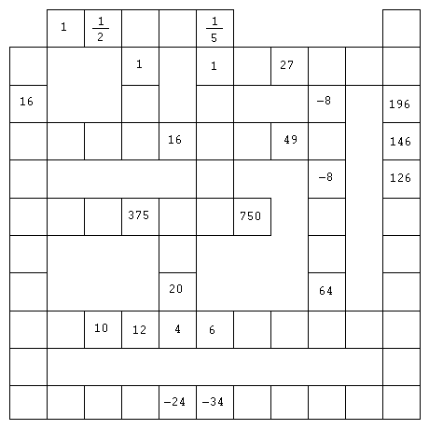pa

