Dragon Bump - Adding 9

 | 11 |  | 15 | 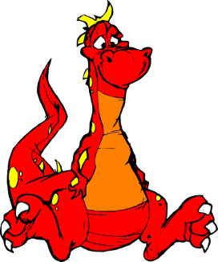 | 14 |  | 13
 | 14 |  | 10 |  | 15 |  | 12
 | 13 |  | 12 |  | 10 |  | 11
Instruction:  Take turns with a partner. Roll the die. Add 9 to the number you roll. Put a cube on the number. If another player’s cube is on that number, “bump” it off. If your cube is on that number, stack a second cube on top to “freeze” that spot. The player to use all of their cubes first wins! |  |  |  |  |  | Materials:  - One 6 sided die  - 10 cubes of one color  - 10 cubes of another color

Dragon Bump - Adding 9

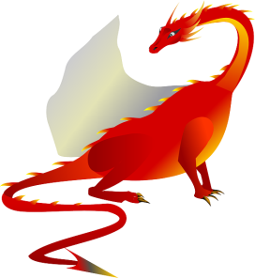 | 14 |  | 11 |  | 12 |  | 17
 | 11 |  | 14 |  | 17 |  | 15
 | 16 |  | 13 |  | 10 |  | 18
Instruction:  Take turns with a partner. Roll the die. Add 9 to the number you roll. Put a cube on the number. If another player’s cube is on that number, “bump” it off. If your cube is on that number, stack a second cube on top to “freeze” that spot. The player to use all of their cubes first wins! |  |  |  |  |  | Materials:  - One 9 sided die  - 10 cubes of one color  - 10 cubes of another color

Dragon Bump - Adding 8

 | 11 |  | 9 |  | 14 |  | 13
 | 14 |  | 10 |  | 9 |  | 12
 | 13 |  | 12 |  | 10 |  | 11
Instruction:  Take turns with a partner. Roll the die. Add 8 to the number you roll. Put a cube on the number. If another player’s cube is on that number, “bump” it off. If your cube is on that number, stack a second cube on top to “freeze” that spot. The player to use all of their cubes first wins! |  |  |  |  |  | Materials:  - One 6 sided die  - 10 cubes of one color  - 10 cubes of another color

Dragon Bump - Adding 8

 | 14 |  | 11 |  | 12 |  | 17
 | 11 |  | 14 |  | 17 |  | 15
 | 16 |  | 13 |  | 10 |  | 9
Instruction:  Take turns with a partner. Roll the die. Add 8 to the number you roll. Put a cube on the number. If another player’s cube is on that number, “bump” it off. If your cube is on that number, stack a second cube on top to “freeze” that spot. The player to use all of their cubes first wins! |  |  |  |  |  | Materials:  - One 9 sided die  - 10 cubes of one color  - 10 cubes of another color

