https://education.alberta.ca/primary-grades-k-3/primary-grades-k-3/everyone/program-resources/
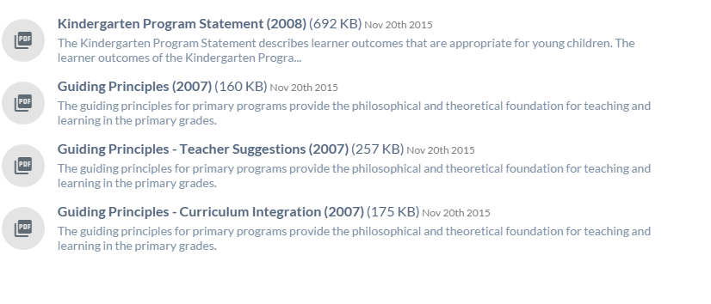

Kindergarten Curriculum Overview
https://education.alberta.ca/media/160232/kindergarten-curricululm-overview.pdf

Standards for the Provision of Early Childhood Special Education
https://education.alberta.ca/media/1626521/ecs_specialedstds2006.pdf

Kindergarten at a Glance - for Parents
http://www.learnalberta.ca/content/mychildslearning/gradeataglance/kindergarten.pdf

