Cuisenaire Rods for Multiplication Tables

Materials:
- Cuisenaire Rods
- “Blank multiplication table” (see this document)
- Smart Notebook Lesson “Cuisenaire Rods for Multiplication Tables”
- Pencils
- Pencil crayons to match the color of the Cuisenaire Rods.

Instructions:
Say “We’re going to be building some numbers today with our Cuisenaire rods and recording our results on this chart. Let’s start by showing one of each type of rod.”

On the Smartboard, place a one rod below the grid.
Have them do this as well.
Ask “How many?” one
Ask “How much is this worth?” one
Move it up to the 1x1 spot in the table. Tell them to move theirs too. | 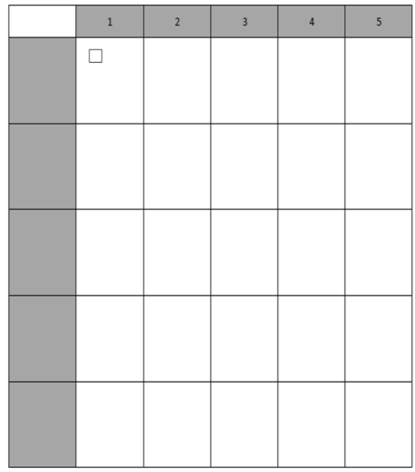
Say “Leave that there. Don’t take form it to build the next numbers.
Now let’s build 2 ones in our work mat.”
Let them build two 1s. Wait 5 seconds and then move two 1s below the grid on the board.
Ask them “How much is this?” 2
Move yours to the 2x1. Tell them to move theirs also and put their blocks one below the other and touching. | 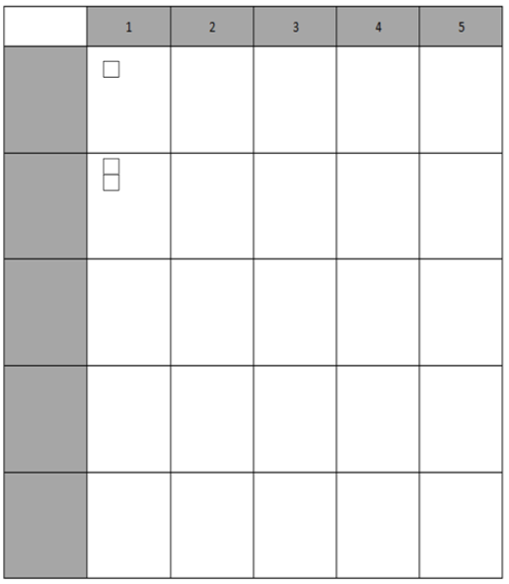
Point to the 1x1 spot and say “Here we built using ones. How many ones did we use? 1  Write 1.  Say “We have one 1” | 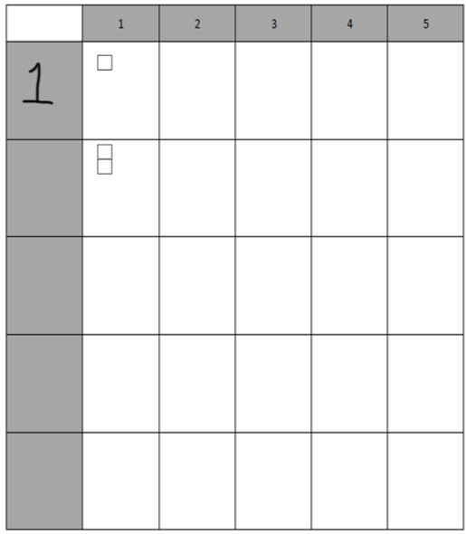
Point to the 2x1 spot and say “What rods did we use here?” 1s  Ask “How many did we use?” 2  Write 2.  Say “We have two 1s” | 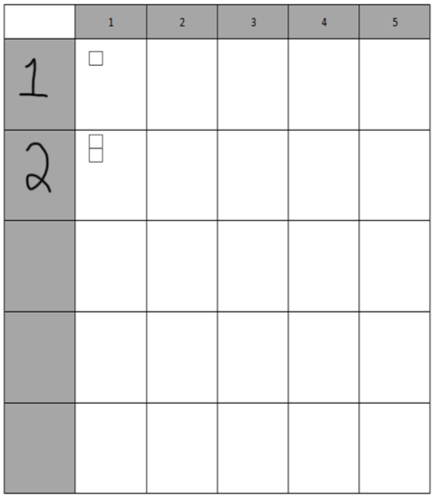
Point to the 3x1 spot.  Ask “I want you to predict what you think will be put in this box here. Think for a moment to yourself. Be ready to tell your partner what you think belongs there, how many and why you think that.” Partners discuss.  Say “You are going to show me your prediction by holding up everything that should go in the box.” They should hold up three 1s.  Ask students to convince you that it belongs there. How do they know? They should see the pattern of increasing by 1.  Tell them to place their rods on their chart. You place three 1s on the board. | 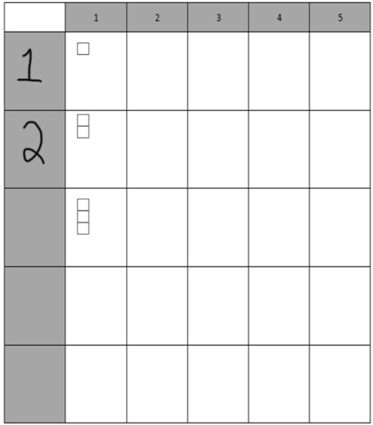
Say “I wonder what number I should write in the grey box. Take a moment to think and decide which number goes here. When you’re ready, discuss with your seat partner. Explain why you think that. Partners discuss.  Group shares.  Write the number 3. | 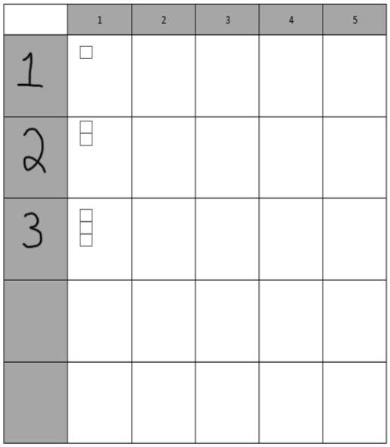
Say “I wonder what the next two boxes will look like. I’d like you to fill them in using the patterns we have seen.” Students work to fill them in with their blocks.  When they are finished, they compare to their seat partners.  Class share. You fill in the blocks. | 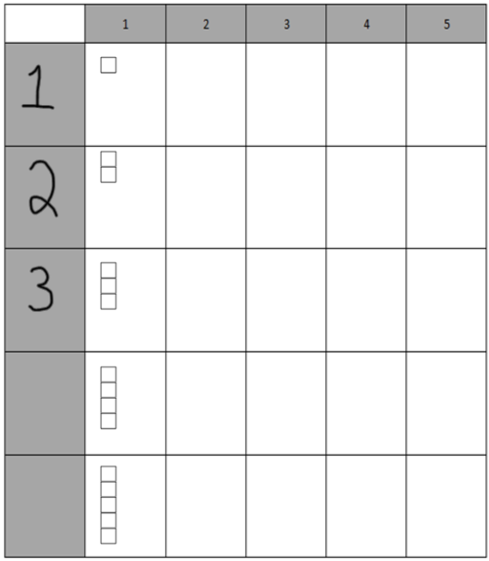
Ask “What number do you think belongs in this box?” Point to the grey box that will be 4. 4  Ask “How do you know?” one more than 3  Repeat for the 5th box. | 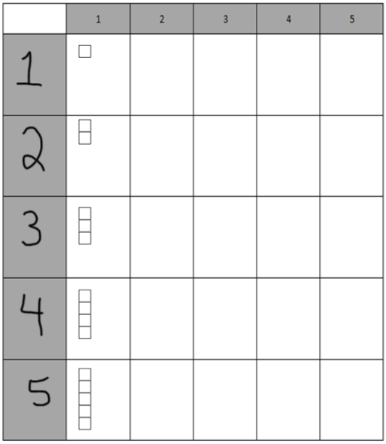
Say “It could be difficult to do the next part with all of these ones in the way, so let’s turn them into drawings.”

Say “Let’s remove these blocks (point to the 5x1 blocks) and draw them in instead, using our pencil.”

Repeat with the other blocks, working your way from the bottom to the top as it will be easier for them to draw this way.

Ask “What block do you think we’ll use in this spot here?” Point to the 1x2 spot. 2s  Ask “How many of the 2s do you think we’ll put in this spot?” one  Build it. Have them build it and place in the 1x2 spot. | 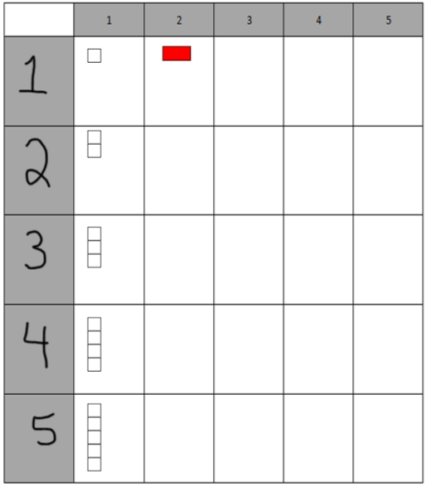
Say “I wonder if you can figure out what comes next?”  Give students time to decide and share their reasoning.  Ask them what the 2x2 box will look like. Two 2s.  Ask students to always build them so they make a rectangle. | 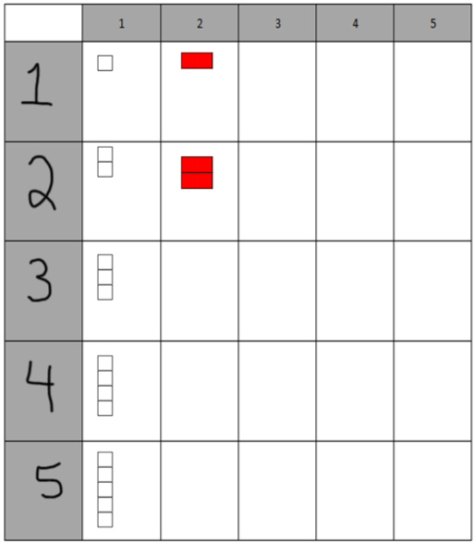
Give students time to work on the rest of the 2s, redrawing the blocks using a red pencil crayon.
When they finish that, ask them to predict what will go in the next column. They may ask if they can just draw the blocks with a green pencil crayon instead of building and then drawing. That’s totally fine.  Repeat until all sections are filled in. | 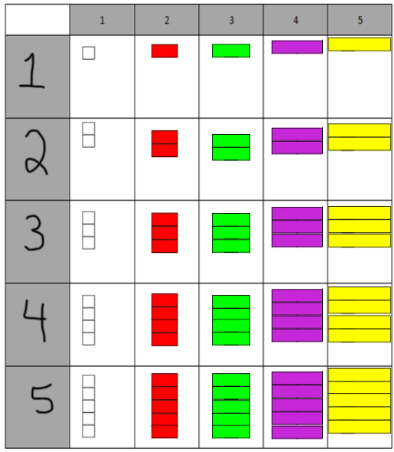

Point to the 3x1 spot. Ask what we built here. Three 1s.  Say “We could represent this by writing “THREE 1s”  Write “three 1s” below the drawing. Have students write this as well. | 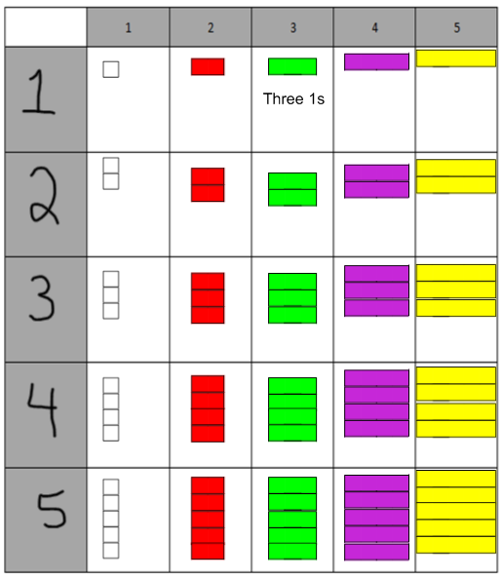
Point to 2x4.  Ask “What did we build here?” Two 4s.  Say “We could write this as “TWO 4s”.  Write “Two 4s” in the box and have students write that as well. | 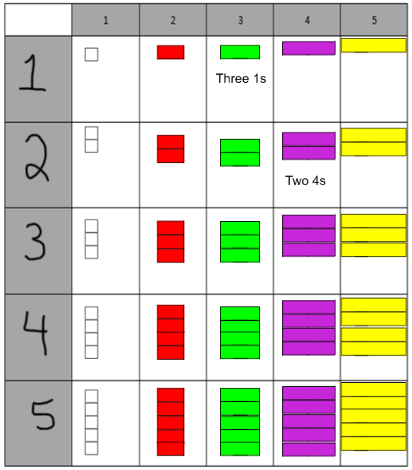
Repeat with other examples until students “get the point”.
Have students fill in the rest of the boxes.

Point to 2x5.  Say “I’ll give you a minute to figure out how much is here altogether.” Give them time to figure out.  Say “Tell your seat partner how many and how you know.” Give time.  Ask students to share their strategies.  Say “two 5’s is 10”. Write = 10 so the spot on your board now says two 5s=10 | 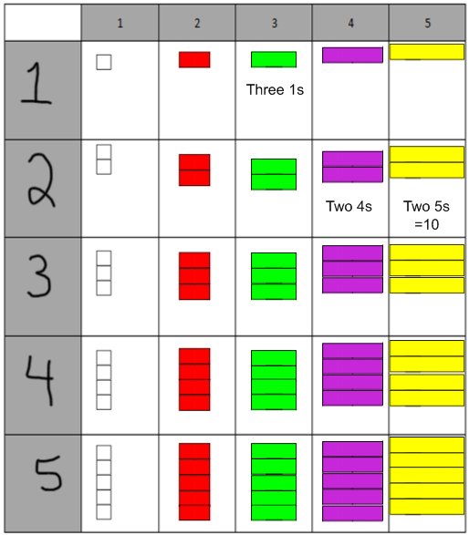
Repeat with other examples until they “get the point”.
Have them fill in the rest of the boxes.

Ask “What patterns do you see? Take a few minutes on your own to find some patterns” Give them time to find a few patterns on their own.

Say “Tell your partner what patterns you found. Can you find others?”

Group share.

Write a 0 below the table in Smart Notebook.  Ask “What would you fill in for this row?” Students discuss and fill in. | 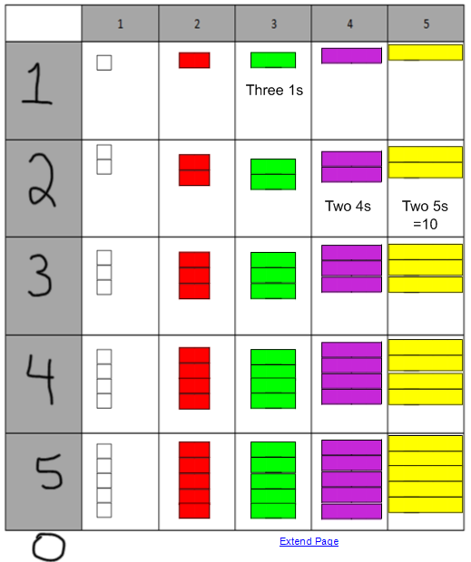

Write a 0 to the right of the table in Smart Notebook.  Ask “What would you fill in for this column?” Students discuss and fill in. | 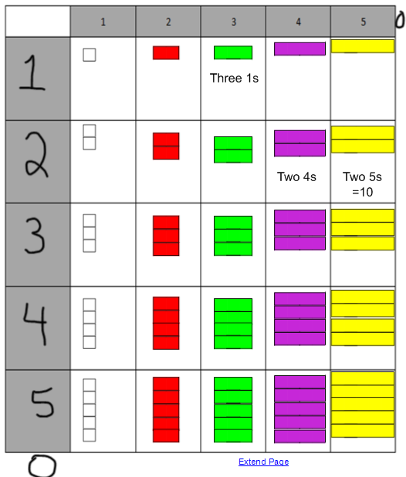

Ask “What if the spot (cell) I am looking at has 8 in all. How could I have built it?” Discuss
Ask “What if the spot (cell) I’m look at has 6 in all but I’m looking at 2 rods. How could I have built it?”

Explore other options like 8 in all but built with two rods. 4 rods. 8 rods.
Ask “What would it look like if I doubled what’s in the 5x3 spot?”

Ask “What would it look like if I tripled that 5x3 spot?”

Ask “How could you use the table to help you figure out eight 2s?” Students discuss and share strategies. Do they see two sets of four 2s?

Repeat with 7x3, 3x7, 7x5 and other examples.

Multiplication Table

 | 1 | 2 | 3 | 4 | 5

