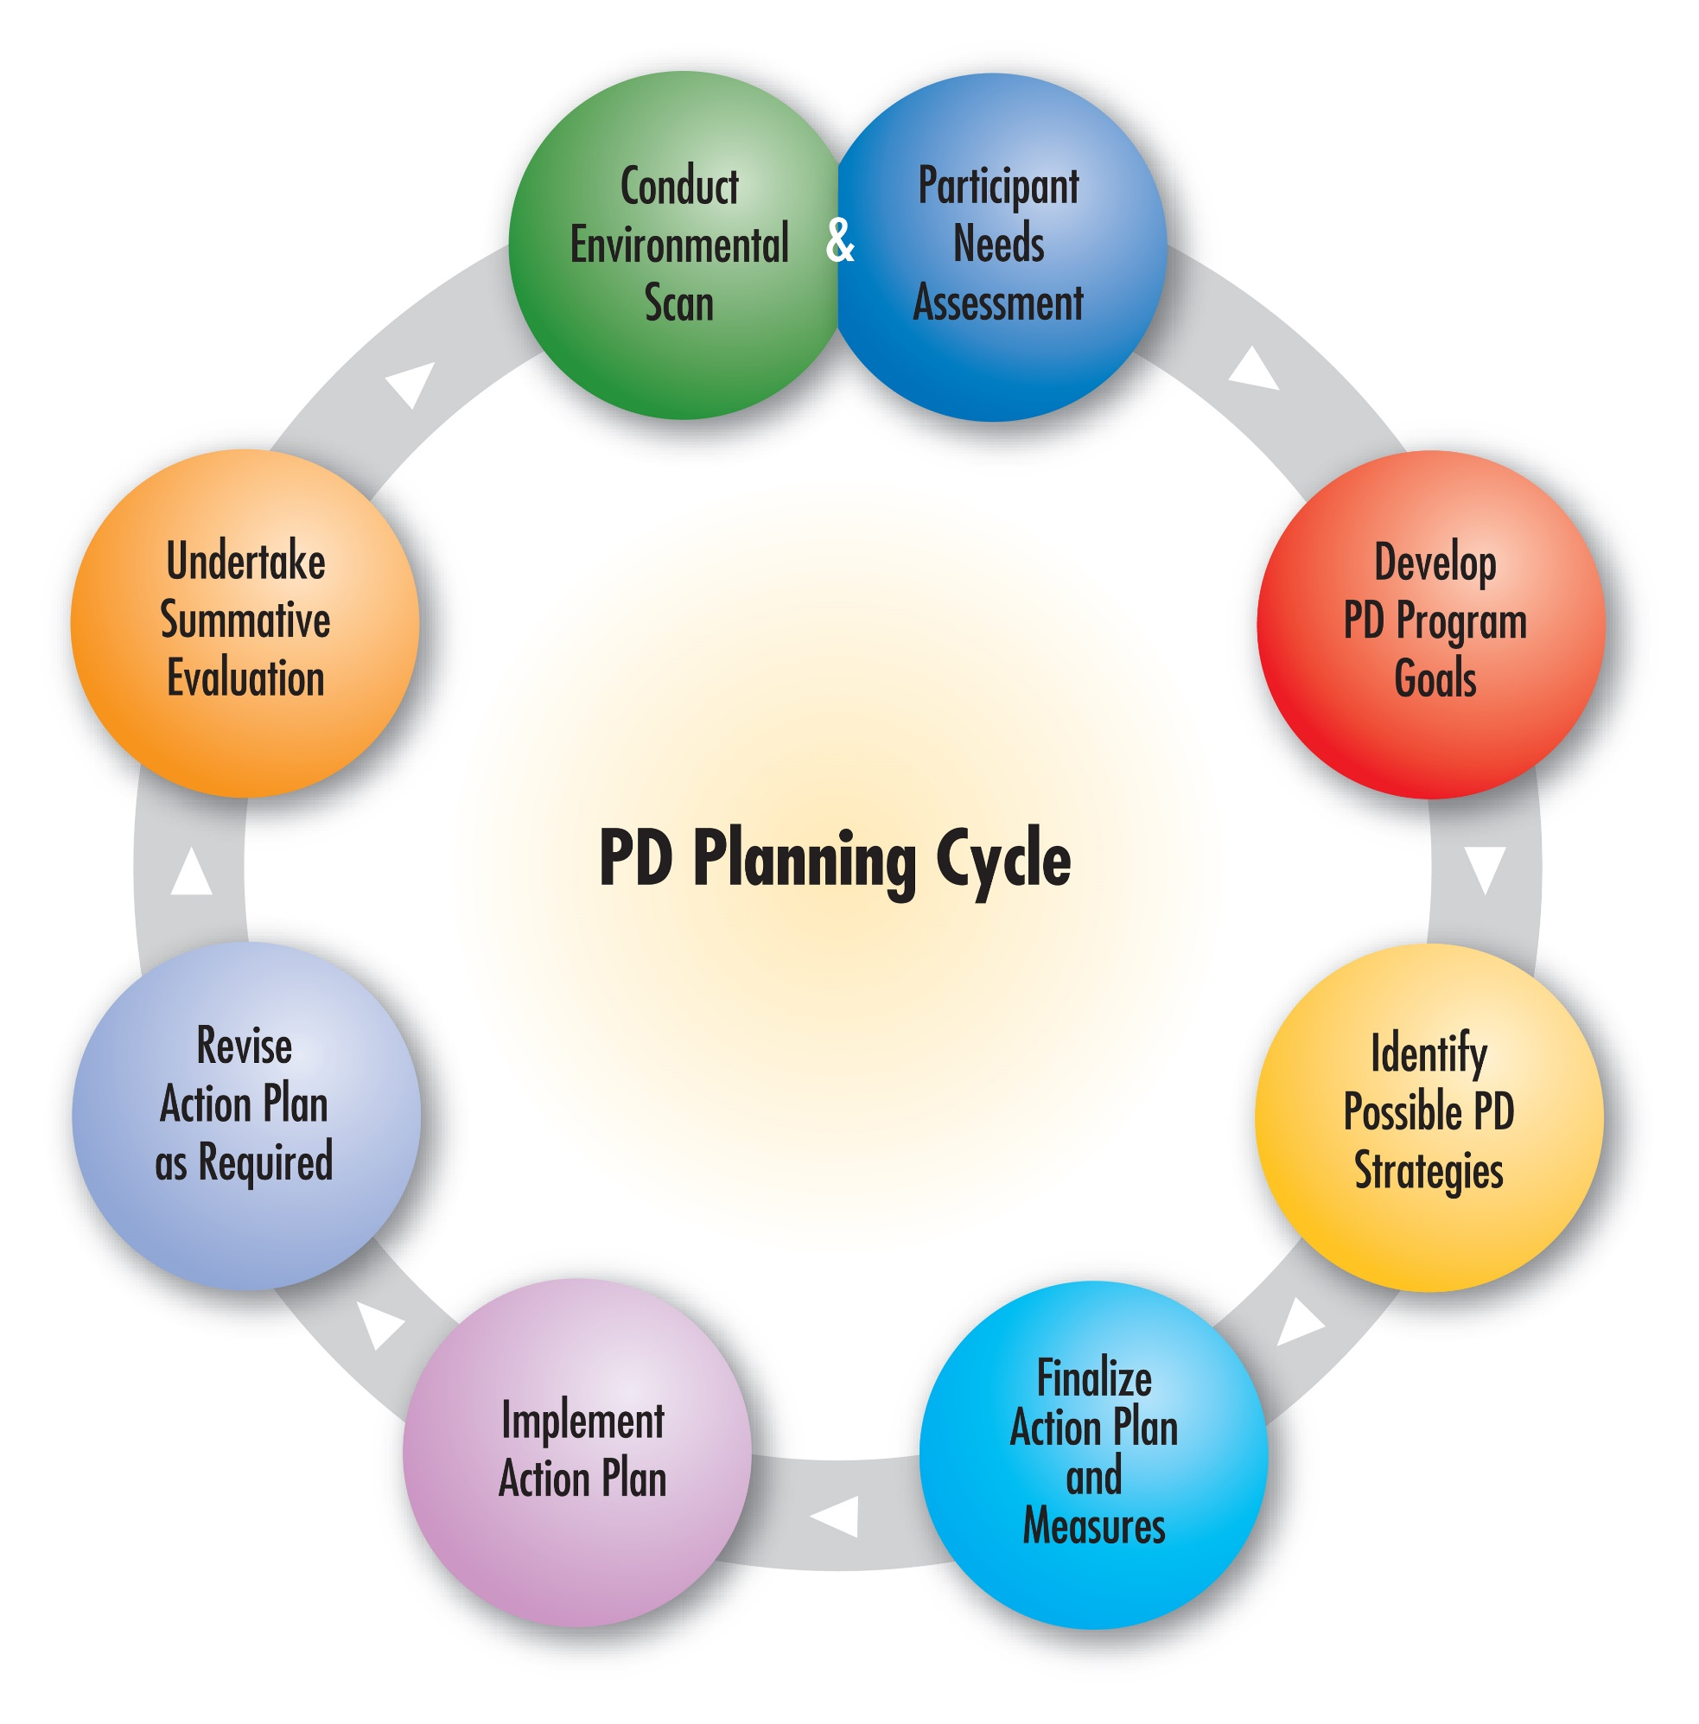

Planning using A Guide to Comprehensive Professional Development Planning http://bit.ly/2lDSAm9

This guide is intended to support a process of collaborative conversation among education stakeholders working together to develop a comprehensive plan for professional learning. It is designed with guiding questions to facilitate dialogue and planning. Research continues to show that student learning is enhanced when staff has capacity - implying standards of practice can be enhanced through professional learning. It is believed that a comprehensive plan for professional learning has the potential to develop the capacity of your staff - more so than any individual professional learning opportunity.

This template offers selected questions for consideration in supporting implementation of the quality standards (adapted from A Guide to Comprehensive Professional Development Planning). It also provides space for you to record your group’s responses as a result of dialogue.

Conduct Environmental Scan  - What currently exists that supports quality standards of practice? (e.g. policy, practice, research, supports for professional learning)  - How do your district vision, mission and/or goals support staff capacity?  Participant Needs Assessment  - What data currently exists that identifies professional learning needs? Current staff capacity? (e.g. student learning data, staff survey data, other support organization data)  - How might you collect data on the professional learning needs of your team?  - Can you collaborate with others to collect data? (e.g. CASS, ARPDC, ATA)  Develop PD Program Goals  - Based on your district’s vision and mission, school plans, as well as data analysis of individual needs, what will your goals for professional learning be?  - How will your goals include a focus on both staff capacity and the impact on student learning?  - Are goals different for the district, the school, and the individual staff member?  Identify Possible PD Strategies  - Which professional learning designs best suit the diverse needs of your team?  - What professional learning opportunities are offered by other organizations? (e.g. CASS, ATA, ARPDC, AAC, post secondary programs)  - How will professional learning be ongoing and sustained?  - How will the impact of your professional learning plan be measured? | Finalize Action Plan and Measures  - Does the plan contain goals, learning designs and strategies, ways to measure impact and the necessary resources to actualize the plan?  - How will the plan be communicated? Resourced?  - What will you accept as evidence that staff capacity has been enhanced?  Implement Action Plan  - Based on the stakeholders involved in developing the plan, how will they continue to be involved in supporting implementation and monitoring impact?  - How often will you collect and analyze data to know your efforts are having an impact?  Revise Action Plan as Required  - Based on data you have collected and analyzed, how will you adapt your plan?  - Is the comprehensive plan influencing practice and student learning?  Undertake Summative Evaluation  - Did the plan meet its goals? (e.g. student learning)  - Did the plan meet participants’ needs? (e.g. enhanced practice)

