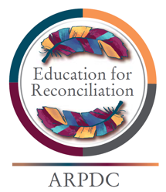
Assembling Strength - Education for Reconciliation

The Secret Path: Healing Historical Trauma

Chanie Wenjack died 50 years ago. The Ojibwa boy froze by the side of Northern Ontario train tracks after running away from a residential school. Although, his death resulted in Canada’s first inquiry into the practice of removing Indigenous children from their families, the 12-year-old’s story isn’t common knowledge. Now, a number of influential artists have adopted the story of Chanie – or Charlie, as he was called at school – as their own.
The Secret Path shares his story to redress the wrongs of residential schools, forced upon thousands of Indigenous children and families across Canada.
Activity 1: Handout: K-W-H-L Chart
Participants use a K-W-L-H chart to record what they know, what they want to know about the impact of residential schools.
Activity 2
After watching The Secret Path clip by Gordon Downie, participants answer the questions about what they learned and how they can learn more. Build time in for a reflection circle with a feather, rock or any sort of item to pass along.
In groups of three or four, participants talk about what they already know about the impact of residential schools on Inuit, Metis and First Nation people. Ask participants to complete the first two columns of the chart.
Activity 3
In the same groups of three or four, participants discuss what they learned and how they can find more information about residential school survivors. Remind participants to complete the remainder of the chart, including the section on how this knowledge impacts classroom practices.
In a large group, sitting in a circle, share what they learn from the video The Secret Path and from one another the impacts of residential schools.

What do we know? | What do we want to learn? | What did we learn? | How can we learn more?

Outline some of the ways in which this knowledge supports your own practices:

