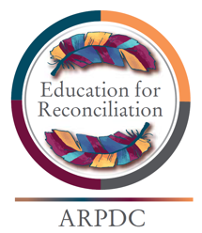
Assembling Strength - Education for Reconciliation

Land Acknowledgement

I wish to acknowledge that the land on which we gather is in Treaty ________ (treaty number) territory. This is within and surrounding the traditional meeting grounds and home for many Indigenous Peoples, including ________________________________ (names of language groups). This is also home to the Métis communities of ________________________ (list communities). I also wish to acknowledge the Inuit people who join us in this area and bring with them a rich and beautiful culture from which we learn. I want to acknowledge our Elders in this area who ______________________ (list special contributions and role of Elders) in our communities. I also wish to honour the Elders, Knowledge Keepers and traditionalists who have gone before us and those who continue to walk with us today.

