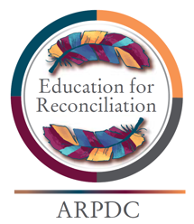
Assembling Strength - Education for Reconciliation

Elders and Knowledge Keepers

Activity

After reading the roles elders and knowledge keepers have within their communities and viewing the videos about the importance of elders, begin the KWLH graphic organizer to record how an elder or knowledge keeper could be honored within your own contexts.

 | What we Know | What we want to find out | What we learned | How can I use what we learned
Who is an Elder-Knowledge Keeper
What is the role of the Elder –Knowledge Keeper
What protocols are used to invite an Elder-Knowledge Keeper into the our own context?

