Name .
Chapter Quiz - Sets and Logical Reasoning
Part 1 Multiple Choice
Use the following information to answer questions 1 – 3

A = {1, 4, 6, 9} B = {2, 3, 4, 5} C= {2,7,8}
1. What is the set A ∪ B?

a) {1,4,6,9} b) {1,2,3,4,5,6,9}
c) {4} d) {7,8}

2. What is the set A ∩ B?
a) {1,4,6,9} b) {1,2,3,4,5,6,9}
c) {4} d) {7,8}

3. Which pair of sets are disjoint?
a) A and C b) A and B
c) B and C d) none of the above

Use the following information to answer questions 4-6

U = {natural numbers less than 10} Hint: Zero is not a natural number

A = {odd numbers less than 10} B = {1,5,7} C = {4,5}

4. The empty set is a subset of which of the following?
a) A b) B
c) C d) all of the above

5. What is the value of n(B)?
a) {1,5,7} b) {2,3,4,6,8,9}
c) 3 d) 6

6.Only one of the following statements are true. Which one is it?
a) U B b) C B U
c) C A U d) B A U

7. The set {1,2,3,7} could best be described as
a) B ∩ C b) B ∪ C '
c) B' ∩ C d) B' ∪ C

Part 2: Written Response

These next problems ask you to shade a specified area.

8. Shade the area that represents A or B

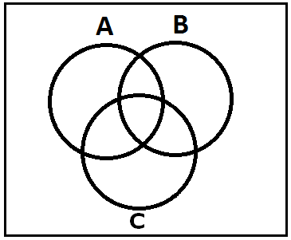

9. Shade the area that represents not A and B

10.Shade the area that represents (A’’ B ) C

11. Sarah has decided to open an ice cream shop. She has takes a tally and finds that she
has....
- 10 flavors that contain chocolate
- 5 flavors that contain nuts
- 2 flavors that contain chocolate and nuts
- 11 flavors that do not contain chocolate or nuts
Using a Venn diagram, determine the total number of ice cream flavors Sarah has.

12. Using the students at STM as a universal set, give an example of the following.
a) A subset
b) Two sets that are disjoint
c) An empty set

13. Dennis gets a job at Sarah’s ice cream shop as the V.P. of market research. He conducts a survey with a sample of 150 people and finds that....
- 94 people like vanilla ice cream
- 114 people like strawberry ice cream
- 12 people did not like strawberry or vanilla ice cream
How many people liked both strawberry and vanilla ice cream?

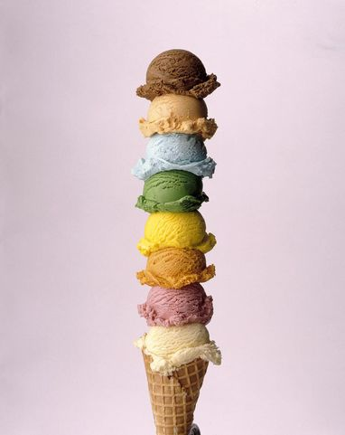

14. Randy and Victoria have decided to open a zoo. They asked Dennis to conduct a survey seeing what kind of animals people like. Afterwards they all went to Sarah’s for ice cream. Here are the results of Dennis’ survey.
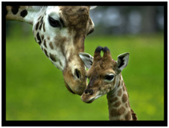

- 46 people like elephants
- 89 people like monkeys
- 63 people like bugs
- 24 people like bugs and elephants
- 17 people like monkeys and bugs
- 30 people like monkeys and elephants
- 13 people like monkeys, elephants and bugs
- 4 people did not like monkeys, elephants or bugs

How many people did Dennis talk to during this survey?

