Fundamental Counting Principles

*Warm-up Activity*

Around the classroom there are license plate displayed from different provinces across Canada. With a partner, walk around the classroom identifying how many different license plates are possible in total from that particular province. For this activity, we are going to say that all letters and all numbers from 0-9 are allowed.

|  |  |  |  |
| --- | --- | --- | --- |
| **License Plate**  **(province)** | **License Plate Order** | **Mathematical Process** | **Total** |
| *e.g.* Saskatchewan |  |  |  |
| Manitoba |  |  |  |
| Alberta (new plates) |  |  |  |
| Quebec |  |  |  |
| P.E.I. |  |  |  |

If a task can be completed in _____ ways and a second task can be completed in _____ way, and so on, until the $k^{th}$ task can be completed in _____ ways; then the number of completing all of the tasks is:

____ ____ ____ … ____

*DEFINITION:* **Fundamental Counting Principle**

Consider a task made up of several parts.

If the number of choices for the first part is *a*,

the number of choices for the second part is *b*,

the number of choices for the third part is *c*, etc.,

then the number of ways in which the task can be completed is

**NOTE:**

__________________ and ___________________ means no repetitions are allowed.

Also note that ______________ cannot be repeated. (For instance, the same person cannot received gold, silver, and bronze).

The Fundamental Counting Principle does _______ apply when tasks are related by the word _______. Determine whether the fundamental counting principle can be used or not in the situations below.

*_____*Counting the number of possibilities of rolling a 2 or a 4 using two standard die.

_____Counting the number of possibilities when choosing between a whole wheat or white bagel; and blueberry, strawberry, or plain cream cheese.

*Examples*

1. A car purchaser has a choice of two upholstery materials (leather and nylon) and four color choices (blue, purple, black, red). How many different choices are there? Draw a tree diagram.
2. An all-star baseball team has 7 pitchers and 3 catchers. How many different batteries consisting of a pitcher and a catcher can the manager select?
3. There is a 15-member prestigious yacht club in Kelowna. How many different combinations of a president, vice-president, and secretary can the 15-member club elect?

Rules: Digits

* Beginning zeros do not count as a digit; therefore, 4 digits numbers cannot have “0” in its first position.
$___________×____________×____________×___________$

* All ______ numbers must have an ______ last digit i.e. ___, ___, ___, ___, ___
* All ______ numbers must have an ______ last digit i.e. ___, ___, ___, ___, ___
* If the digits are listed, then no repetitions are not allowed, unless otherwise stated
* Deal with all restrictions ___________

1. Consider the digits 2, 3, 5, 6, 7 and 9.
   1. If repetitions are permitted, how many 3-digit numbers can be formed?
   2. How many of these are
      1. Less than 400?
      2. Even?
      3. Odd?
      4. Multiples of 5?
2. Consider the word ENGLISH.
   1. How many distinguishable arrangements can be made using all of the letters?
   2. What are the number of distinguishable 4-letter arrangements which can be made if no letters are repeated and:
      1. the first letter must start with an S?
      2. the first and last letter must be vowel?

**~ Diploma Connection ~**

Sandra is taking an examination which consists of two parts, A and B, with the following instructions.

* Part A consists of three questions and the students must do two.
* Part B consists of four questions and the students must do two.
* Part A must be completed before starting Part B.
* At the end of the exam the student has to list the order in which she attempted the questions.

|  |  |  |  |
| --- | --- | --- | --- |
|  |  |  |  |

The number of different possible orders is _________.

(Record your answer in the numerical response box from left to right)

Homework: ________________________

2.2 *Introducing Permutations and Factorial Notation*

**2.1 Review Question**

The Tiffany Restaurant offers the following menu:

|  |  |  |
| --- | --- | --- |
| Main Course | Dessert | Beverages |
| Chicken  Ham  Steak  Prime Rib  Roast Pork | Cheesecake  Ice Cream  Apple Pie | Coffee  Tea  Milk  Lemonade |

1. In how many ways can a customer order a meal consisting of one choice from each category?
2. Using the digits: 0, 1, 3, 5, 6 and 8, determine
   1. How many three-digit numbers can be formed
      1. Without repetition
      2. With repetition

**2.2 Notes**

*Warm-up Activity*

You are a photographer sitting a group in a row for pictures. You need to determine how many different ways you can seat the group.

1. There are three people in the first group: Matthew, Jesus, and Peter
   1. If Matthew is the first to sit down, show all of the possible seating arrangements.
   2. If Jesus is the first to sit down, show all of the possible seating arrangements.
   3. If Peter is the first to sit down, show all of the possible seating arrangements.
   4. How many totally seating arrangements are there for three people?
2. There are four people in the second group: Judas, Thomas, Simon, and Bartholomew. Writing out all of the different possible arrangements can be quite time consuming. Can we use another method to determine the number of different ways the group can be ordered?

If , then 

This means…

* *n* must be ____________ to or ________________ than 0
* *n* cannot be a _______________ or ______________

*Cross out* the expressions that are undefined.



















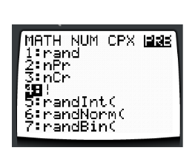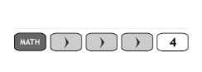Directions on where to find *Factorial Notation (!)* on your calculator:

Evaluate the following expressions.

1. =_____________
2. =____________
3. =____________

Write the next four terms of the following expressions.

______________________________________________________________

______________________________________________________________

______________________________________________________________

______________________________________________________________

Simplify the following:

1. 
2. 

1. 

Simplify the following:

1. 
2. 
3. 

Solve the equation.

1. 
2. 
3. 
4. 

**~Diploma Connection~**

In a competition on the back of a cereal packet, seven desirable qualities for a kitchen (e.g. spaciousness, versatility, etc.) must be put in order of importance. The number of different entries that must be completed in order to ensure a winning order is ______.

|  |  |  |  |
| --- | --- | --- | --- |
|  |  |  |  |

Homework: ________________________

**2.3 Permutations when all Objects are Distinguishable**

*2.2 Review Question*

Darlene and Arnold belong to the Asham Stompers, a 10-member dance troupe based in Winnipeg Manitoba, that performs traditional Metis dances. During the Red River Jig, they always arrange themselves in line with Darlene and Arnold next to each other. How many different arrangements of the dancers are possible for the Red River Jig?

_____________________ notation can be used to determine the number of arrangements of “___” objects taken “___” at a time, ONLY IF

* If there are no restrictions
* All restrictions have to be dealt with

**VERY IMPORTANT:**

**Permutation 🡪 _______________________!!!**

*Formula:*

This is on our formula sheet



*Recall*: A **factorial** is the product of consecutive ___________ numbers, in decreasing order to the number _____________, can be represented using factorial _____________.

 🡪 ____ objects arranged ____ at a time 🡪_________

*Proof:*

 🡪 ____ objects arrange ____ at a time 🡪_________

*Proof:*

We can use our calculator to determine the value of a permutation:

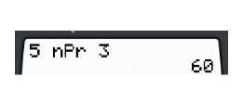

🡪

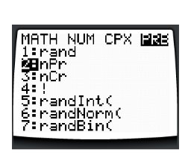

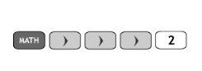

*Examples*

1. A bowl contains an apple, a peach, a pear, a banana, an apricot, a plum, and an orange. In how many ways can the fruit be distributed among the 7 children? (Use permutation notation).
2. There are 10 different books. How many ways can 4 of these books be arranged on a shelf?
3. A map of the 4 western provinces is to be colored, with a different color for each province. Nine colors are available. How many different ways are possible?
4. Which of the following expressions are undefined?
   1. 
   2. 
   3. 
   4. 
   5. 
   6. 
5. Solve each equation for *n*.
   1. 
   2. 
   3. 
6. Solve each equation for r.
   1. 
   2. 
   3. 
7. Simplify each expression.
   1. 
   2. 
   3. 

~Diploma Connection~

Numerical Response

The number of different arrangements can be made using all the letters of the word REGINA is_____________

|  |  |  |  |
| --- | --- | --- | --- |
|  |  |  |  |

Multiple Choice

At Ben’s Bowling Alley you get to choose ten bowling pins for your lane. The bowling pins either have a red, gold, or silver stripe. How many distinct arrangements can be made for a bowling lane?

1. 

1. 

1. 

1. 

Homework: ________________________

2.4 Permutations When Objects are Identical

In today's lesson we are going to further discuss the idea of creating orders of objects when some of the objects are repeated.

*Please keep in mind:*

* When *n* objects are arranged in________________ orders, there are _______________ then *n!* permutations if some of the objects are_____________
* For a set of *n* objects, if *____* objects are identical, another *____* are identical, another *____* are identical, and son on, then the number of permutations is

1. In a sample group of 20 there are students from four different countries represented. 3 are from Canada, 1 are from Argentina, 10 are from Ukraine, and 6 are from Peru. This sample group is to be arranged in a row,
   1. how many different arrangements are possible?
   2. How many different arrangements are possible if the ends of the lines must have people from Peru?
2. How many different arrangements can be made using the all the letters in the word MISSISSIPPI?
3. Over twelve days Mary is going to cross country ski on five of the days, swim on three of the days, play indoor soccer on three of the days, and go for a run once. How many different workout schedules can Mary create over twelve days?
4. Find the number of pathways from A to B if paths must always move closer to B.

|  |  |
| --- | --- |
| a) | b) |
| c) | d) You must go through the dot in this case. |

1. The bakery is four blocks south and three blocks west of the supermarket. The bakery driver, bored with taking the same route, decides to use a different route for each delivery. Assuming that he always travels closer to the supermarket, how many deliveries are possible before he as to repeat the same route?

~Diploma Connection~

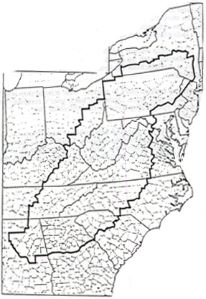The number of different arrangements can be made using all the letters of the word APPALACHIAN is

1. 
2. 
3. 
4. 

*Use the following to answer the next question.*

A particular model of stove has four burners each with its own dial that can be set on off, low, medium, or high. An example is shown below.

˅ ˅ ˅ ˅

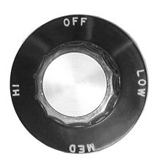

The number of different ways that the four burners can be adjusted is ___________.

|  |  |  |  |
| --- | --- | --- | --- |
|  |  |  |  |

Homework: ________________________

Homework: __________________________

2.5 & 2.6 Combinations

*~Diploma Connection~*

The number of ways that an executive committee consisting of prime minister, deputy prime minister, treasurer, and secretary can be chosen from 16 student council members is

1. 
2. 
3. 
4. 

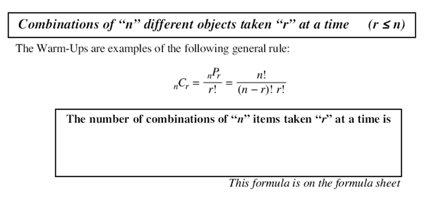

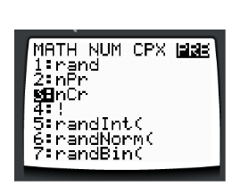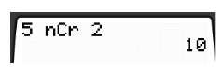

1. Three students from a class of ten are to be chosen to go on a school trip.
   1. In how many ways can they be selected? (Write the answer in factorial notation and evaluate)
   2. Confirm the answer in a) using the  key on the calculator.
2. A group of five students is to be selected from a class of 35 students. How many different groups can be selected?
3. The flags of most countries are designed in some combinations of the colours: red, white, blue, green, yellow, and black. How many color combinations are possible if at most three colors is used for each flag?
4. To win the LOTTO 649 a person must correctly choose six numbers from 1 to 49. Jasper, wanting to play the LOTTO 649, began to wonder how many numbers he could make up. How many choices would Jasper have to make to ensure he had the six winning numbers?
5. The Volleyball Committee decides to for a sub-committee of seven council members to look how funds raised should be spent on sports activities in the school. There are a total of 15 volleyball council members, 9 males and 6 females. The sub-committee must consist of exactly 3 females.
   1. In how many ways can the females be chosen?
   2. In how many ways can the males be chosen?
   3. In how many ways can the sub-committee be chosen?
   4. In how many ways can the sub-committee be chosen if Bruce, the volleyball coach must be included?

Homework: ________________________

*Recall*: When we were learning about permutations we had to remember that ________________________. In other words, AB is _________________ than BA. Or, having Rochelle in front of Darius is different than having Darius in front of Rochelle.

Combinations are completely different in respect to order.

A ______________ is a grouping of objects where order ________________ matter. For example, the two objects A and B have _______ combination because AB is __________________ BA.

Brainstorm two examples of a possible combination…

e.g. ______________________________

e.g.____________________________

Given the following questions below, determine whether it is a permutation problem or a combination problem. Put **P** you think it is a **permutation** question or put a **C** if you think it is a **combination** question on the line provided.

____A trick-or-treater is given the choice of five treats at one of the houses that she visits. If the home-owner allows her to choose three treats, in how many different ways can she select them?

____ A popular logic game uses eight different colored pegs to create a secret code that is five pegs long. The order of the colors is an important part of the code. If no two pegs are of the same color are in the secret code, how many different codes are possible?

____ In the game of SCRABBLE you try to create words form a group of seven lettered tiles on your rack. How many different orders of the tile must you consider if you are trying to make a three-letter word from the tiles G S U T Y R A?

____ Two friends play squash together regularly. If they decide to play three times a week, in how many ways can they select the days on which to play?

____ A teacher requires some help to prepare a bulletin board for the class. There are 28 students in the class. How many different volunteer groups of four students are possible?

____ A student council of seven people is to have its photograph taken for the school yearbook. In how many ways can the seven students be arranged if they all line up in a row?

~Diploma Connection~

1. There are three girls and six boys on the school baseball team. The team consists of a pitcher, a catcher, four infielders, and three outfielders. How many ways can the nine different positions be filled if the pitcher must be a girl and the catcher must be a boy?
2. 
3. 
4. 
5. 

*Use the following to answer the next* ***two*** *questions.*

There are seven dots around the circumference of a circle as shown below.

1. The number of triangles that can be created using the shape above is ___________.

|  |  |  |  |
| --- | --- | --- | --- |
|  |  |  |  |

1. The number of rectangles that can be created using the shape above is ___________.

|  |  |  |  |
| --- | --- | --- | --- |
|  |  |  |  |

1. In a soccer league each team must play each other **twice**. In one regular season there were 56 games. How many teams are in this soccer league?
   1. 6 teams
   2. 7 teams
   3. 8 teams
   4. 9 teams

Homework: ________________________