$$A∪B$$ | $$A∩B$$ | $$A∩B'$$
$$A∪B'$$ | $$A⊂B$$ | $$B⊂A$$
$$A∩A'$$ | $$A∪A'$$ | $$\left(A∩B\right)'$$
$$A∩B=∅$$ | $$A'$$ | $$B'$$
$$\left(A∪B\right)'$$
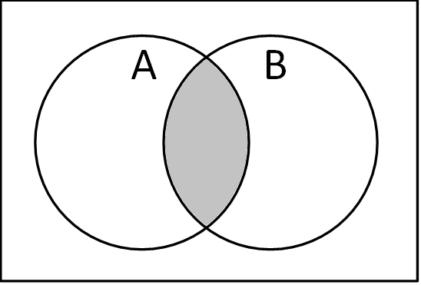 | 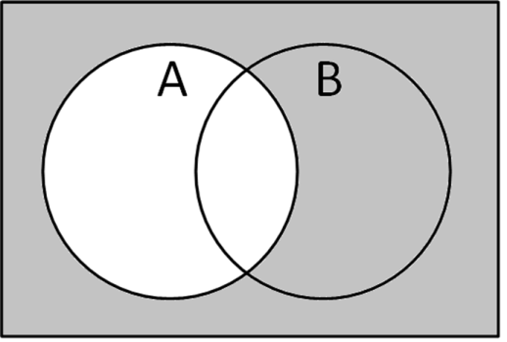 | 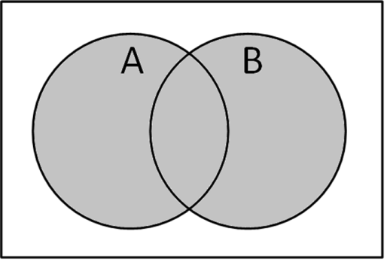
A  B | A  B | 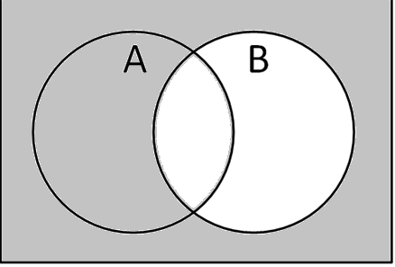
A  B | 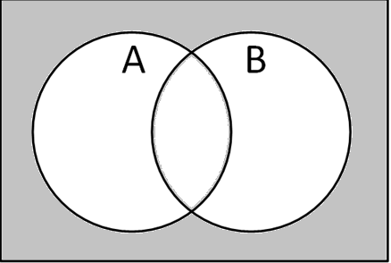
A or B | A or the complement of B | A and the complement of A
A and B are disjoint sets | Not A and  not B | A is the  subset of B
A and B | A or the complement of A | Not A
A and the complement of B | B is the  subset of A | Not A or  not B
Not B

Recommendations for Making Matching Cards

Do the following before laminating:
- Label the bottom right corner of all of the cards as described below in order to help provide an answer key.
  - Label all of the set notation cards with numbers.
  - Label all of the Venn diagrams with lowercase letters.
  - Label all of the word descriptions with uppercase letters.
- Photocopy each type (set notation, Venn, words) on a different colour.
- Label the back of every card in each complete set with the same number. This makes clean up much easier if sets get mixed up.

