Math 30-1: Trigonometry Investigation

Use a protractor, ruler and this circle with a radius of 1 to complete the chart on the other side of the page. Measure angles as precisely as possible and round coordinate values to the nearest hundredth.

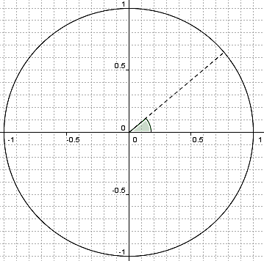

Angle in Standard Position | x-coordinate | y-coordinate | Ratio of y/x
0 degrees
10 degrees
20 degrees
30 degrees
40 degrees
50 degrees
60 degrees
70 degrees
80 degrees
90 degrees
100 degrees
110 degrees
120 degrees
130 degrees
140 degrees
150 degrees
160 degrees
170 degrees
180 degrees
190 degrees
200 degrees
210 degrees
220 degrees
230 degrees
240 degrees
250 degrees
260 degrees
270 degrees
280 degrees
290 degrees
300 degrees
310 degrees
320 degrees
330 degrees
340 degrees
350 degrees
360 degrees
“This is a diagram showing a circle with a radius of one. There is a 40-degree angle drawn on top of it. Please check now to see that the angle ends at (approximately) the point (0.76, 0.64). We can approximate to the hundredths place from this diagram.
“On the opposite side of this sheet you will see a table with rows for every angle between 0 and 360 degrees, in increments of ten degrees. In the row for 40 degrees, please enter 0.76 under the x-coordinate, because 0.76 is the x-coordinate of the end of the 40-degree angle on the diagram. Please enter 0.64 under the y-coordinate, because 0.64 is the y-coordinate of the end of the 40-degree angle. Finally, please enter 0.84 under “ratio of y/x,” because 0.64/0.76 is approximately 0.84.
“Your homework is to fill out this chart completely, for all 35 of the other angles listed. The coordinates you get will vary as you choose other angles. You will need a protractor to draw angles – please actually draw the angles you need to measure, and do not attempt to estimate angles without a protractor. If you find a logical shortcut, you may use it.”

