**Math 30-1 2. Radical Functions Review**

1. Graph each function using a table of values. Then, identify the domain and range.

**a)**  **b)**  **c)** 

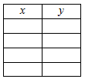  

Domain Domain Domain

Interval Notation

Range Range Range

Set Builder Notation

1. Explain in words how to transform the graph of  to obtain the graph of each function. State the domain and range in each case.

**a)**  **b)**  **c)** 

1. Match each function with its graph.

**a)**  **b)**  **c)**  **d)** 

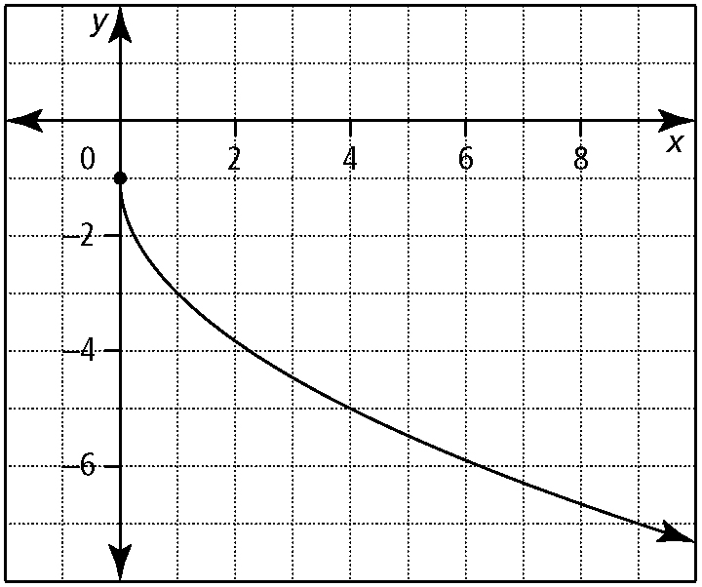 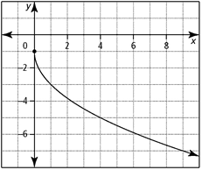 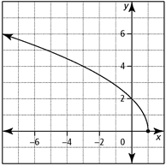 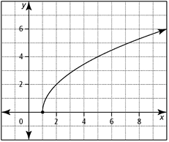 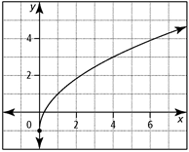

1. Sketch a possible graph for each situation involving the transformations  on the graph of .



a)  b)  c) d)



1. The point (4, *y*) is on the graph of  The graph is transformed into *g* (*x*) by a horizontal stretch by a factor of 2, a reflection about the *x*-axis, and a translation up 3 units. Determine the coordinates of the corresponding point on the graph of *g* (*x*).
2. The graph of  was translated horizontally and vertically only. The domain of the translated graph is and the range is . Describe the horizontal and vertical translations in words and using the notation .
3. The point (4, 10) is on the graph of the function  What is the value of *k*?
4. Write the equation of a radical function that would result by applying each set of transformations to the graph of  .

**a)** horizontal reflection in the *y*-axis, translation up 3 units, and translation left 2 units



**b)** vertical reflection in the *x*-axis, horizontal stretch by a factor of and translation down 7 units

1. Explain how to transform the graph of  to obtain the graph of each function.

a)  b) 

1. For each function, write an equation of a radical function of the form 

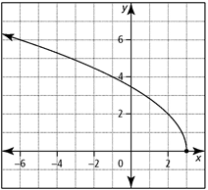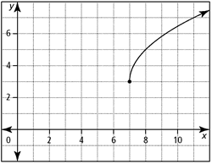 a) b)

1. For each point given on the graph of *y*  *f* (*x*), does a corresponding point on the graph of  exist? If so, state the coordinates to the nearest hundredth.

**a**) (9, 121) **b)** (−2, 7) **c)** (32, −1)

1. Determine the domains and ranges of each pair of functions. Explain why the domains and ranges differ.

**a)** *y*  *x*  5,  **b)** *y*  *x*  10, 

1. 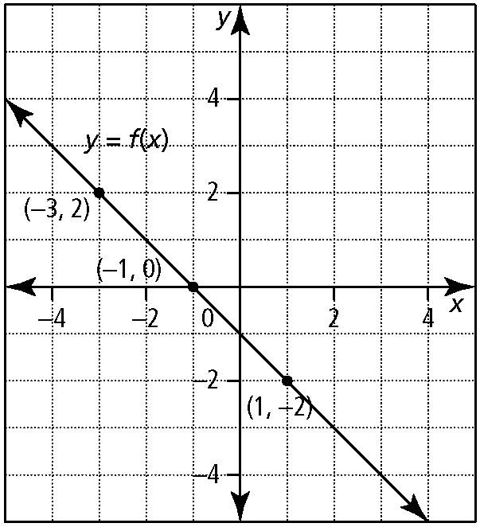 Using the graph of *y*  *f* (*x*), sketch the graph of

State the domain and range of

State the invariant points.

1. Use technology to graph *y*  *x*2  *x*  20 and

Provide a sketch in the window.

List window settings

X{ _____, _____, _____}

Y { _____, _____, _____}

List the domain and range for 

Why is the graph of  undefined over an interval?

State the coordinates of all invariant points.

1. The graph of  is shown. Provide a possible sketch for the graph of .

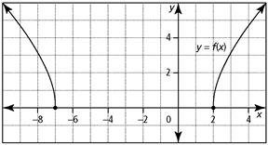

1. The solutions to a radical equation can also be referred to as the ______ of the equation.

The solutions to a radical equation are related to the ________ of the graph of the related function.

1. Solve each equation graphically.

**a)**  **b)** 

1. Solve  algebraically.
2. The speed of a tsunami wave in the ocean is related to the depth of the water by the equation where *s* is the speed of the wave, in metres per second, and *d* is the depth of the water, in metres. What is the depth of the water, to the nearest metre, if the speed of a tsunami wave is 10 m/s?
3. The radius, *r*, of a sphere is related to the surface area, *A*, by the equation 

**a)** The surface area of a baseball is about 172 cm2. Find the radius of a baseball, to the nearest tenth of a centimetre.

**b)** The radius of a tennis ball is about   
3.3 cm. Find the surface area, to the nearest square centimetre.

1. **Multiple Choice:** Given that the point (*x*, 4*x*2), *x* ≥ 0, is on the function *y*  *f* (*x*), which of the following is the point on?

**A** ( 4*x*2) **B** (*x*, 2*x*) **C** (*x*, 2*x*2) **D (**2*x*)

1. **Multiple Choice:** The radical function  has an *x*-intercept at 2. If the graph of the function is stretched horizontally by a factor of  about the *y*-axis, what is the new *x*-intercept?

**A** 2 **B** 1 **C**  **D** 