This activity promotes Communication, Connections, Estimation, Reasoning, Problem Solving, Technology, and Visualization.
Part 1: Hands on Activity. Students were challenged to construct a rectangular box with the largest volume possible from a standard 8.5 x 11 sheet of paper. They cut out squares from each corner and folded up the sides. Each student was encouraged to cut out a square that was a different size from students around them. I used the TI Nspire file to demonstrate how the dimensions of the box changed by cutting out a larger sized square. (Pull the red dot in the TI Nspire file to change the dimensions.)
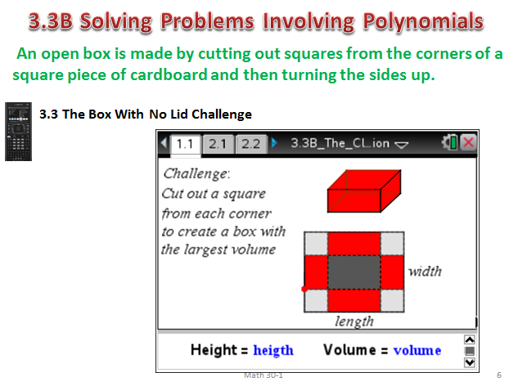
Students measured the length and width of the paper in centimeters. Length is 28 cm and width was 21.5 cm. Each student recorded the measurement of “x” (side length of square cut out) and volume of the rectangular box on the Smartboard.
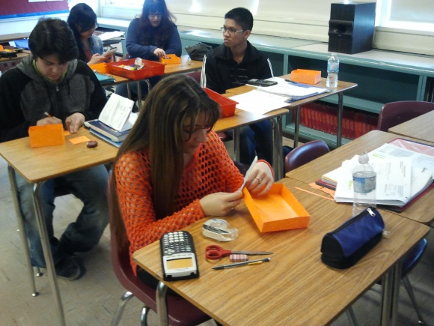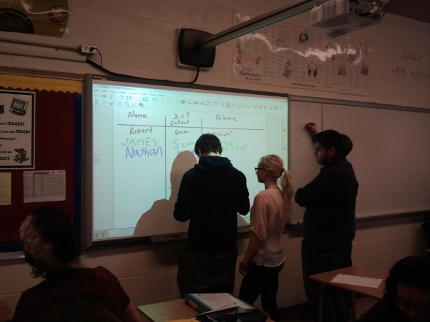
The student data was analysed to determine which value of “x” gave the largest volume. Dijana cut out a square with side length 4 cm. The maximum volume was 1080 cm³.
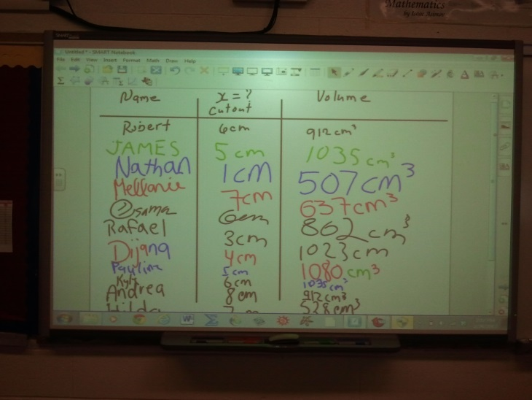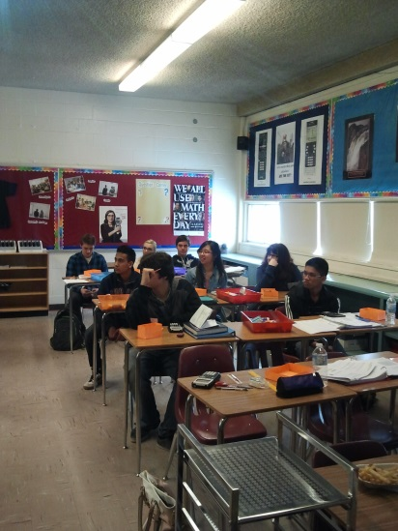
Part 2: Using Algebra
Using the variable x to represent the side length of the cut out square, students were able to determine that x also represented the height of the box. They used this variable to write expressions for the length and width of the base of the box. Students used these dimensions to write an expression, in factored form, to represent the volume of the box. Students used technology to graph the Volume equation.
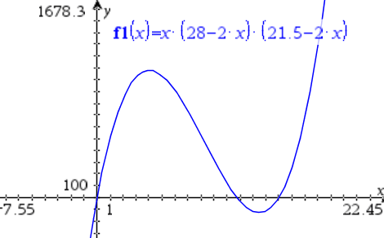
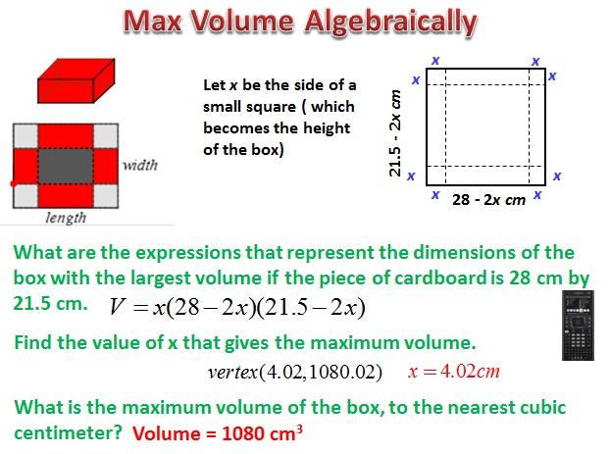
Students had discussions about the shape of the graph, the labels on the axes, and the restrictions on domain of this situation. They used the graphing calculator to determine the local maximum of the graph within the domain interval. Discussions included the meaning of the coordinates and the value of x that would produce the maximum volume. We also acknowledged Dijana for her great guess. This led to a discussion regarding the choice of side length to cut out. We found it interesting that all students chose a whole number side length. Hear some interesting reasons why no one chose a fraction of a cm such as 2.5.

Part 3: Solving a Similar Problem
Students used the TI Nspire file included with the activity to solve a similar problem involving a sheet with dimensions 8 ft by 10 ft. They answered all questions on the Nspire and were able to share their answers. Here are some screen shots of the Nspire file.
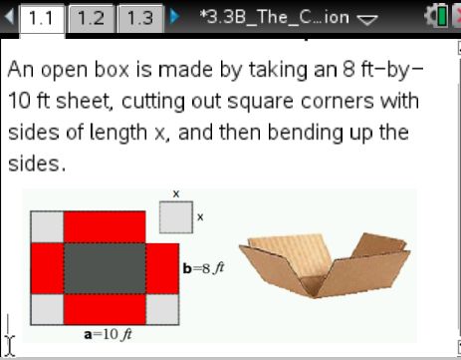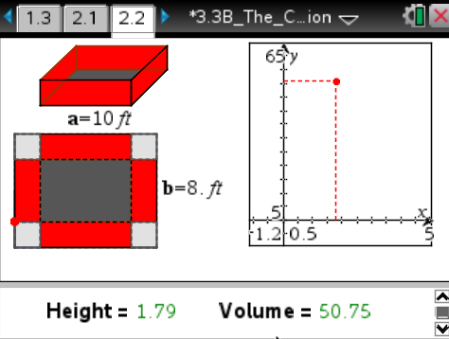
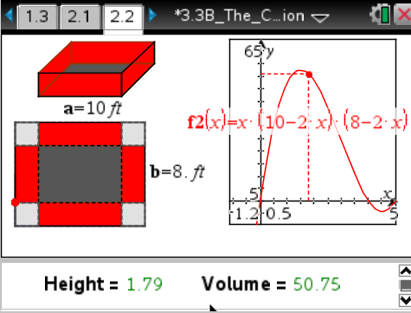
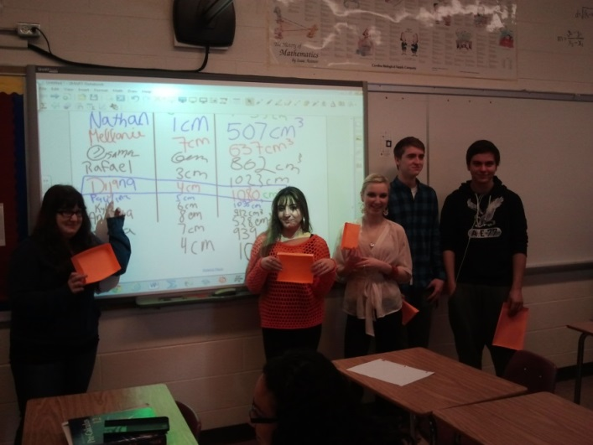
Dijana celebrating her guess.

