Performance Task: Polynomials
Polynomial Trending
A type of trend that represents a large set of data with many fluctuations. As more data becomes available, trends often become less linear and a polynomial trend takes its place. Graphs with curved trendlines are generally used to show a polynomial trend.
Why Facebook is Now a Classic "Turnaround Stock"
It may be one of the fastest reversals of fortunes we've seen with an initial public offering (IPO) in quite some time.
Before its May 18 IPO, Facebook (Nasdaq: FB) was growing its user base like wildfire, and investors couldn't wait for a chance to tap into that hot growth trend. Then, right after the stock went public, Facebook's growth streak and advertising business started to crumble, cutting the newly-issued shares in half within weeks of their debut.
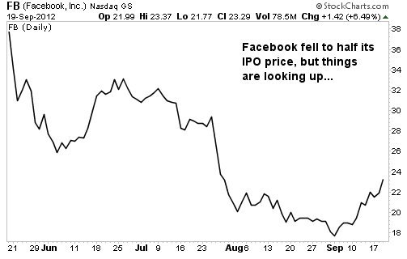

http://jutiagroup.com/20120920-why-facebook-is-now-a-classic-turnaround-stock/
Part A:
- Based on the charts above, draw a “line of best fit” that best represents the polynomial trend of Facebooks IPO in the first 4 months of public market. (1 mark)

- Based on the graph segment represented in the chart, speculate on the least possible degree and nature of the leading coefficient of the polynomial trend. Justify your answer using your knowledge of the characteristics of polynomial functions. (3 marks)

- Speculate the y intercept of the function using June 21 as time zero. What part of the polynomial is this y intercept? (2 marks)

- Based on the chart, explain why there is no x intercept. What context would make an x intercept possible? (2 marks)

0 2 4 6 8 10 12 14 16 18 20 22 24 26 t= weeks

Part B:
- Assume that the investors in Facebook consider it a loss when the stocks IPO price falls less than 22 /share.
  - State the x intercepts. Explain what they mean in the context of the question. (2 marks)

  - State the intervals where the function is positive and the intervals where the function is negative. (2 marks)

  - Explain whether the graph might represent a polynomial that has zero(s) of multiplicity 1, 2 or 3. (1 mark)

- Below is a different data set representing the IPO of Facebook stock.
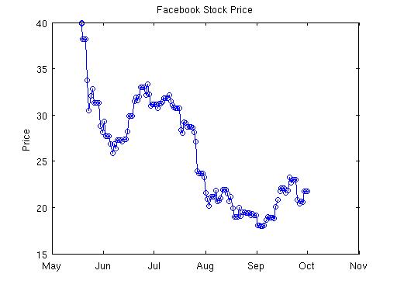
0 4 8 12 16 t= weeks

- Based on the graph segment represented in the chart, speculate on the least possible degree and nature of the leading coefficient of the polynomial trend. Justify your answer using your knowledge of the characteristics of polynomial functions. (3 marks)

- Explain whether the graph might represent a polynomial that has zero(s) of multiplicity 1, 2 or 3. (1 mark)

- Estimate the zero (s) of the function. (1 mark)

- Using the scale, determine a possible equation for the polynomial function (2 marks)

Part 3:
A possible line of regression for the Facebook IPO could be
$f\left(x\right)=0.5x^{4}-6.5x^{3}+30x^{2}-58x+40$

  - Algebraically verify that f(2) is a zero of the function. (2 marks)

  - If the factor of (x-2) has a multiplicity of 2, factor f(x). State the zero(s) of the function. Hint: GCF 0.5 First. (3 marks)

  - State the intervals where the function is positive and the intervals where the function is negative. (2 marks)

