**Math 30-1 Chapter 3 Review**

**Polynomial Functions**

**Name ___________________________**

Date reviewed with teacher:

Signature of teacher:



**Math 30-1: Chapter 3 Review Assignment**

**Polynomial Functions**

***Answer the following questions. Remember to show all your work.***

1. Express the following polynomials in factored form. **(RF11.1)**
   1. 
   2. 
2. What are the zeros of the function ? **(RF11.3)**
3. What is the remainder when  is divided by ? **(RF11.4)**
4. When  is divided by , the remainder is 0. What is the value of *p*?  
    **(RF11.4)**
5. a) Create a cubic expression, that when divided by , will have a remainder of 6.

**(RF11.4)**

* 1. Explain or demonstrate how you know your expression is correct. **(RF11.4)**

1. For each of the following, determine if the expression is a factor of   
    and explain how you know. **(RF11.5)**
   1. 
   2. 
   3. 
   4. 
2. If  is a factor of , determine the value of *k*. **(RF11.5)**
3. For each of the following five functions, determine if the function represents a polynomial function. Explain why or why not. **(RF12.1)**
   1. 
   2. 
   3. 
   4. 
   5. 
4. Sketch the graph of a fifth degree polynomial function with one real root of multiplicity 3 and with a negative leading coefficient. *(Note: There may be other roots as well)* **(RF12.2, 12.3)**
5. The graph of  is shown below. **(RF12.4)**

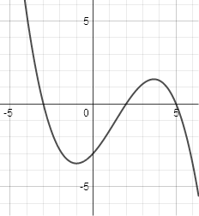

Determine the roots of . Explain how you know.

1. Given the function , **(RF12.6)**
   1. Accurately sketch the graph, and label any key points (*x*-intercepts, *y*-intercepts, maximum, minimum).
   2. State the domain and range.
   3. Determine the zeros of the function.
2. The graph of the polynomial function  is shown below.

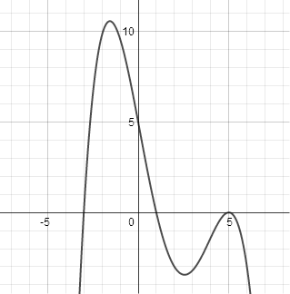

* 1. What is the minimum possible degree for the polynomial function above? Explain   
     how you know. **(RF12.3)**
  2. Determine an equation of the function in factored form. **(RF12.5)**

1. The graphs of four polynomial functions are shown below.

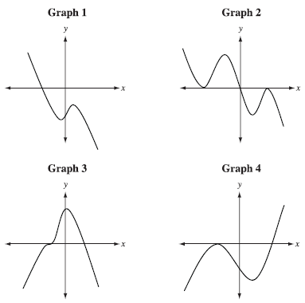

Match three of the graphs numbers above with a statement below that best describes the function.

* 1. The graph that has a positive leading coefficient is graph number _______.

Explain how you know. **(RF12.2)**

* 1. The graph of a function that has two different zeros, each with multiplicity 2, is graph number _______.

Explain how you know. **(RF12.5)**

* 1. The graph that could be a degree 4 function is graph number _______.

Explain how you know. **(RF12.3)**

1. A box with no lid is made by cutting four squares of side length *x* from each corner of a 10 cm by 20 cm rectangular sheet of metal. **(RF12.7)**

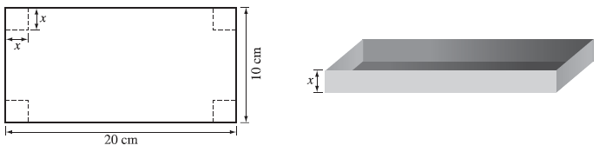

* 1. Find an expression that represents the volume of the box.
  2. State the restrictions on the domain.
  3. Sketch the graph of the function.  
     Label the key points.



* 1. Find the value of *x*, to the nearest hundredth of a centimetre, that gives the maximum volume.
  2. What is the maximum volume of the box, to the nearest cubic centimetre?

1. A large software company determines that its profit, *P*, in dollars, for a certain program can be modeled by the function , where *x* represents the number, in thousands, of programs sold. **(RF12.7)**
   1. What is the degree of the function ?
   2. What is the leading coefficient of this function?
   3. What is the constant of this function?
   4. What does the constant represent in this situation?
   5. What are the restrictions on the domain?
   6. What do the *x*-intercept(s) of the graph represent in this context?
   7. What is the profit from the sale of 50 000 programs?