**Transformation Connections**

For each given function:

* draw the transformed function on the same grid
* write the mapping notation for the transformation (how the points change)
* write the equation of the transformed function in function notation, 
* describe the transformation (horizontal, vertical, stretch, reflection, translation).

1. Linear function,  becomes 

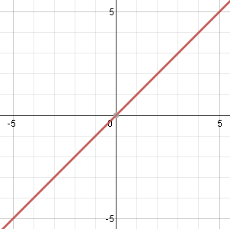

mapping notation



equation in 

describe the transformation.

1. Sinusoidal function,  becomes 

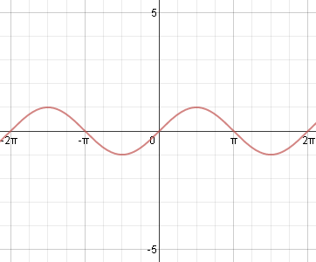

mapping notation



equation in 

describe the transformation.

1. Quadratic function,  becomes 

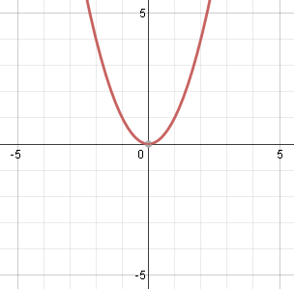

mapping notation



equation in 

describe the transformation.

1. Sinusoidal function,  becomes 



mapping notation



equation in 

describe the transformation.

1. 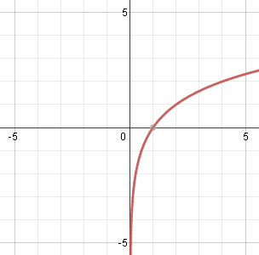Logarithmic function,  becomes 

mapping notation



equation in 

describe the transformation.

1. Sinusoidal function,  becomes 



mapping notation



equation in 

describe the transformation.

1. 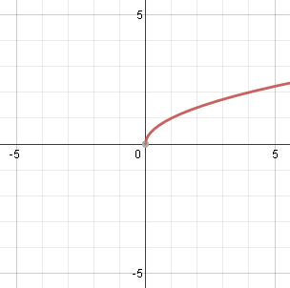Radical function,  becomes 

mapping notation



equation in 

describe the transformation.

1. Sinusoidal function,  becomes 

mapping notation



equation in 

describe the transformation.

1. 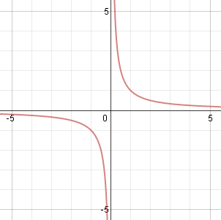Rational function,  becomes 

mapping notation



equation in 

describe the transformation.

1. Sinusoidal function,  becomes 

mapping notation



equation in 

describe the transformation.

1. 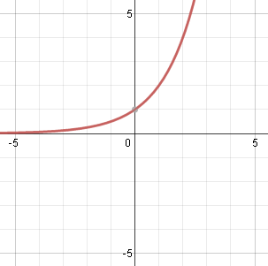Exponential function,  becomes 

mapping notation



equation in 

describe the transformation.

1. Sinusoidal function,  becomes 

mapping notation



equation in 

describe the transformation.

1. 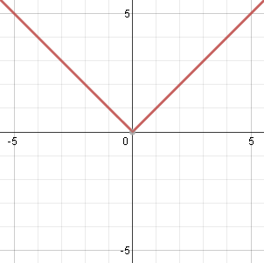Absolute value function,  becomes 

mapping notation



equation in 

describe the transformation.

1. Sinusoidal function,  becomes 

mapping notation



equation in 

describe the transformation.

Conclusions:

|  |  |  |  |
| --- | --- | --- | --- |
|  | Mapping Notation | General Function | Sinusoidal Function |
| Original Function |  |  | or |
| Horizontal stretch |  |  |  |
| Vertical stretch |  |  |  |
| Horizontal reflection |  |  |  |
| Vertical reflection |  |  |  |
| Horizontal translation |  |  |  |
| Vertical translation |  |  |  |
| Generally |  |  |  |