**Math 30-1 Chapter 7 Review**

**Exponential Functions**

**Name ___________________________**

Date reviewed with teacher:

Signature of teacher:



**Math 30-1: Chapter 7 Review Assignment**

**Exponential Functions**

***Answer the following questions. Remember to show all your work.***

1. Given that , **(RF9.2)**
   1. Determine the domain of .
   2. Determine the range of .
   3. Determine any asymptotes in the graph of .
   4. Determine the intercepts in the graph of .
   5. Is  an increasing or decreasing function? Explain how you know.
2. Determine the *y*-intercept on the graph of . **(RF9.2)**
3. Given that :
   1. Sketch the graph of . **(RF9.1)**

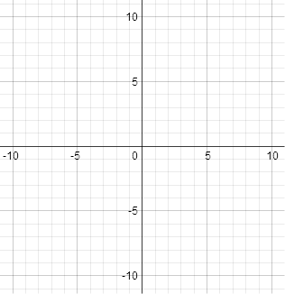

* 1. Describe the transformations you would need to apply to the graph of  to sketch the graph of . **(RF9.3)**
  2. Sketch the graph of. **(RF9.3)**



1. Algebraically solve the equation . **(RF10.1)**
2. Graphically solve the equation . **(RF10.2)**  
   *(Round your answer to 2 decimal places.)*
3. Graphically solve the equation **(RF10.2)**  
   .   
   *(Round your answer to 2 decimal places.)*
4. You invest $500 at 4% compounded annually. (**RF10.6)**
   1. Write an exponential function to model the value of your investment after *n* years.
   2. Sketch a graph of your investment for the first twenty years.
   3. Determine when your investment will be worth $1000.