**Math 30-1 8.1 to 8.3 Review of Logarithms**

1. Sketch a graph of each function listed. Determine the characteristics for each graph.

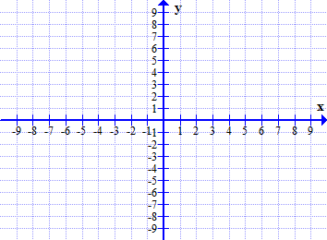 a) 

domain ____________

range ____________

equation of asymptote

___________________

*x*- intercept _________

*y*- intercept _________

increasing or decreasing

b) 

domain ____________

range ____________

equation of asymptote

___________________

*x*- intercept _________

*y*- intercept _________

increasing or decreasing

1. The point  is on the graph of the logarithmic function *f* (*x*)  log*c* *x*. The point (*k*, 64) is on the graph of the inverse, *y*  *f* −1(*x*). Determine the value of *k*.
2. Describe in words how the graph of  can be obtained from the graph of *y*  log4 *x*.
3. Write the equation of the asymptote of the inverse of *f* (*x*)  3 log7 (*x*  2)  1.
4. Write the equation of the final transformed image function if the graph of *y*  log2 *x*  is stretched horizontally by a factor of 3 about the *y*-axis, translated 5 units to the right and translated 4 units down.

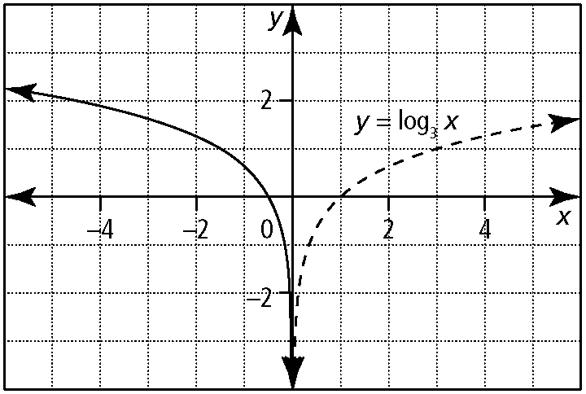

1. In the graph shown, the solid curve is a stretch and/or reflection of the dashed curve. Write the equation of the solid graph in the form.
2. Express in logarithmic form ________________
3. Express *y*  2*x*  1  5 in logarithmic form ________________
4. Write  in exponential form ________________
5. Express in exponential form ________________
6. Express log2 (*x*  1)  5  *y* in exponential form ________________
7. Evaluate each expression

a)  ________________

b)  ________________

c)  ________________

d)  ________________

e)  ________________

f)  ________________

g)  ________________

h)  ________________

i)  ________________

j)  ________________

1. Evaluate each to three decimal places:

a)  ________________

b)  ________________

1. Express  as a single logarithm ________________
2. Write each expression as a single logarithm.

a)  ________________

b)  ________________

c)  ________________

1. Express as a sum or difference of logarithms.

a)  ________________

b)  ________________

1. Determine if each statement is true or false.

a)  _________ b)  _________

c)  _________ d)  _________

e)  _________ f)  _________

f)  _________ g)  _____

h)  ________ i)  _________

1. If  and , express  in terms of *x* and *y*.
2. If log5 9  *k*, write an algebraic expression in terms of *k* for log5 94.
3. Simplify each expression.

a)  _____________

b)  _____________

c)  _____________

d)  _____________

e)  _____________

f)  _____________

g)  _____________

h)  _____________

1. Given that , determine an expression in terms of *x* for 
2. If log5 *x*  25, determine the value of .
3. Determine the value of log*n* *ab*2 if log*n* *a*  5 and log*n* *b*  3.
4. If , then  _____________
5. If , then  _____________
6. If , then  _____________
7. If  can be expressed as _____________