**Math 30-1 Chapter 8 Review**

**Logarithmic Functions**

**Name ___________________________**

Date reviewed with teacher:

Signature of teacher:



**Math 30-1: Chapter 8 Review Assignment**

**Logarithmic Functions**

***Answer the following questions. Remember to show all your work.***

1. The graph of  is reflected in the line . Determine the equation of the transformed graph. Remember to isolate *y* in your equation. **(RF7.1)**
2. Determine, without technology, the value of .   
   Explain how you arrived at your answer. **(RF7.3)**
3. The equation  can be written in exponential form as: **(RF7.2)**
   1. 
   2. 
   3. 
   4. 
4. Without using technology, estimate the value of . Explain how you arrived at your answer. **(RF7.4)**
5. Without using technology, rank these logarithms in order from least to greatest:   
   , , , . **(RF7.4)**
6. The expression  is equivalent to: **(RF8.3)**
   1. 
   2. 
   3. 
   4. 
7. Written as a single logarithm, is: **(RF8.3)**
   1. 
   2. 
   3. 
   4. 
8. Given that  and , determine the value of . **(RF8.3)**

*Use the following information to answer the next question.*

A student’s work to simplify a logarithmic expression is shown below, where *a* > 1.

**Step 1: **

**Step 2: **

**Step 3: **

**Step 4: **

**Step 5: **

1. The student made his **first** error when going from: **(RF8.3)**
   1. Step 1 to Step 2
   2. Step 2 to Step 3
   3. Step 3 to Step 4
   4. Step 4 to Step 5
2. Determine the value of . Round your answer to two decimal places. **(RF8.4)**
3. Determine the equation for the vertical asymptote for the graph of , where  and . **(RF9.5)**
4. Describe the translations for the graph of to become the graph of .  
    **(RF9.6)**
5. Determine the domain of the graph of , where . **(RF9.5)**
6. Graphically demonstrate that  and  are inverses of each other. **(RF9.7)**

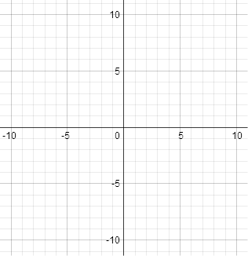

1. Solve the equation  algebraically. Round your answer to the nearest hundredth. **(RF10.2)**
2. Solve algebraically . Verify your solution. **(RF10.3)**
3. Explain what would cause a solution in a logarithmic equation to be extraneous. **(RF10.4)**

*Use the following information to answer the next question.*

Earthquake intensity is given by , where  is the reference intensity and *M* is the magnitude. An earthquake measuring 5.3 on the Richter scale is 125 times more intense than a second earthquake.

1. Determine, to the nearest tenth, the Richter scale measure of the second earthquake. **(RF10.7)**
2. Sound loudness is measured in a special scale called the decibel scale. The decibel reading, dB, is determined by the formula , where L is the loudness of the sound. If heavy traffic has a decibel reading of 90 dB and ordinary conversation has a decibel reading of 50 dB, then how many times louder is heavy traffic than ordinary conversation? **(RF10.7)**
3. The population of a particular town on July 1, 2011 was 20 000. If the population   
   decreases at an average annual rate of 1.4%, **algebraically determine** how long will   
   it take for the population to reach 15 300? **(RF10.8)**