**Math 30-1 Chapter 10 Review**

**Function Operations**

**Name ___________________________**

Date reviewed with teacher:

Signature of teacher:



**Math 30-1: Chapter 10 Review Assignment**

**Function Operations**

***Answer the following questions. Remember to show all your work.***

1. Given the functions  and , determine the equation of ,   
   sketch the graph of  and state the domain and range of  for each of the next   
   4 questions. **(RF1.2, RF1.3)**
   1. 



Domain:

Range:

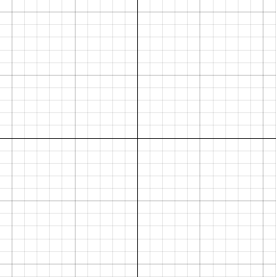

* 1. 



Domain:

Range:



* 1. 



Domain:

Range:



* 1. 



Domain:

Range:



*Use the following information to answer the next question.*

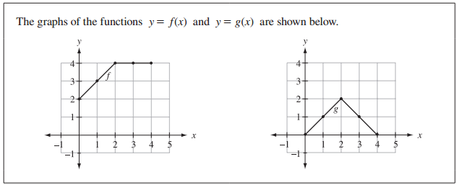

1. Sketch the graph of . **(RF1.1)**

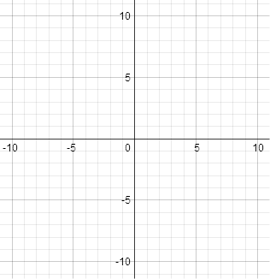

*Use the following information to answer the next question.*

The graphs of  and  are show below.

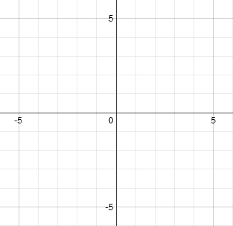

 

1. Sketch the graph of  **(RF1.1)**



1. Given , , and , determine
   1.  **(RF1.5)**
   2. = **(RF1.5)**
   3.  **(RF1.5)**
   4.  **(RF1.5)**
   5.  **(RF1.5)**
   6.  **(RF1.6)**
   7.  **(RF1.6)**
2. Given that , determine possible equations for  and . **(RF1.4)**
3. Given that , determine possible equations for  and .

**(RF1.8)**

1. Given that  and , sketch the graph of .

