Name: _________________________________ Date: _____________________

Mid-Unit Quiz: Radical Functions

**1.** Solve the following radical equations algebraically. Be sure to verify your solutions.

1.  **b.** 

**2.** Explain the transformations required to change the basic function  to the function

. Sketch the new function by mapping the points and state the new

domain and range.



**3.** For each graph, write the equation of the radical function in the form  **and**

 . State the domain and range.

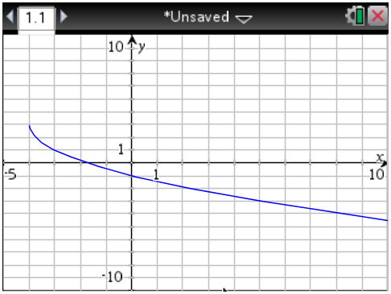

**4.** Use technology to graph the function  given that  . Sketch the graph on the grid. State any restrictions on the variable and state the domain and range of both functions.



**5. a.** Solve the equation graphically, using technology. State any restrictions on the variable.

State your answers to the nearest tenth.



1. Solve the equation graphically, in two different ways. State any restrictions on the

variable. State your answers to the nearest tenth.



**Bonus:** If the function  passes through the point  , what is the

value of  ?