Name: _________________________________ Date: _____________________

Chapter Checkup Quiz: Rational Functions

1. Graph the following function using transformations. Explain the transformations required to transform the basic rational function from  to  .

Show all the important parts of the graph.



1. Algebraically manipulate the function  so that you can state the

Transformations to change it from the basic rational function .

**3.** Match the graph of each rational function with its equation. You must give an explanation for each choice.

  

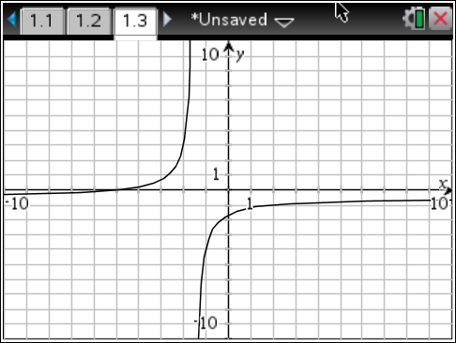 

**4.** Use technology to solve the radical function graphically. 

Sketch and label the graph of the solution. State your answer to the nearest hundredth.



Algebraically solve the equation.

Leave your answer in exact form.

**5.** Explain why the previous question, when solved graphically gives an approximate solution, while solving algebraically yields an exact root.

**6.** Alex and Donovan are traveling to a store in Vulcan, 400 km away, to purchase the last set of Spock Ears in the Province. Alex leaves one hour earlier than Donovan, but Donovan travels at an average speed 20km/h faster than Alex. If they arrive at the store at exactly the same time, what was the average speed that each of them traveled?

1. Let t represent the time it takes Alex to travel to the store. Write an expression for the average speed that each person travels.
2. Write and solve an equation that represents the difference in their average speeds.