Math 30-3 Probability Review

Probability C1 - Probability Basics

- A charity lottery claims that the chance of winning a prize is 1 in 5. Express the probability of winning as a fraction, a decimal, and a percent.

- You roll one die.
  - What is the probability of rolling a 4?
  - What is the probability of rolling a 5?
  - What is the probability of rolling a 6?
  - Explain why the answers to parts a), b), and c) are the same.
  - What is the probability of rolling an even number?

- On the drive to school you pass two traffic lights.
  - List all of the possible combinations of lights you could get. Use R for red, G for green, and Y for yellow.
  - What is the probability of getting 2 red lights?
  - What is the probability of getting at least 1 red light?

- Lucy manages a produce store. When ordering apples, she expects that 15% of the apples will arrive spoiled.
  - If she orders 350 kg of apples, how many kilograms would she expect to arrive spoiled?
  - On one order, 30 kg of the apples arrived spoiled. How many kilograms would you expect Lucy ordered?

Math 30-3 Probability Review

Probability C2 - Probability and Odds

- You spin the spinner once.
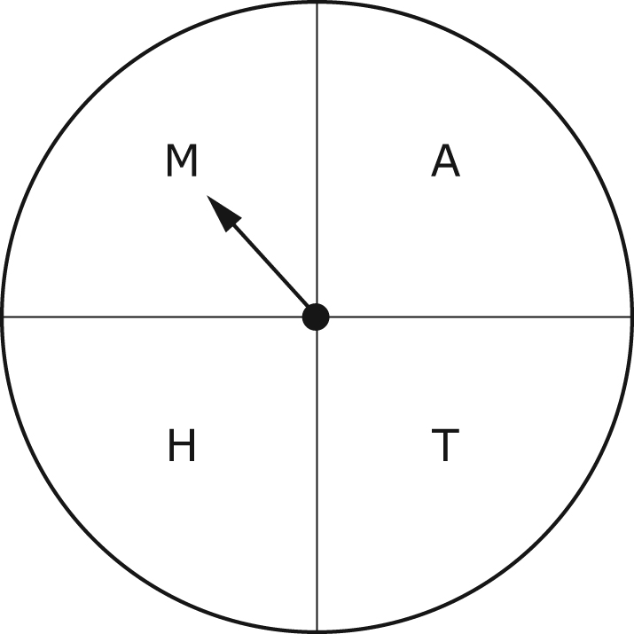
  - What is the probability of landing on M?
  - What are the odds of landing on M?
  - What are the odds against landing on M?

- You roll two dice.
  - What is the probability of rolling a total of 9 or more?
  - What is the probability of rolling a sum that is an odd number?
  - What are the odds of rolling a sum that is an odd number?
  - What are the odds against rolling a sum of 3 or less?

- A restaurant has a scratch-and-win contest. You play four cards and win once.
  - What percent of tries did you win?
  - You find out that the odds of winning are 1 in 4. What is the probability of winning?
  - Did you do better or worse than the odds of winning?

Math 30-3 Probability Review

Probability C3 - Theoretical & Experimental Probability

- Explain the difference between theoretical and experimental probability. Include an example in your explanation.

- After testing 300 light bulbs, 15 were found to be defective. What is the experimental probability of finding a defective light bulb? Express your answer as a fraction, decimal and percent.

- What is the theoretical probability of getting a head when you flip a coin? If you flip a coin 20 times how many heads would you expect to get? Flip a coin 20 times and calculate the experimental probability of getting a head. Compare the experimental probability to the theoretical probability.

Math 30-3 Probability Review

Probability C4 - Working with Probability

- What are the odds of obtaining success in each experiment?
  - rolling a die and the number facing up is 4
  - choosing a vowel from the letters in G-R-A-D-U-A-T-I-O-N
  - cutting a deck of cards and getting a red card

- Scott is laying laminate flooring. He needs 80 boards of laminate. About 15% of the boards are not usable. How many boards should Scott have available?

- Four gyms are having contests to win a free membership. The chances of winning are different for each gym.
Fit Bodies: 1 in 25 probability of winning
Great Fit: 70 in 75 probability of not winning
Life Fitness: 1 to 25 odds of winning
World Gym: 70 to 75 odds of not winning

Which contest gives you the greatest chance of winning?

- A store that sells electrical receptacle plates claims that about 2% of the plates they sell arrive at the store damaged. The plates are sold in packs of 10.
  - On average, there is approximately one damaged plate in how many packs?
  - A customer purchases 8 packs of plates. Predict how many plates will be damaged.

