Scatterplots and Trends with Microsoft Excel 2010

The following instructions will show you how to create a scatter plot with a line of best fit using Microsoft Excel 2010.

- Enter data into Excel.
  - The first column should be the values for the horizontal axis. The second column should be the values for the vertical axis.

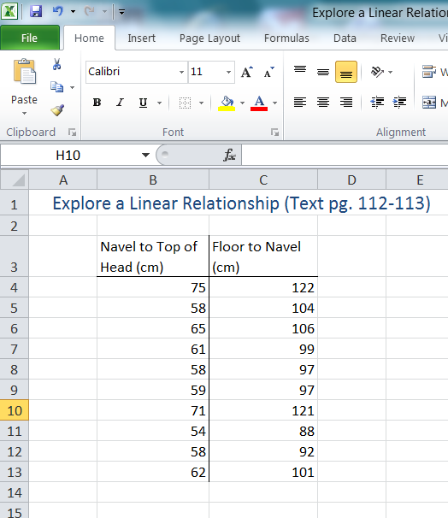

- Select all the data and then click on Insert – Scatter.

- Change the Chart Layout to the type that includes a line of best fit.

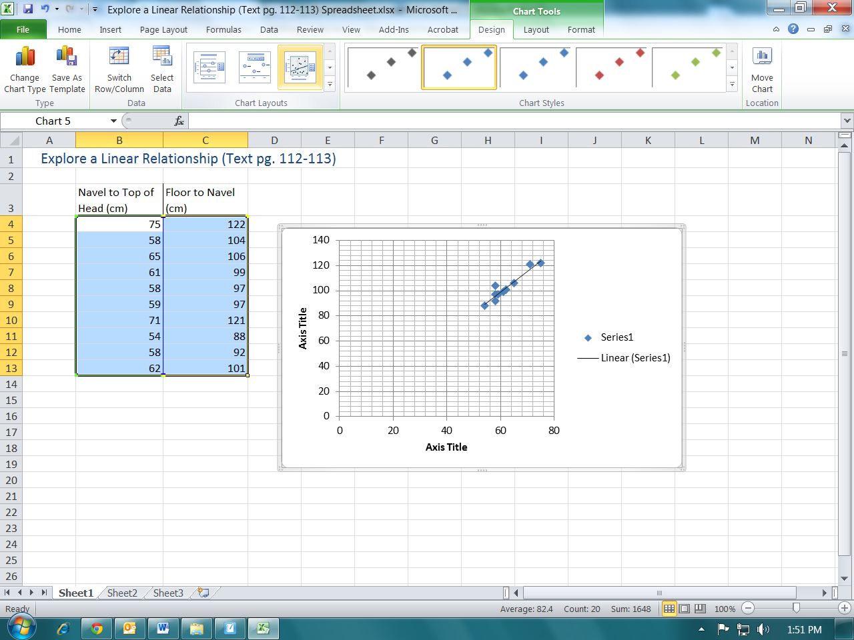

- Now you can adjust scales and titles to make it look better.

- This scatterplot can now be used to analyze trends (Positive Linear Trend) and to interpolate and extrapolate.

