**Math 30-3: Investigating Lines (Direct Variation)**

**Part A**

1. The cost of a private dinner with a set menu at a restaurant is represented by the equation where *n* is the number of people in attendance and *C* is the total cost. Complete the partial table of values below. Then, graph the data on the grid provided. Label the graph L1.

|  |  |
| --- | --- |
| ***n*** | ***C*** |
| 0 |  |
| 1 |  |
| 2 |  |
| 3 |  |
| 4 |  |
| 5 |  |
| 6 |  |

1. The cost of a different menu is represented by the equation  where *n* is the number of people in attendance and *C* is the total cost. Complete the partial table of values below. Then, graph the data on the same grid as number 1. Label the graph L2

|  |  |
| --- | --- |
| ***n*** | ***C*** |
| 0 |  |
| 1 |  |
| 2 |  |
| 3 |  |
| 4 |  |
| 5 |  |
| 6 |  |

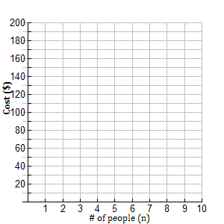

3. Are the graphs above linear or non-linear?

How do you know?

4. How are L1 and L2 different? How are they similar?

5. What would happen to the **graph** if the equation was ?

6. (a) What does the number in front of the variable “*n*” represent in this problem?

(b) What does the number in front of the variable “*n*” represent in general?

7. Given the graphs below, determine:

(a) The cost/person

(b) The equation of the line.

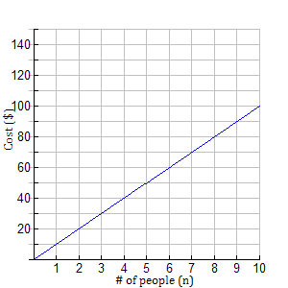 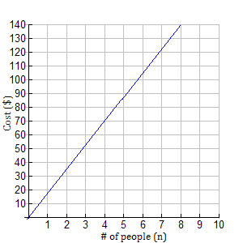

1. (a)
2. (b)

8. How did you find the value in front of the variable in question #7?

9. What if you were told that the cost for 8 people was $96? What would be the equation of the line?