**Math 30-3: Investigating Lines (Partial Variation)**

1. The cost of a dinner at a restaurant is represented by the equation where *n* is the number of people in attendance and *C* is the total cost. Complete the table of values below. Then, graph the data on the grid provided. Label the line L1.

|  |  |
| --- | --- |
| ***n*** | ***C*** |
| 0 |  |
| 1 |  |
| 2 |  |
| 3 |  |
| 4 |  |
| 5 |  |
| 6 |  |

1. The cost of a different menu at the same restaurant is represented by the equation  where *n* is the number of people in attendance and *C* is the total cost. Create a table of values below. Then, graph the data on the same grid as number 1. Label the line L2.

|  |  |
| --- | --- |
| ***n*** | ***C*** |
| 0 |  |
| 1 |  |
| 2 |  |
| 3 |  |
| 4 |  |
| 5 |  |
| 6 |  |

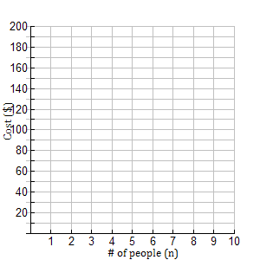

3. How are L1 and L2 different? How are they similar?

4. What would happen to the **graph** if the equation was ?

5. What does the constant number (the number NOT multiplied by a variable) in the equation represent?

6. What is the equation of the line shown below? Explain.

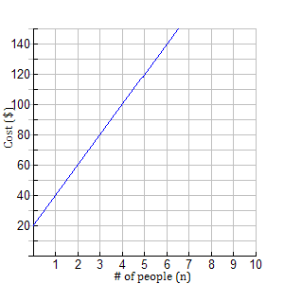

7. What if you were told that the fixed cost of renting a room is $40 and the cost per person is $15. Write the equation of the line.