**MATH 30-1**

**TRIGONOMETRY 1**

**Quiz 1**

1. State the following angles in radians. (as an exact value) **[4 marks]**

a) 30 b) 150

c) 330 d) -135

2. State the following angles to the nearest degree. **[4 marks]**

a)  b) 

c) 4.5 radians d) 

3. Find one positive and one negative coterminal angle for . **[2 marks]**

4. Write an expression that states all coterminal angles for **[2 marks]**

a) 30 b) 

5. A circle has a radius of 8 cm. If its central angle subtends an arc 11 cm long, find the measure of the angle to the nearest tenth of a degree. **[3 marks]**

6. Complete the chart. **[6 marks]**

|  |  |  |  |
| --- | --- | --- | --- |
| **REFERENCE ANGLE** | QUADRANT | SKETCH | ROTATION ANGLE (angle in standard position) |
| 30 | 2 |  |  |
| 45 | 4 |  |  |
| 60 | 1 |  |  |
| 25 | 3 |  |  |
| 15 | 4 |  |  |
| 36 | 3 |  |  |

7. A circle has its center at the origin and a radius of 1. Find the value of x in the point  if it lies in quadrant 1. **[2 marks]**

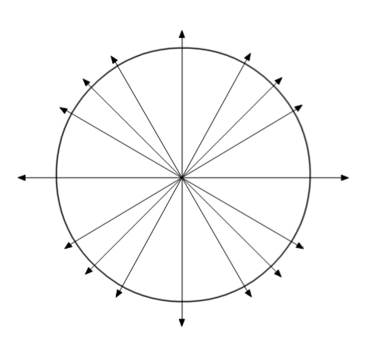8. Complete the Unit Circle. Show all points and all angles in both degrees and radians.

**[8 marks]**