Math 30-1

TRIG 2

Quiz 1

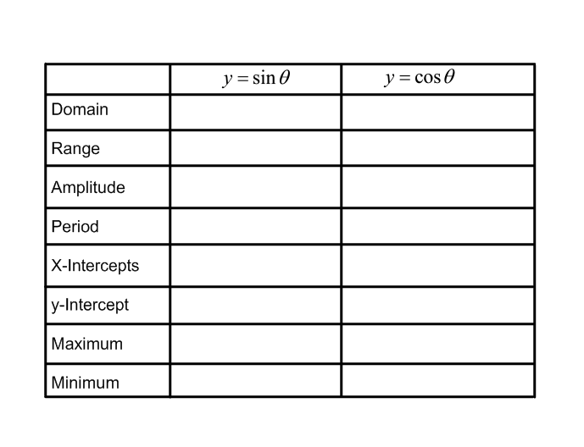

1. Complete the following table.

2. Consider the function 

a) What is the period, in radians, of this function?

b) What is the amplitude of this function?

3. a) Write the equation of the function that results when y = sinx is stretched vertically by a factor of 5, and stretched horizontally by a factor of 2.

b) What is the amplitude and period of this new function?

4. What is the equation of this cosine function?

