Math 30-1

TRIG 2

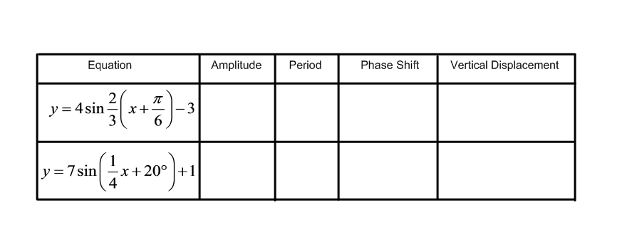Quiz 3

1. Determine the amplitude, period, phase shift, and vertical displacement of each function. (4 marks)

2. Write a **positive** cosine function for the graph: (4 marks)

3. At midnight, the depth of water at a pier is at low tide depth of 4.5 m.

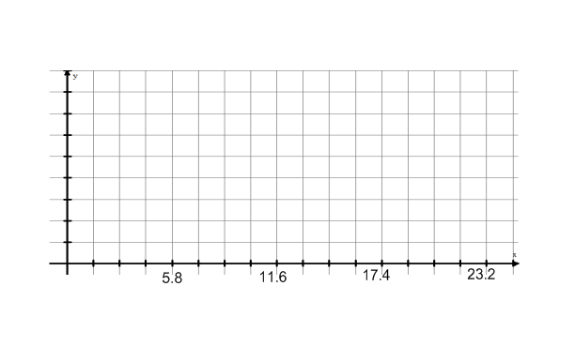 At high tide, 5.8 hours later, the depth of the water at the pier is 8.5 m. (5 marks)

a) Using the following grid to sketch two tidal periods. Consider 0 to be midnight.

b) Write a cosine function that models the depth of the water over time.

c) What is the depth of the water at 1:00 AM? (show how you get your answer)

d) When is the water first at a depth of 7.0 m? (show how you get your answer)

4. State the following for y = tan x. (5 marks)

Period:

x-intercepts:

y-intercepts:

vertical asymptote(s):

horizontal asymptote(s):