**Math 30-3 Number Name: _________________**

Number Review Assignment

***C1 Buying or Leasing a Vehicle***

1. Briefly describe each of the following purchasing options:
   1. Buying
   2. Leasing
   3. Lease-to-Own
2. Please list at least three factors to consider when purchasing a vehicle.
3. Willow saves $4000 to buy a used car. She found one that costs $3800.

**a)** What is the total cost of the car after tax?

**b)** Does Willow have enough saved to buy the car?

1. Nick borrows $5000 from a bank to buy his first car. His monthly payment is $117.20 for four years.

**a)** Calculate the total amount that Nick will repay the bank.

**b)** How much interest will he pay over the life of the loan?

1. George has found two used trucks that he likes.

Truck #1:

• One year old, two-door cab, manual transmission

• $22 000 (not including tax), interest rate of 4.9% for 60 months

Truck #2:

• Three years old, four-door cab, automatic transmission

• $20 000 (not including tax), interest rate of 4.9% for 48 months

**a)** Use technology to calculate the monthly payments for each truck.

**b)** How much would George pay, in total, for truck #1? truck #2?

**c)** George commutes more than 100 km to his job site every day. Which truck should George buy? Justify your answer.

1. David is financing his motorcycle at an interest rate of 6.9%. The total cost of the motorcycle is $10 170, including taxes.

**a)** Use technology to calculate his monthly payment if he finances for

**i)** 24 months  
**ii)** 36 months  
**iii)** 48 months  
**iv)** 60 months

**b)** How does the length of the loan affect the monthly payment?

**c)** Calculate the cost of financing for the 24 month loan and the 60 month loan. What happens to the total amount of interest paid if you take a longer time to pay off the loan?

1. Janice just bought a new hybrid car. The before-tax cost was $32 068. The dealership had 0% financing.

**a)** Janice has a 72-month loan. What is her monthly payment?

**b)** After one year, how much will Janice have paid on the car? How much will she still owe?

1. Lana just signed a four-year lease agreement for her first car. She had a down payment of $575.00. Her monthly payments are $287.24.
   1. How much will Lana have paid to lease the car at the end of the four-year term?
   2. If the residual value of the car is $5000 and Lana can get financing of 2.5% over three years, how much will Lana pay in total to own the car?
2. Paul is leasing a truck for three years. He expects to drive about 80 000 km in the three-year period. The lease agreement allows him to drive 24 000 km a year. The penalty for extra kilometres is $0.08 per kilometre. Paul’s monthly payment on the lease is $348. He knows it would cost $490 per month to finance the truck. Should Paul lease the truck or buy it? Justify your answer.

***C2 Operating a Vehicle***

1. List at least two fixed costs of operating a vehicle.
2. List at least three variable costs of operating a vehicle.
3. Derrick has a used car. His monthly car payment is $113.85. He pays $126 to license his car each year. His insurance premium is $1300 annually.

**a)** Calculate Derrick’s monthly fixed costs.

**b)** Calculate Derrick’s annual fixed costs.

**c)** How much will Derrick pay in fixed costs over a three-year period?

**d)** Calculate Derrick’s fixed costs after the car is paid off.

1. Kevin’s net annual salary is $42 678. His annual fixed costs of owning his truck are $6238.45. What percent of his annual salary are his fixed truck costs?
2. The fuel consumption rate on a truck is 9.2 L/100 km on the highway. How many litres of gasoline are needed to travel the following distances?

**a)** 125 km

**b)** 450 km

**c)** 725 km

**d)** 1000 km

**e)** 2500 km

1. How much does it cost to fill up vehicles with the following gas tank capacities? Use the current price of gas.

**a)** 40 L

**b)** 55 L

**c)** 90 L

1. Quinton purchases new studded winter tires for his vehicle at $189.99 each. What is the cost, including taxes, of all four tires?
2. Robert has a five-year-old truck with 125 000 km on it. He drives about 25000 km per year. How much should he budget to spend on maintenance and repairs over the next two years? Use the information below.

|  |  |  |
| --- | --- | --- |
| Maintenance/Repair | Schedule | Cost |
| Change oil and filter | Every 6 months/ 15 000 km | $65 |
| Rotate tires | Every 6 months/ 15 000 km | $25 |
| Replace air filter | Every 12 months | $30 |
| Replace windshield wipers | Every 12 months | $25 |
| Replace front brakes | Every 50 000 km | $400 |
| Replace rear brakes | Every 100 000 km | $400 |
| Replace tires | Every 4 years | $1000 |
| Replace timing belt | Every 150 000 km | $1100 |

***C3 Small Business***

1. Ella is starting a small business operating an ice cream cart at beaches and parks in her community. She already owns a truck that she will use to transport her cart around the town. She has made the following list of expenses. Categorize her expenses as start-up costs or operating costs.



1. List some expenses for each business. Classify each expense as fixed or variable.

**a)** paving company

**b)** craft store

**c)** limousine business

**d)** hot dog vendor

1. Miranda runs a small yoga studio. Her annual revenue and expenses for the past three years are shown.

|  |  |  |
| --- | --- | --- |
| Year | Revenue | Expenses |
| 1 | $12 625 | $6025 |
| 2 | $15 775 | $8618 |
| 3 | $13 125 | $7427 |

During which year did Miranda have the largest profit? How much was her profit for that year?

1. The table shows the revenue and expenses for a business.

|  |  |  |  |
| --- | --- | --- | --- |
| Month | Revenue | Expenses | Net Income  (Profit or Loss) |
| January | $1500 | $2100 |  |
| February | $1200 | $2200 |  |
| March | $1800 | $2000 |  |
| April | $2000 | $2500 |  |
| May | $2500 | $2400 |  |
| June | $2600 | $2500 |  |
| July | $3500 | $2600 |  |
| August | $3800 | $2600 |  |
| September | $2400 | $2200 |  |
| October | $2300 | $2000 |  |
| November | $2600 | $2200 |  |
| December | $4000 | $2800 |  |

* 1. Graph the revenue and expenses on the same grid.
  2. For each month calculate the net income. State whether the net income was a profit or a loss.

1. Matthew is a wedding photographer who runs a business from his home. The graph shows his revenue and expenses for the year.

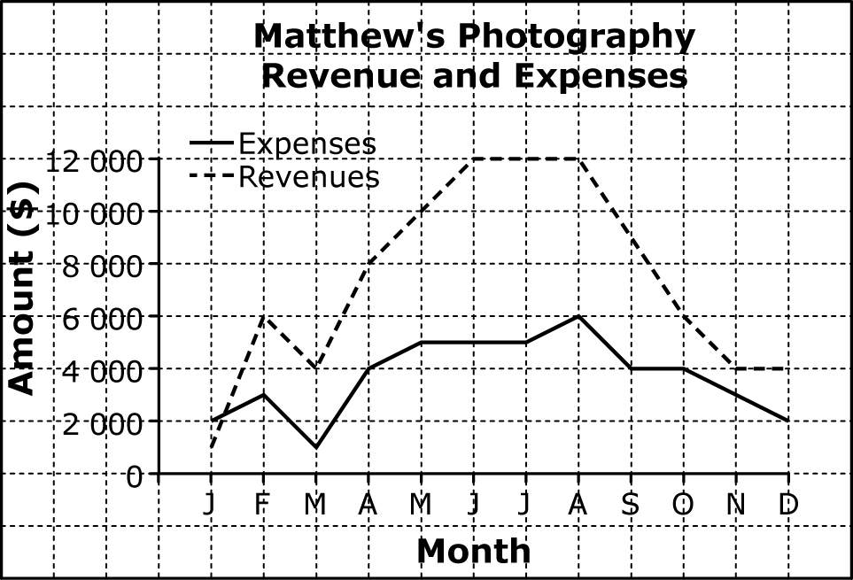

**a)** During which month(s) was Matthew’s revenue the highest? What might be the reason for this?

**b)** During which month(s) was Matthew’s revenue the lowest? expenses the highest? expenses the lowest?

**c)** Was there any month in which Matthew’s revenue was lower than his expenses? If so, when?

1. Edwin runs a hot dog stand at the beach during the summer. In one month, he had the following revenue and expenses.

Identify each item as either an expense or revenue, and fixed or variable.



Calculate his total revenue, total expenses and net income.

1. Linnea plans to open a silk-screening shop where she will print custom designs onto T-shirts. She needs to purchase a printer and ink, which she estimates will cost about $2750.00. If she can buy T-shirts in bulk for $5.85 each, and she plans on selling the shirts for $14.95, how many shirts will she have to sell before she covers the cost of the printer?
2. What are some important things to consider when starting and running a business?