**M30-3 Polygons Name: __________________**

C1 Triangles Assignment

1. Complete the following chart by drawing a triangle that matches the description in the row and column.

|  |  |  |  |
| --- | --- | --- | --- |
|  | Equilateral | Isosceles | Scalene |
| Acute |  |  |  |
| Obtuse |  |  |  |
| Right |  |  |  |

1. Classify by sides (equilateral, isosceles, scalene) and by angles (right, acute, obtuse).



1. Classify each triangle by angle measure and side length. Give reasons for your classifications.

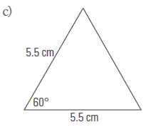

1. Use the following diagram to answer the questions below.

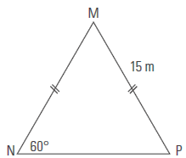

a) What is the measure of ∠M?

b) Classify triangle MNP by angle measure and by side length.

1. Use the following diagram to answer the questions below.



a) What is the length of PR?

b) Classify triangle PQR by angle measure and side length.

c) Classify triangle QRS by side length.

1. Determine the missing value.

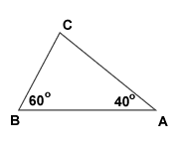

x

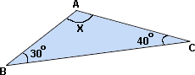

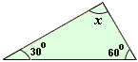

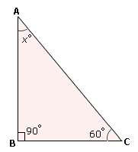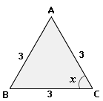







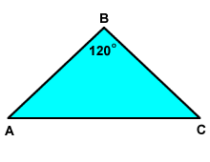





x

y

