M30-3 Polygons Name: _________________
C2 Parallel Lines & Transversals Notes
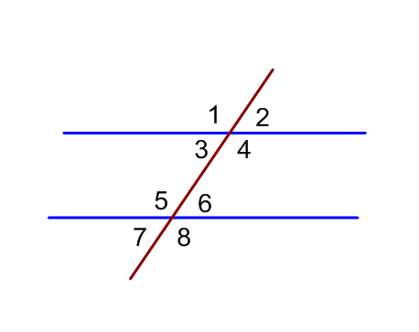
Corresponding Angles Alternate Interior Angles

Alternate Exterior Angles Co-interior Angles
(or Consecutive Interior Angles)

