M30-3 Polygons Name: _________________
C2 Parallelogram Investigation

Part A: Investigate Sides and Angles of Parallelograms

For each parallelogram measure all sides and angles.

What do you notice about side lengths and angles?

Part B: Investigate Diagonals of Parallelograms

For each parallelogram measure the length of each diagonal (AC, BD) and each diagonal piece (AE, BE, CE, DE). Measure the angles formed by the diagonals.

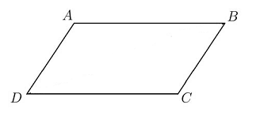
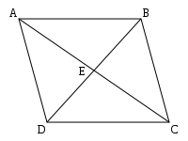

E

What do you notice about the diagonal lengths and angles?

M30-3 Polygons Name: _________________
C2 Rectangle & Rhombus Investigation

Part A: Investigate Diagonals of Rectangles

For each rectangle measure each diagonal and each diagonal piece.
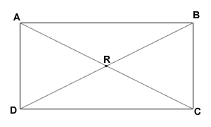

What do you notice about the diagonal pieces?

Part B: Investigate Diagonals of a Rhombus

For each rhombus measure each diagonal and each diagonal piece. Also measure the angles formed by the diagonals.
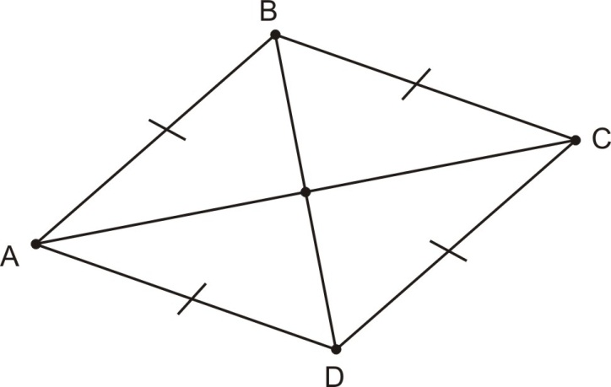
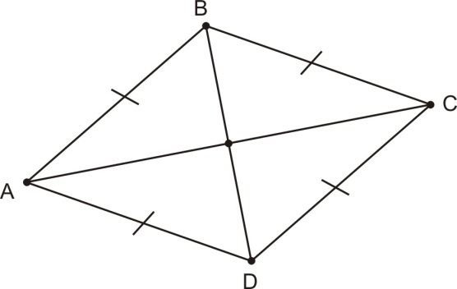

What do you notice about the diagonal lengths and angles?

M30-3 Polygons Name: _________________
C2 Isosceles Trapezoid Investigation

Part A: Investigate Sides and Angles of Isosceles Trapezoids

For each isosceles trapezoid measure each side and each interior angle.

What do you notice about the sides and angles?

Part B: Investigate Diagonals of Isosceles Trapezoids

For each isosceles trapezoid measure each diagonal.

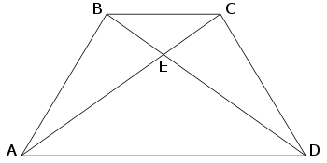

What do you notice about the diagonal lengths?

