**M30-3 Polygons Name: __________________**

C3 Regular Polygons

**Polygon**: a closed figure of three or more sides.



**Regular Polygon:** a polygon with congruent side lengths and congruent interior angles.

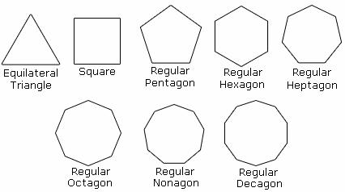

**Polygon Investigation: Patterns in Polygons Name: ________________**

Complete the table by following the steps below. The first one is done for you.

1. Determine the number of interior triangles that may be drawn by choosing a vertex and drawing as many diagonals as possible from that one vertex.

|  |  |  |  |
| --- | --- | --- | --- |
| **Diagram** | **Number of sides**  **(n)** | **Number of interior triangles** | **Sum of the Interior angles** |
|  | **3** | **1** | **180°** |
|  | **4** |  |  |
|  | **5** |  |  |
|  | **6** |  |  |

1. Determine the sum of the interior angles using your knowledge that the sum of the interior angles of a triangle is 180°.

Can you see how to determine the sum of the interior angles for any ‘*n’* sided polygon?

**Sum of the Interior Angles of a Polygon**

The sum of the interior angles of a polygon with *n* sides is:



Use the equation above to complete the following chart:

|  |  |  |
| --- | --- | --- |
| **Name** | **Number of Sides** | **Sum of Interior Angles** |
| Triangle | 3 |  |
| Quadrilateral | 4 |  |
| Pentagon | 5 |  |
| Hexagon | 6 |  |
| Heptagon | 7 |  |
| Octagon | 8 |  |
| Nonagon | 9 |  |
| Decagon | 10 |  |
| Dodecagon | 12 |  |

**Problem #1**

Octagonal houses were popular in the 1850s, and a number of historical octagonal houses exist in Canada and the United States. One such building is the Captain George Scott House in Wiscasset, Maine, USA.

a) If the house is a regular octagon, what is the sum of the interior angles at the vertices where the exterior walls meet?

b) If the front wall of the house is 10 feet wide, what is the perimeter of the house?

**Problem #2**

The sum of the interior angles of a polygon is 2340°. How many sides does the polygon have?

**Sum of EACH Interior Angle of a Regular Polygon**



**Problem #1**

The Barbados dollar is in the shape of a regular polygon, as shown in the photograph.

a) What type of polygon is it, and what is the sum of the interior angles?

b) What is the size of each interior angle? (*Remember: All interior angles in a regular polygon are equal)*

The sum of EACH interior angle of a regular polygon with n sides is:



**Problem #2**

Shelby is building her mother a special wall clock. She wants to make it in the shape of a regular dodecagon, like the one shown here.

a) What is the measure of each interior angle of a dodecagon?

**Problem #3**

The floor of a gazebo has the shape of a regular hexagon.



a) What is the measure of each interior angle of the gazebo?

b) The floor is painted in a pattern that divides the hexagon into triangles. Draw the lines needed to divide the floor into 6 congruent triangles.

c) What are the interior angles of the triangles? Classify the triangles by side length.