Tessellation

Tessellate means to cover an area using a repetition of shapes with no overlaps or gaps.

Which of the shapes below can tessellate? What strategies can be used to determine if a shape can tessellate?

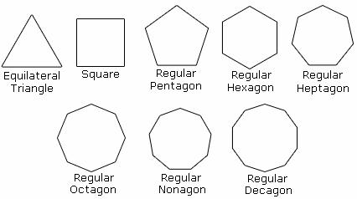

(See Text pg. 233-234 if you need assistance)

