**Exponential and Logarithmic Functions: Math 30 – 1:**

**Diploma Review:**

1. is equal to:
2. is equal to:
3. When is converted to base 2, the exponent is:
4. If , then the value of is:
5. The solution to the equation , to the nearest tenth, is

|  |  |  |  |
| --- | --- | --- | --- |
|  |  |  |  |

1. The solution to the equation , to the nearest hundredth, is

*x* = ______.

|  |  |  |  |
| --- | --- | --- | --- |
|  |  |  |  |

1. The solution to , to the nearest tent, is *x* =_____.

|  |  |  |  |
| --- | --- | --- | --- |
|  |  |  |  |

1. Which equation represents an exponential function?

*Use the following to answer the next three questions:*

A student is attempting to sketch the graph of the function without using a graphing calculator.

1. Which of the following is an asymptote of the graph?
2. The range of is:
3. The x-intercept of the graph is:
4. 0
5. 2
6. 3
7. There is no x-intercept
8. What is the *y*-intercept for the graph of *y = bx* - 2, *b >* 1?

A .  B. -*b*2 C .  D. 2

1. In the equation *y* = *bx*, *b* > 1, *x* is replaced by *x* - 3 and *y* is replaced by *y* - 4. Which of the following statements describes the transformation?

A. The point (*x*, *y*) on the graph of *y* = *bx* has been transformed to the point (*x* + 3, *y* + 4).

B. The point (*x*, *y*) on the graph of *y* = *bx* has been transformed to the point (*x* - 3, *y* - 4).

C. The graph of *y* = *bx* has been translated 4 units to the right and 3 units up.

D. The graph of *y* = *bx* has been translated 3 units to the left and 4 units down.

1. The graph of *f*(*x*) = *ax*, *a* > 1, is transformed into *g*(*x*) = 4*ax* + 3 - 2. Which characteristic remains the same?

A. domain

B. range

C. *x-*intercept

D. *y-*intercept

1. The graph of the function *f*(*x*) = 3*ax* + 2, *a* > 0, has the same horizontal asymptote as which of the following?

A. *y* = -*f*(*x*) - 4

B. *y* = -*f*(*x*) - 2

C. *y* = -*f*(*x*) + 2

D. *y* = -*f*(*x*) + 4

1. Mary was asked to solve for *x* and *y* inthe exponential equations 5*x* + 3*y* = 1 and . Which of the following linear equations would lead to a correct solution?

A. *x* + 3*y* = 1, *x* + *y* = -1

B. *x* + 3*y* = 0, 2(*x* + *y*) = -1

C. *x* + 3*y* = 1, 2*x* + *y* = -1

D. *x* + 3*y* = 0, *x* + *y* = -2

1. Which function(s) would you graph to solve the equation  graphically?

A. *y*1 = 16-0.5*x*, *y*2 = 0.54*x* + 3

B. 

C. 

D. *y*1 = 4*x*, **

1. Given the function *f*(*x*) = 2*x*, match the graph with the correction equation.

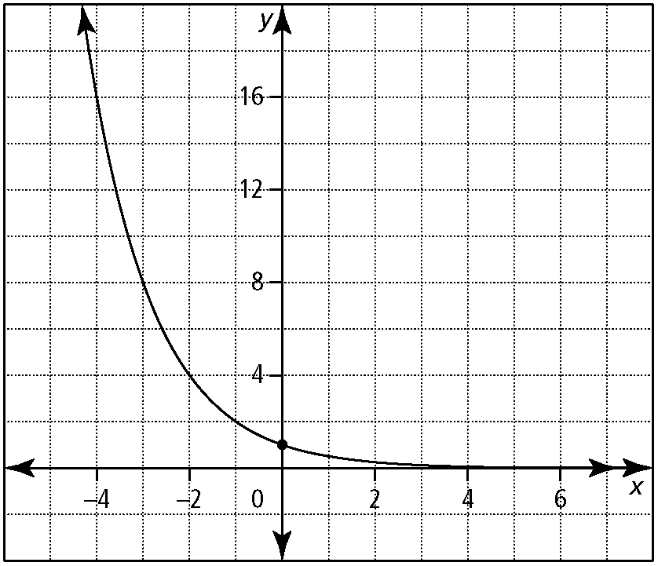 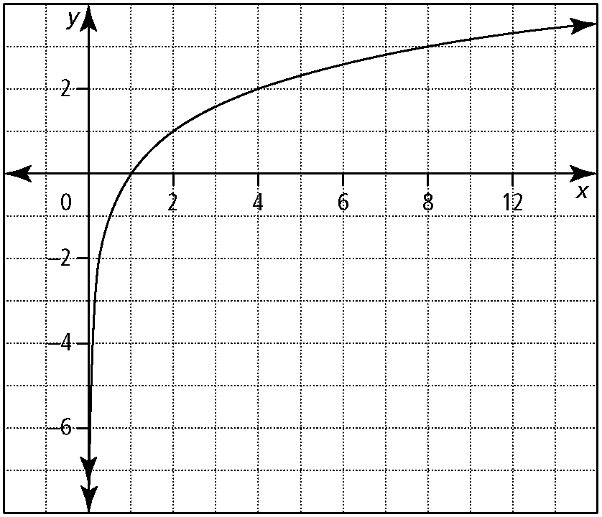

Graph 1 Graph 2

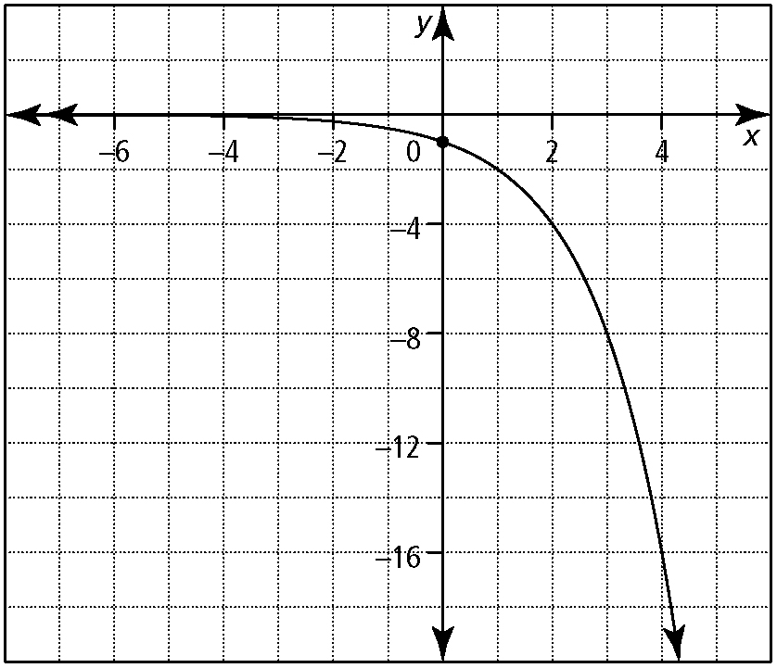 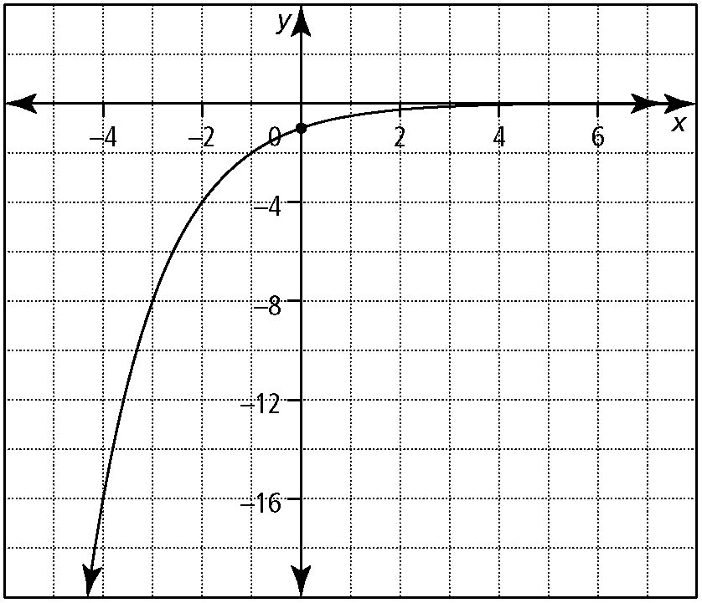

Graph 3 Graph 4

Place the number of the graph that corresponds to *y* = -*f*(*x*) in the first box.  
Place the number of the graph that corresponds to *y* = *f*(-*x*) in the first box.  
Place the number of the graph that corresponds to *y* = *f* -1(*x*) in the first box.  
Place the number of the graph that corresponds to *y* = -*f*(-*x*) in the first box.

|  |  |  |  |
| --- | --- | --- | --- |
|  |  |  |  |

1. The function *f*(*x*) = -5(2*x*) is transformed by a translation 2 units right and 5 units down. The transformed function passes through the point (*x*, -10). Determine the value of *x*.

|  |  |  |  |
| --- | --- | --- | --- |
|  |  |  |  |

1. The graph of *f* (*x*) = log*b x*, *b* > 1, is translated such that the equation of the new graph is expressed as *y* - 2 = *f* (*x* - 1). The domain of the new function is

A. {*x* | *x* > 0, *x* ∈ R}

B. {*x* | *x* > 1, *x* ∈ R}

C. {*x* | *x* > 2, *x* ∈ R}

D. {*x* | *x* > 3, *x* ∈ R}

1. The *x*-intercept of the function *f* (*x*) = log5 *x* + 3 is:

A. 5-3 B. 0

C. 1 D. 53

1. The equation  can also be written as:

A.  B. 

C. 23*x* = *y* D. 23*y* = *x*

1. The range of the inverse function, *f* -1, of *f* (*x*) = log4 *x*, is:

A. { *y* | *y* > 0, *y* ∈ R}

B. { *y* | *y* < 0, *y* ∈ R}

C. { *y* | *y* ≥ 0, *y* ∈ R}

D. { *y* | *y* ∈ R}

1. A graph of the function *y* = log3 *x* is transformed. The image of the point (3, 1) is (6, 3). The equation of the transformed function is:

A. *y* = 3 log3 (*x* - 3)

B. *y* = 3 log3 (*x* + 3)

C. *y* - 3 = log3 (*x* - 3)

D. *y* + 3 = log3 (*x* + 3)

1. If log27 *x* = *y*, then log3 *x* equals:

A.  B. 

C. 3*y* D. 4*y*

1. If , then equals:
2. The graph of is:

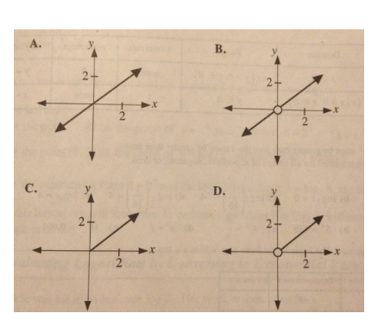

1. To the nearest tenth, the y-intercept of the graph of is _______.

|  |  |  |  |
| --- | --- | --- | --- |
|  |  |  |  |

1. If , then the value of to the nearest whole number is _____________.

|  |  |  |  |
| --- | --- | --- | --- |
|  |  |  |  |

1. Which of the following has a negative value?
2. The value of the expression , to the nearest tenth, is ______.

|  |  |  |  |
| --- | --- | --- | --- |
|  |  |  |  |

1. Given the equation , the value of x to the nearest whole number is ____.

|  |  |  |  |
| --- | --- | --- | --- |
|  |  |  |  |

1. If , the value of x to the nearest whole number is

|  |  |  |  |
| --- | --- | --- | --- |
|  |  |  |  |

*Use the following to answer the next question:*

Three students were asked to find an alternate expression for .

Alex gave the answer

Bahman gave the answer

Connor gave the answer

1. The correct alternative answer was given by:
2. Connor only
3. Alex and Connor
4. Baham and Connor
5. Some other combination of students
6. is equal to:
7. is equal to:
8. is equivalent to:
9. The expression , where . Is equal to:
10. is equivalent to:
11. 3
12. 4
13. 4p
14. p4
15. If , then
16. If and , then the value of k is _____.

|  |  |  |  |
| --- | --- | --- | --- |
|  |  |  |  |

1. The graph of is transformed to the graph of by a horizontal stretch about the y-axis by a factor of p followed by a horizontal translation of q units left. The value of p + q is:
2. 3
3. 4.5
4. 5.5
5. 7
6. An equation of the asymptote of is:
7. The graph of is reflected in the x-axis, the equation of the image can be written in the form . The value of c, to the nearest hundredth, is ____.

|  |  |  |  |
| --- | --- | --- | --- |
|  |  |  |  |

1. A current, amperes, falls to amperes after t seconds according to the formula . The value of the constant, k, to the nearest whole number, if a current of 25 amperes falls to 2.5 amperes in 0.01 seconds is ______.

|  |  |  |  |
| --- | --- | --- | --- |
|  |  |  |  |

1. Kyle determined the exact solution to the exponential equation . He wrote the answer as the quotient of 2 logarithms in the form . The value of M is ____.

|  |  |  |  |
| --- | --- | --- | --- |
|  |  |  |  |

1. A student invests $100 @ 8% per year compounded semi-annually. The amount of money that the student will have at the end each year is increased from the amount at the end of the previous year by a factor of:
2. 1.04
3. 1.08
4. 1.0816
5. 1.16
6. George invested $2500in an account which pays compound interest of 8.1% per annum compounded quarterly. The number of quarters it will take George’s investment to at least double in value is ________.

|  |  |  |  |
| --- | --- | --- | --- |
|  |  |  |  |

1. The tripling period, to the nearest tenth of an hour, of a bacteria culture which grows from 500 cells to 64000 cells in 50 hours is _____.

|  |  |  |  |
| --- | --- | --- | --- |
|  |  |  |  |

1. Radioactive decay material decays to 40% of its original mass in 5 years. The half-life of the radioactive material, to the nearest hundredth of a year, is ____.

|  |  |  |  |
| --- | --- | --- | --- |
|  |  |  |  |

**Answer Key:**

1. A
2. C
3. A
4. B
5. 5.0
6. 0.36
7. 1.2
8. C
9. D
10. D
11. B
12. C
13. A
14. A
15. C
16. B
17. A
18. 3124
19. 2
20. B
21. A
22. D
23. A
24. A
25. C
26. B
27. D
28. 3.0
29. 729
30. D
31. 7.0
32. 313
33. 4.29
34. B
35. B
36. A
37. D
38. C
39. B
40. A
41. 27
42. A
43. C
44. 0.14
45. 230
46. 12.5
47. C
48. 35
49. 11.3
50. 3.78