Name: ____________________

Math 30-1 **Polynomials** Review

***Multiple Choice:***

1. When 2*x*5 – 3*x*3 – 8*x*2 – 8 is divided by *x* – 2, the sum of the coefficients of the terms in the quotient is
2. –59
3. –23
4. –19
5. 17
6. If *P*(*x*) = *x*3 – 7*x* – 3 is divided by (*x* + 1), then *P*(*x*) may be written as
7. (*x*2 – 8)(*x* + 1) + 5
8. (*x*2 – *x* – 6)(*x* + 1) + 3
9. (*x*3 – 7*x* – 3)(*x* + 1) + 3
10. (*x*3 – 7*x* – 3)(*x* + 1) + 5
11. If –5*x* is a factor of the polynomial *P*(*x*), then *P*(0) is
12. –5
13. 0
14. 
15. 5
16. If *P*(*x*) is a cubic polynomial function with *P*(1) = *P*(3) = *P*(–4) = 0 and *P*(0) = 36, then *P*(*x*) is
17. –3(*x* – 1)(*x* – 3)(*x* + 4)
18. –2(*x* + 1)(*x* + 3)(*x* – 4)
19. 2(*x* + 1)(*x* + 3)(*x* – 4)
20. 3(*x* – 1)(*x* – 3)(*x* + 4)

*Use the following information to answer the next question.*

A student prepared the following table to graph a third-degree polynomial function, *P*.

|  |  |  |  |  |  |  |  |  |  |
| --- | --- | --- | --- | --- | --- | --- | --- | --- | --- |
| *x* | –4 | –3 | –2 | –1 | 0 | 1 | 2 | 3 | 4 |
| *P*(*x*) | –80 | –24 | 0 | 4 | 0 | 0 | 16 | 60 | 144 |

1. The equation of the polynomial function, *P*, is
2. *P*(*x*) = 4*x*(*x* + 2)(*x* – 1)
3. *P*(*x*) = 4*x*(*x* – 2)(*x* + 1)
4. *P*(*x*) = 2*x*(*x* + 2)(*x* – 1)
5. *P*(*x*) = 2*x*(*x* – 2)(*x* + 1)
6. A student graphed the equation of a polynomial function, *y* = *P*(*x*), to help determine the solution to the equation *P*(*x*) = 0. Which of the following provides the solution to *P*(*x*) = 0?
7. The *x*-intercepts of the graph of *y* = *P*(*x*).
8. The *y*-intercept of the graph of *y* = *P*(*x*).
9. The point(s) of intersection of *x* = 0 and the graph of *y* = *P*(*x*).
10. The point(s) of intersection of *y* = 0 and *P*(0).
11. If  is a factor of the polynomial function *P*, where , then the value of *k* is
12. –13
13. –5
14. 5
15. 13
16. An integral polynomial function is defined by *P*(*x*) = *x*3 – *ax*2 – 2*x* + 2*a*, *a* ≠ 0. Which of the following is a factor of *P*(*x*) for any value of *a*?
17. **
18. 
19. 
20. **

*Use the following information to answer the next question.*

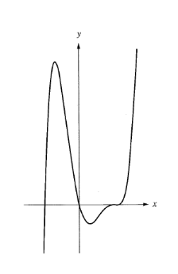

The partial graph of a polynomial function is shown below. All of the *x*-intercepts

are shown.

1. The minimum degree of this polynomial function is
2. 3
3. 4
4. 5
5. 6
6. The equation of a polynomial function is *P*(*x*) = *kx*(*x* + 2)(*x* – 6), *k* ≠ 0. If a new function results from doubling the value of *k* only, then the zeros of the new function
7. remain unchanged
8. are doubled
9. are 0, –1, and 3
10. are 0, –4, and 12

*Use the following information to answer the next question.*

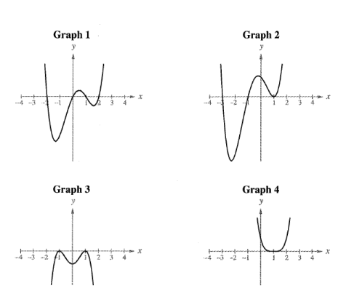The partial graphs of four **fourth-degree** polynomial functions are shown below.

The *x*-intercepts are integers and all are shown.

1. If the zeros of these functions are all integers, then the functions with a zero of multiplicity 2 at *x* = 1 are represented in
2. Graphs 1 and 4
3. Graphs 2 and 3
4. Graphs 1, 2, and 3
5. Graphs 2, 3, and 4
6. If the polynomial function *P*(*x*) = 3*x*3 – 9*x*2 + *kx* – 12 is divisible by *x* – 3, then it is also divisible by
7. 3*x* – 4
8. 3*x* + 4
9. 3*x*2 + 4
10. 3*x*2 – 4

*Use the following information to answer the next question.*

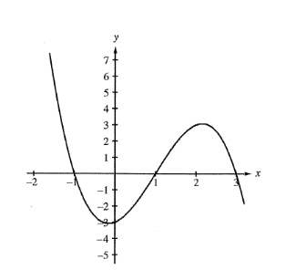

The partial graph of a cubic polynomial function, *y* = *f*(*x*), is shown below.

1. A second graph is created by shifting the graph of *y* = *f*(*x*) down 6 units. The number of *x*-intercepts of the second graph is
2. 0
3. 1
4. 2
5. 3

*Use the following information to answer the next question.*

The graph of a third-degree polynomial function *P* with *x*-intercepts of –3, –1, and 2 is

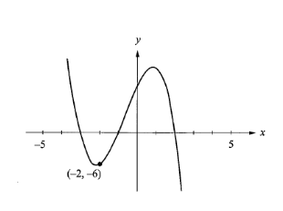shown below. The point (–2 , –6) lies on the graph of *y* = *P*(*x*).

1. The value of the *y*-intercept is
2. 6
3. 8
4. 9
5. 10
6. The area of a rectangle is (*x*3 + 5*x*2 – 4*x* – 20) cm2 and the width is (*x* + 2) cm. If the length of the rectangle is 8 cm, then the width in centimetres is
7. 3 cm
8. 5 cm
9. 6 cm
10. 8 cm

***Numerical Response:***

*Use the following information to answer the next question.*

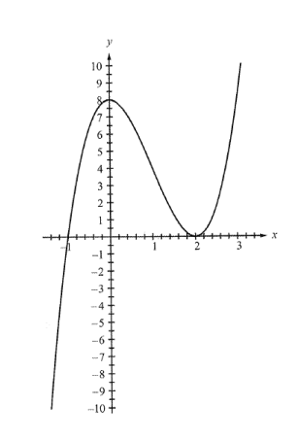A student graphed a third-degree polynomial function and obtained the partial graph

shown below. The *x*-intercepts are –1 and 2, and the *y*-intercept is 8.

1. If the point (15 , *b*) is on the graph of the function, then the value of *b* is __________.

*Use the following information to answer the next question.*

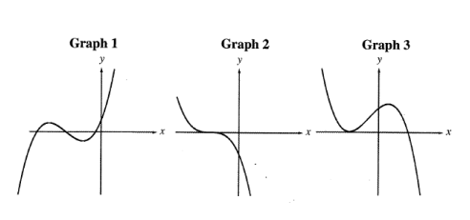For each of three cubic polynomial functions, a partial graph is shown below.

1. Match each of the graphs, as numbered above, with the number of distinct zeros corresponding to it, as given below.

1 distinct zero __________

2 distinct zeros __________

3 distinct zeros __________

1. The polynomial function *P*(*x*) = 4*x*3 – 18*x*2 – *x* – 45 is divided by *D*(*x*) = *x* – 5. The quotient is of the form *Q*(*x*) = *ax*2 + *bx* + *c*. Determine the values of *a*, *b*, and *c*, where *a*, *b*, and *c* € *N*.

*Use the following information to answer the next question.*

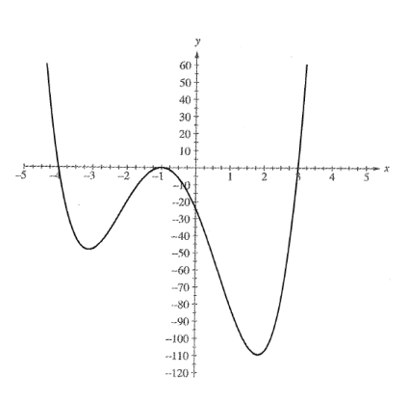The partial graph of a fourth-degree polynomial function, *f*, is shown below.

The *x*-intercepts are –4, –1, and 3, and the *y*-intercept is –24.

1. If *f*(*x*) = *a*(*x* + *b*)2(*x* + *c*)(*x* – *d*), where *a*, *b*, *c*, and *d* are all **positive**, then

The numerical value of *a* is __________.

The numerical value of *b* is __________.

The numerical value of *c* is __________.

The numerical value of *d* is __________.

*Use the following information to answer the next question.*

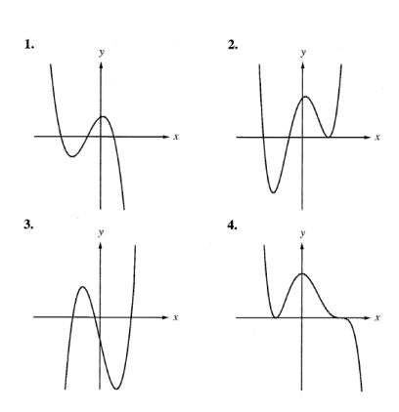The graphs of four polynomial functions are shown below. Each polynomial function is

of the minimum degree consistent with its graph.

1. Match each of the polynomial graphs shown above with a description that applies to it.

* A graph of a fourth-degree polynomial function with a zero of multiplicity 2 would be __________.
* A graph with a negative *y*-intercept would be __________.
* A graph of a polynomial function with a negative coefficient of the term of the largest degree and all zeros of multiplicity 1 would be __________.
* A graph of a fifth-degree polynomial function would be __________.

***Written Response:***

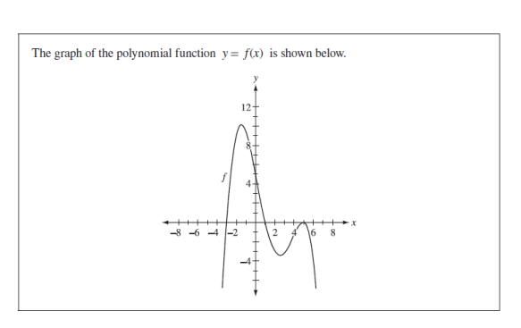

*Use the following information to answer the next question.*

1a) What is the minimum possible degree for the polynomial function above? __________

1b) Determine an equation of the function in factored form.

2. Determine the zeros of the function *f*(*x*) = 2*x*3 – *x*2 – 18*x* + 9 by factoring. Show your work.