Math 30 Transformation Review

1. Sketch the graph of the following functions, 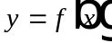, then analyze them by stating the domain, range, intercepts and asymptotes:

a. absolute value, 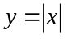 b. quadratic, 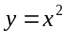

c. cubic, 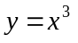 d. square root, 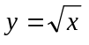

e. exponential, 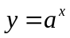 f. reciprocal, 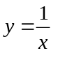

2. If the functions above were translated to the function 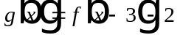, state which ones would have a different:

a. domain

b. range

c. x-, y-intercepts

page 2 Math 30 Transformation Review

3. If 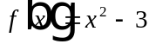, state the effect on the domain and range if the transformation is:
Domain Range
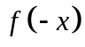

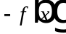

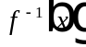

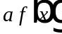, 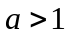

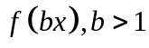

- Given 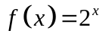 as shown to the right.
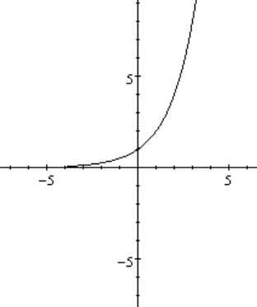
Sketch the graph of 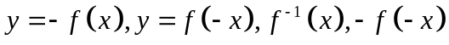. Two on each.
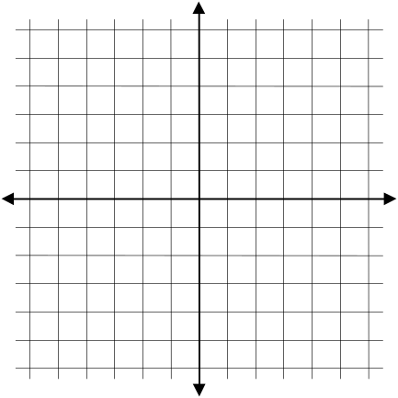
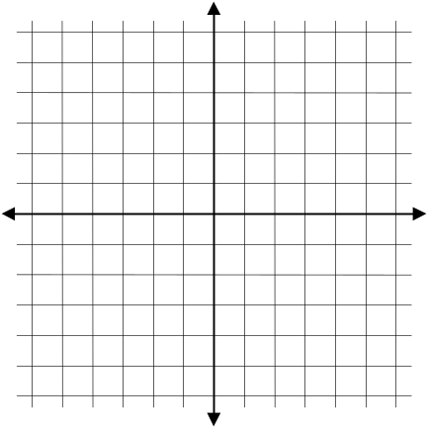

page 3 Math 30 Transformations Review

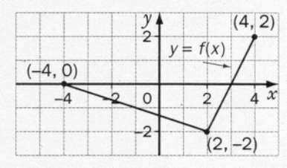
5. The graph of is shown below. Sketch the graphs of:

a. 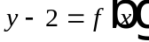 b. 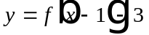

c. 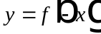 d. 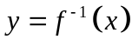

page 4 Math 30 Transformations Review
e. 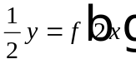 f. 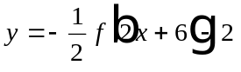
6. Describe the series of transformations that have resulted to the graph of if :
a. x is replaced by 2x and y by 2y.

b. x is replaced by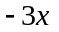, then y with 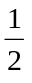y, then y with 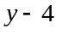

c. x is replaced 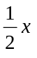and y with 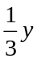, then x with 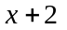 and y with 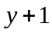

7. Given the following series of transformations, write the equation of the transformed function:

a. is stretched vertically about the x-axis by a factor of 2 then translated 3 units to the left, and translated 4 units up.

b. 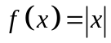 is stretched horizontally about the y-axis by a factor of , then reflected in the x-axis, and translated 4 units to the left.

c. 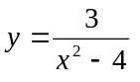 is reflected in the x-axis and translated 3 units to the right.

d. 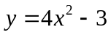is stretched horizontally about the y-axis by a factor of 2

e. 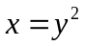 is reflected in the line 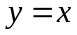, horizontally stretched by a factor of 3 and then vertically translated 2 units down.
page 5 Math 30 Transformation Review

- The graph of a function,  and its transformed function, 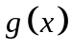are shown below. Find the equation of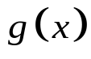. Presume b = 1

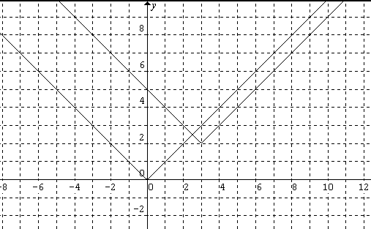
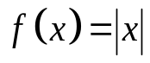
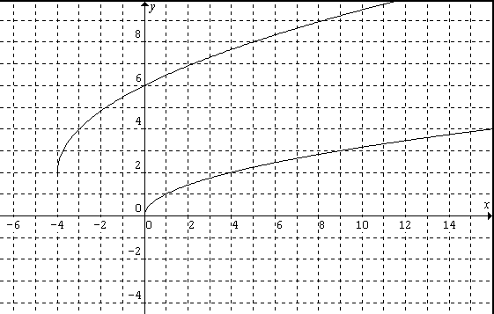
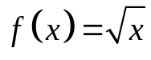
a. b.

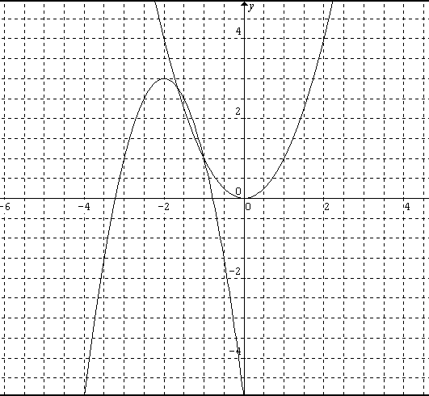
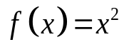
c.

9. The point 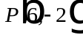 lies on the graph of . Find the image of P on the transformed graph:
a. 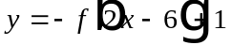 b. 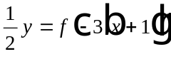

10. Describe the series of replacements required to transform the graph of the first function to the graph of the second function:
a. 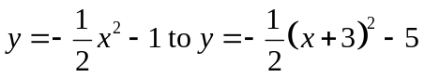 b. 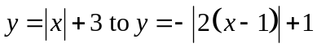

c. 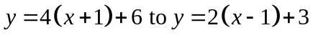
page 6 Math 30 Transformation Review

11. The graph of 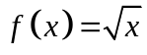 undergoes a series of transformations. What is the resulting equation if the point 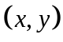 is changed to 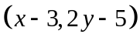?

12. Draw the reciprocal for the graph given below, labeling all the critical points and asymptotes.
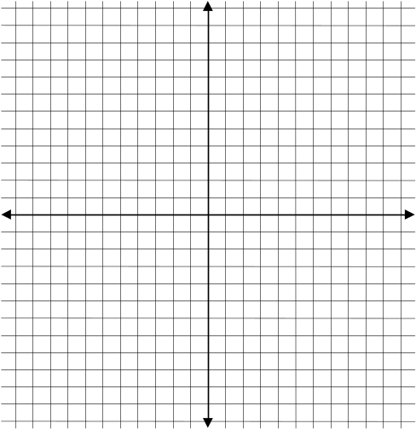
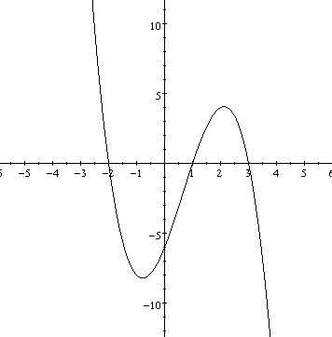

13. The graph of is shown below. Sketch the graph of 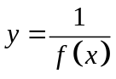.
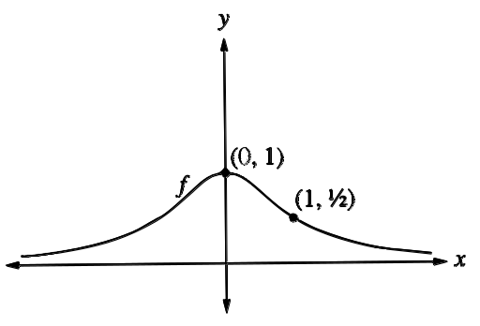
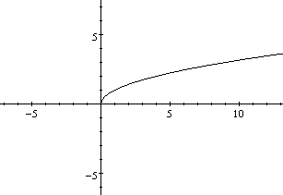
page 7 Math 30 Transformation Review

14. The point 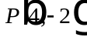lies on the graph of . Find the point on the following transformations.:
a. 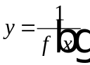 b. 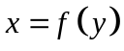

15. Explain what happens to the x-intercepts of when the graph of 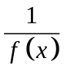is sketched.
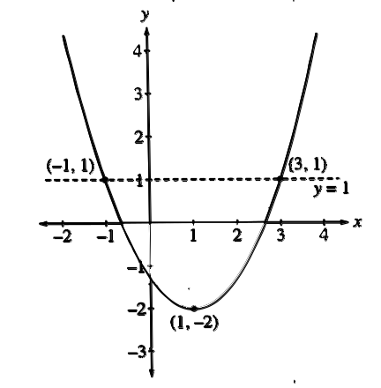

16. The graph of is shown below:

a. is the formed when
is vertically stretched about the
line 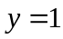 by a factor of 2.
Determine the coordinates of the
vertex of .

b. Determine the 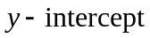 of from 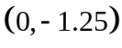, the y-intercept on .

c. Give the invariant points for 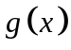.

d. Determine the equation of and write the equation in
the form of 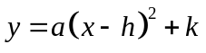.

page 8 Math 30 Transformation Review

17. The point 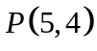is on the graph of . The graph is stretched horizontally about the line 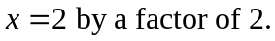 The x-coordinate of the translated point P is ________.

18. A transformed graph, g of a graph f is shown below. Describe two different ways of transforming the graph f to graph g.
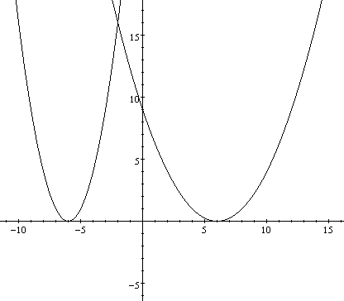
f
g

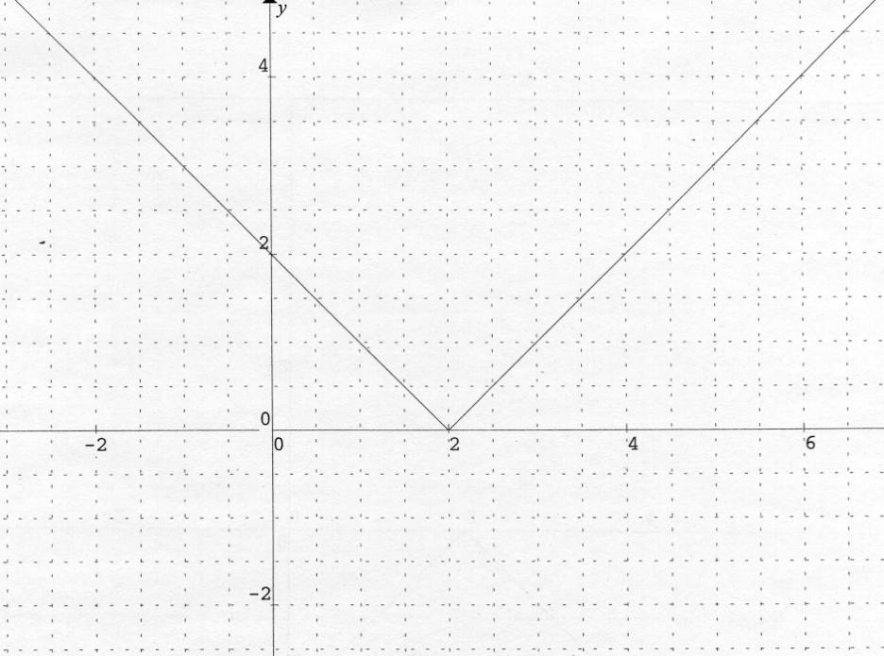
19. If the graph of f is transformed into 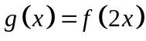, complete the following table of values for .
f

x | y

0

1
 | 2
 | 4

page 9 Math 30 Transformation Review

ANSWER KEY

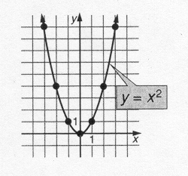
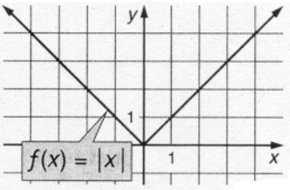
1. a. 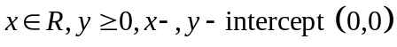 b. 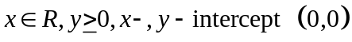

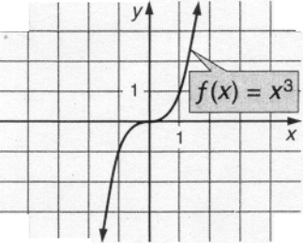
c. 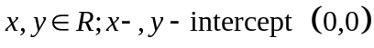 d. 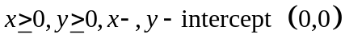
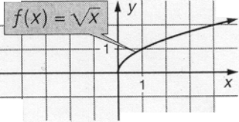

e. 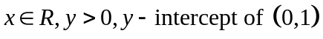 f.
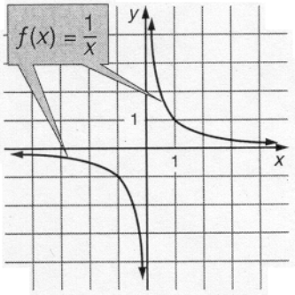
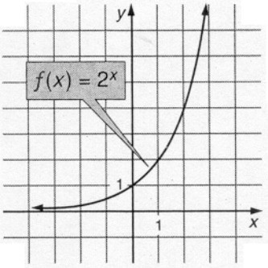
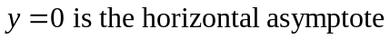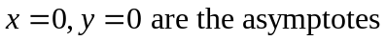

2. a. d, f b. a, b, d, e, f c. all

page 10 Math 30 Transformations Review

3.
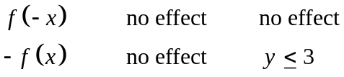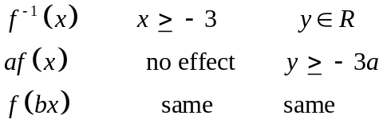

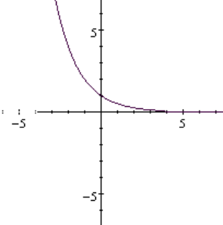
4. a. b.
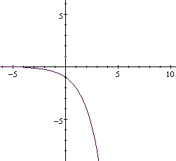
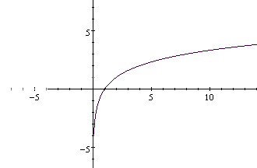
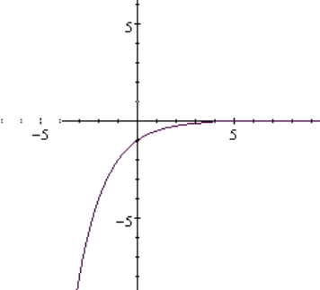
- d.

Endpoints are:
5. a. 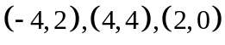 b. 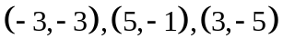
c. 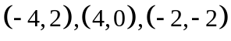 d. 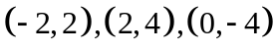
e. 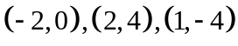 f. 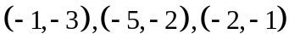

page 11 Math 30 Transformations Review

6. a. stretched vertically about the x-axis by a factor of , and stretched horizontally about the y-axis by a factor of
- reflected horizontally, stretched horizontally about the y-axis by a factor of , then stretched vertically about x-axis by a factor of 2, and then vertically translated 4 units up.

c. horizontally stretched about the y-axis by a factor of 2 then stretched vertically about the x-axis by a factor of 3 then horizontally translated by 2 units left, and vertically translated 1 unit down.

7. a. 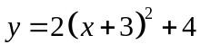 b. 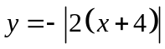

c 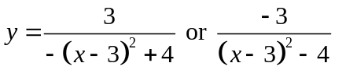 d. 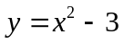

e. 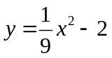

8. a. 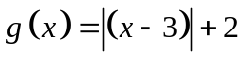 b. 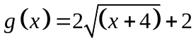

c 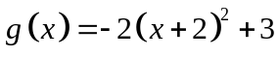

9. a. 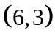 b. 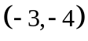

10. a.

b.

c.

11. 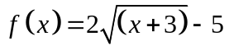

page 12 Math 30 Transformations Review
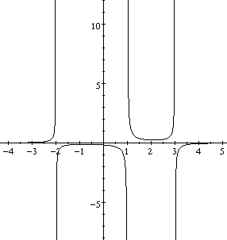
12. Asymptotes are at 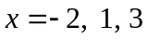

13.
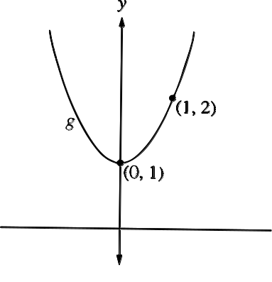
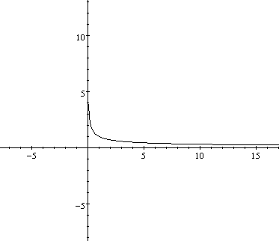
a. b.

14. a. 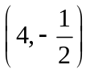 b. 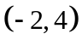
15. The x-intercepts of become the asymptotes of .

16. a. 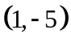 b. 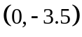 c. 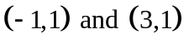
d. 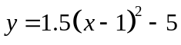

17. 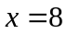 18. 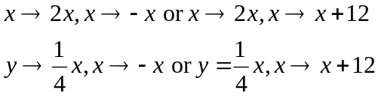

19. 

