**Year End Review**

**Radical, Rational and Composite Functions**

**1.** The graph of the function  is shown below.

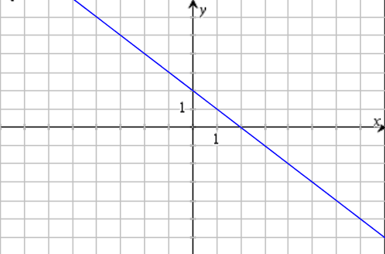

The correct graph of  is

**A.** **B.**

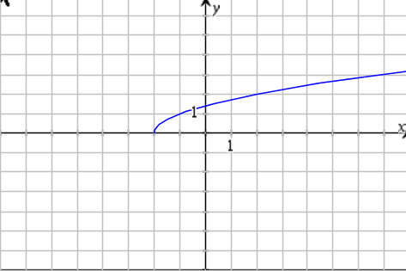 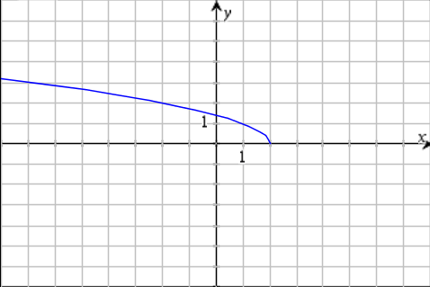

**C.** **D.**

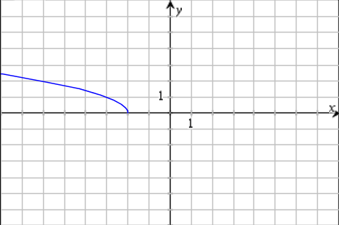 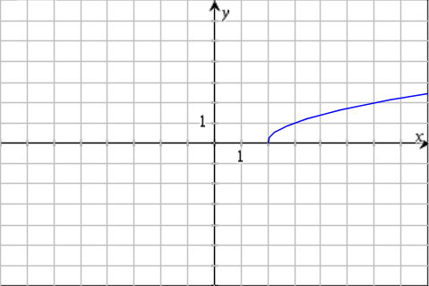

**2.** Compared to the graph of , the graph of  will be reflected in the

**A.**  x-axis and translated 3 units to the right and 5 units down.

**B.** y-axis and translated 3 units to the right and 5 units down.

**C.** x-axis and translated 3 units to the left and 5 units down.

**D.** y-axis and translated 3 units to the left and 5 units down.

**3.** The restriction on the variable for the equation  are

**A.** 

**B.** 

**C.** 

**D.** 

**4.** The equation  has

**A.** 1 solution

**B.** 2 solutions

**C.** no solution

**D.** infinitely many solutions

**5.** If  and  are all equal to 2, the value of  in the equation  is

**A.** 

**B.** 

**C.** 

**D.** 

**6.** The roots of a rational equation correspond to the _______________ of the graph of the related

related rational function.

**A.** y-intercepts

**B.** x-intercepts

**C.** vertical asymptotes

**D.** horizontal asymptotes

**7.** Determine the vertical asymptote of 

**A.** 

**B.** 

**C.** 

**D.** There is no vertical asymptote.

**8.** The x-intercepts of 

**A.** 

**B.** 

**C.** 

**D.** 

**9.** As the function  approaches  from the right side, the value of the function

will be

**A.** constant

**B.** increasing

**C.** undefined

**D.** decreasing

**10.** The restriction on the variable of the rational function  are

**A.** 

**B.** 

**C.** 

**D.** 

**11.**  and  What is ?

**A.** 

**B.** 

**C.** 

**D.** 

**12.** If  , and if  , which of these statements could be correct?

**A.**  , and 

**B.** , and 

**C.**  and 

**D.**  and 

**13.** Two functions are given.  

Some operations involving the given functions are as follows:

**I.**  **II.**  **III.**  **IV.** 

Which of the functions  have domain restrictions?

**A. II** and **IV** only

**B. II** and **III** only

**C. I, II,** and **IV** only

**D. I, II, III**, and **IV**

**14.** The function  undergoes an operation that results in the new function

. The operation on  to give  was to,

**A.** square .

**B.** add  to itself.

**C.** take the square root of .

**D.** multiply  by its conjugate.

**15.** Two graphs of functions  and  are shown.

 

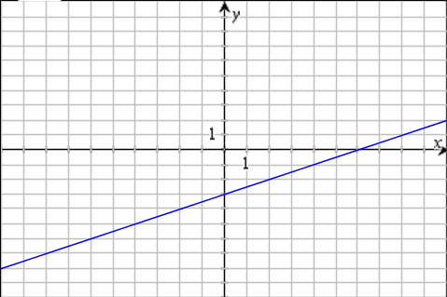 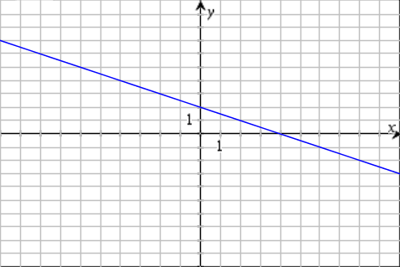

The graph of  would be

**A.** **B.**

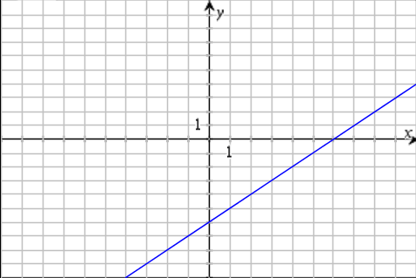 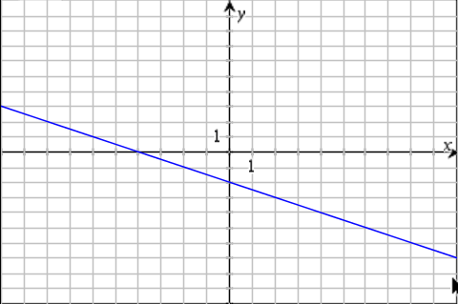

**C. D.**

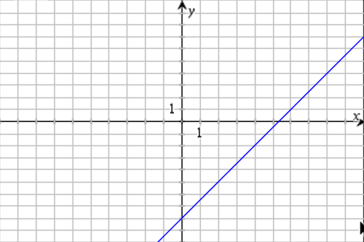 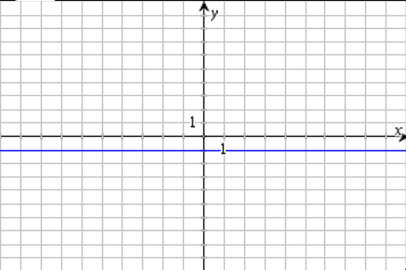

**Numeric Response:**

**1.** The radical function  has an - intercept at  . If the graph of the function is

stretched horizontally by a factor  about the - axis, the new - intercept will be ____________.

**2.** The point  is on the graph of the function . The value of  is

_____________.

**3.** The real number that is exactly one-third of its square root, to the nearest hundredth, is___________.

**4.** The function  has an domain of  and a range of .

The value of  is _____________.

**5.** The equation  has _____________ roots.

**6.** The solution to the equation , rounded to the nearest tenth, is ______________.

**7.** If  and  , the value of  equals ______________.

**8.** If  and , the -intercepts of , stated from largest to

smallest would be ____________.

**9.** Given that  and , the absolute value of  is ____________.

**Written Response:**

**1.** On a clear day, the distance to the horizon, *d*, in kilometres, is given by  where *h* is the height above ground, in metres, from which the horizon is viewed. If you can see a distance of 32.5 km from the roof of a building, how tall is the building, to the nearest tenth of a metre?

**2.** The point (4, *y*) is on the graph of  The graph is transformed into *g* (*x*) by a horizontal stretch by a factor of 2, a reflection about the *x*-axis, and a translation up 3 units. Determine the coordinates of the corresponding point on the graph of *g* (*x*).

**3.** **a)** Describe two methods you could use to solve the equation  graphically.

**b)**  Use one of the methods from part a) to solve the equation.

**4.** **a)** Sketch the graph of the function .

**b)** Identify the domain, range, and asymptotes of the function.

**c)** Explain the behaviour of the function as the value of |*x*| becomes very large.

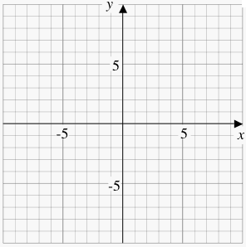

**5.** Let  and  , sketch the graph of  and state its domain and range.



**6.** Consider the functions  ** and .

**a)** Determine the equation of  and state the domain of .

**b)** How does the graph of behave for large values of *x*?