**Exponential and Logarithmic Review**

* There are 5 curriculum outcomes in exponents and logs.
* On the past two diploma exams there has been 7 **question** on the diploma dealing with exponents and logs.

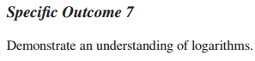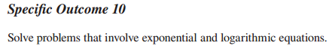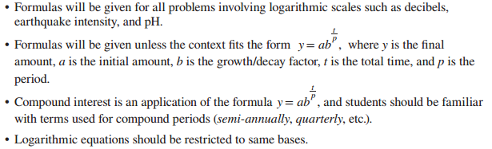

* Logs and Exponents can be broken down into three main areas:

1. Algebra (simplifying expressions, converting to the opposite form, and solving equations)
2. Graphing (Characteristics, and describing transformations)
3. Application (Word) Problems

1. Simplify each of the following. Express as a single log or evaluate where possible.

a)  b) 

c)  d) 

e)  f) 

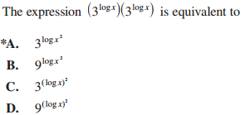

2.



3.

4.

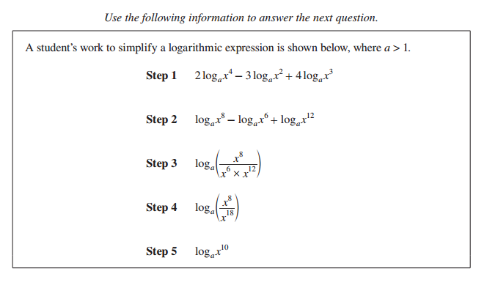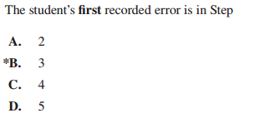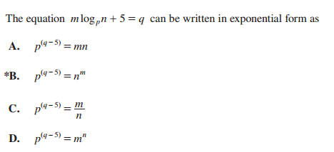

5.

6.

7. Using the equation log3 27 = x, what would the expression log9 *x* equal?

8. If log3 5 = *x*, express  in terms of *x*.

9. Algebraically solve each equation. Express each solution as an exact and approximate value. Round to the nearest hundredth where appropriate.

a)  b) 

c)  d) 

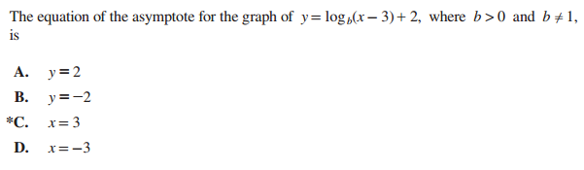

10.

11.

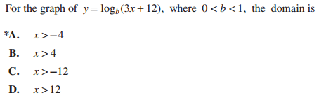

12.

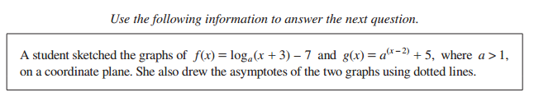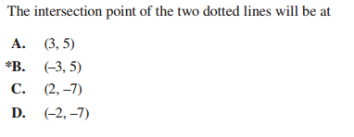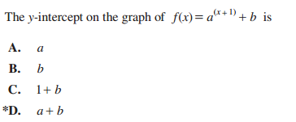

13.

14. 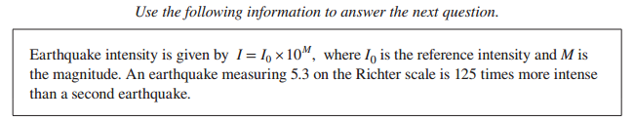 Determine, to the nearest tenth, the Richter scale measure of the second earthquake.

15.



16.