Math 30-1 Chapter 1 Review Name ___________________________
Answers to all the Examples can be found after Page 6.
Transformations
- 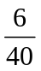 questions on last diploma were transformations; 2 of those questions were standard of excellence (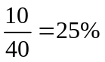 of the test is standard of excellence)
- 1 question from outcome 2; 1 question from outcome 3; 2 questions from outcome 4; 2 questions from outcome 5/6
Outcome 2: Horizontal and Vertical Translations 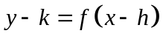
- Horizontal translation is always “opposite” ; the vertical translation is only opposite if k is on the same side of the equation as the y
  - 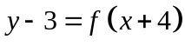
    - This shows a vertical translation of 3 up (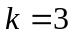 ) and a horizontal translation of 4 left (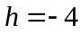)
- No invariant points if a translation is performed! (every point is relocated)

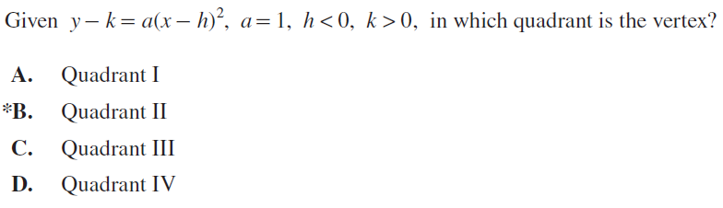

Given the functions 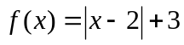 and 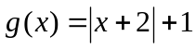 , the transformations that will transform  to become 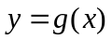 are a translation of

  - 4 units left and 2 units down
  - 4 units right and 2 units up
  - 1 unit left and 3 units up
  - 2 units left and 4 units down

Outcome 3: Horizontal and Vertical Stretches
- Horizontal Stretches 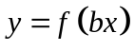
  - Stretch factor is
  - Invariant points are on y-axis

- Vertical Stretches 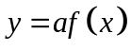
  - Stretch factor is
  - Invariant points are on x-axis

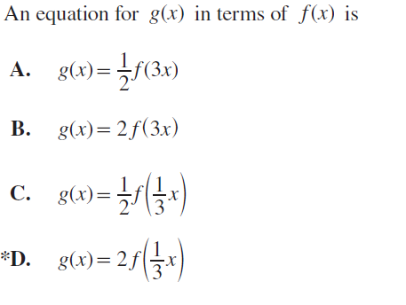
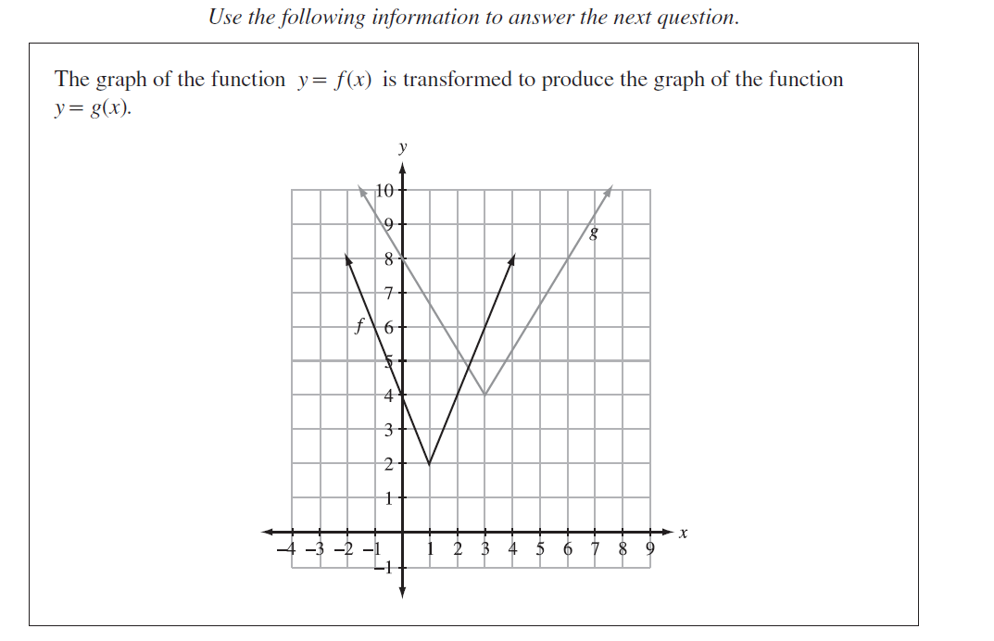

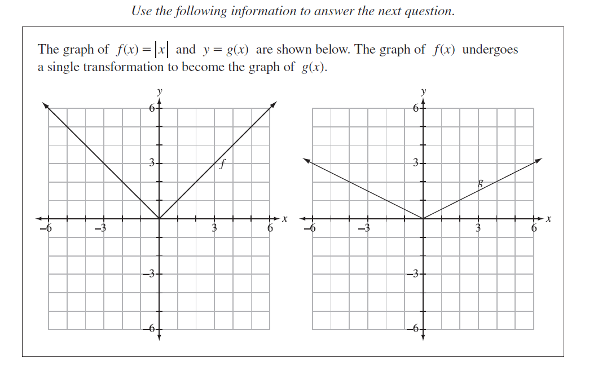

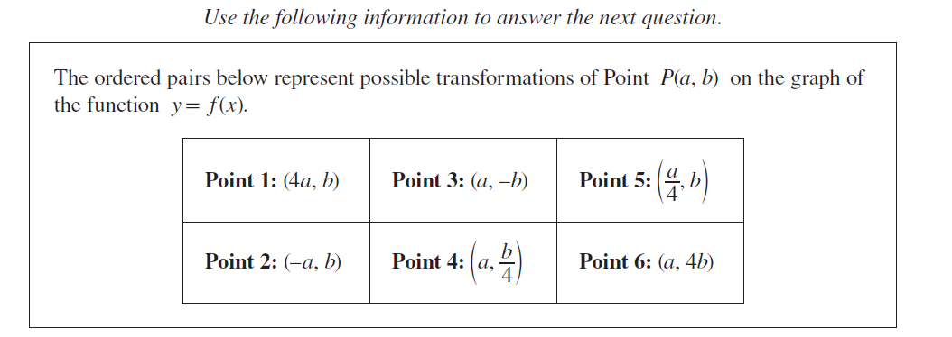
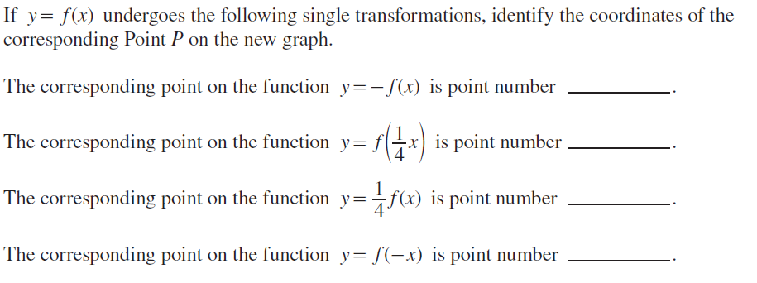
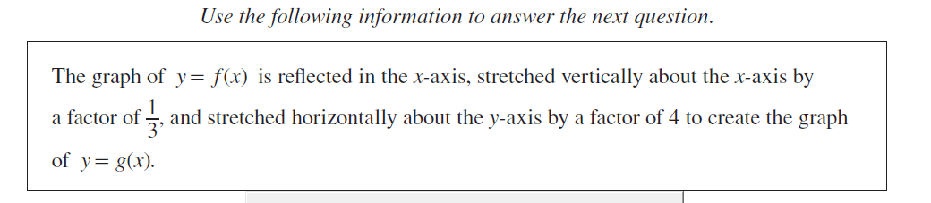
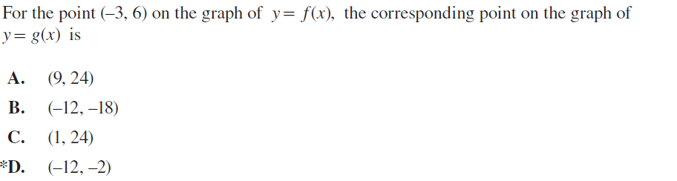
Outcome 4: Combinations of Transformations

- Unless otherwise told, stretches must be done FIRST, before translations
- Write equations in FACTORED FORM before describing or performing!

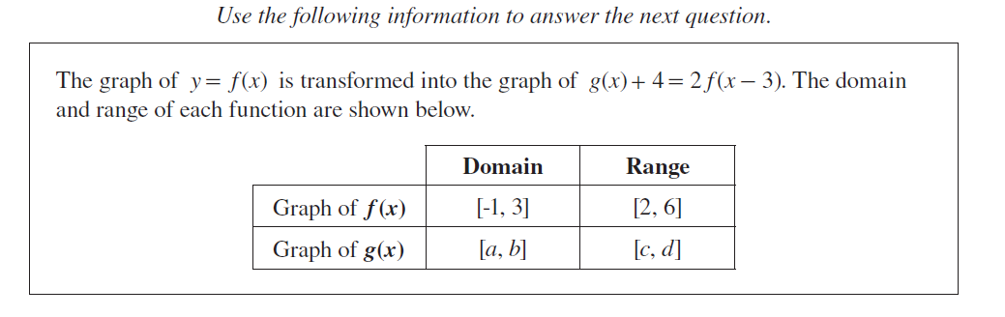

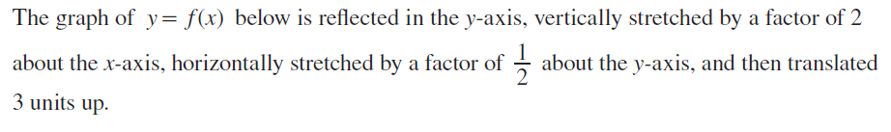
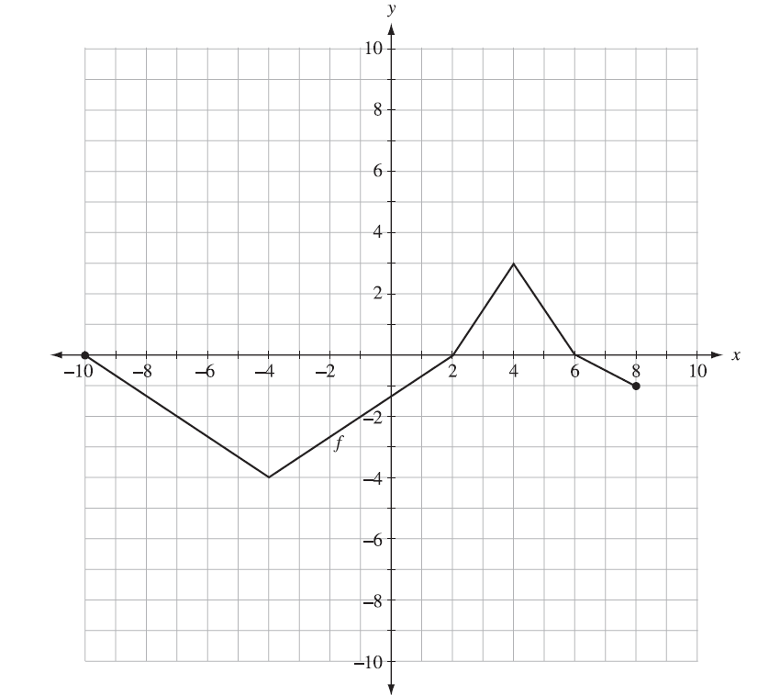

Sketch the graph of the new function.

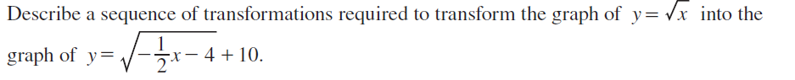
Outcome 5 & 6: Reflections
- If reflected in the x-axis . . .
  - 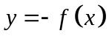
  - Invariant points – on x – axis
- If reflected in the y-axis . . .
  - 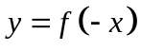
  - Invariant points – on y – axis
- If reflected in the line 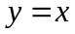 . . . this is the INVERSE of the function
  - 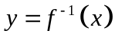 or 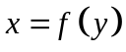
  - Invariant points – on the line where y = x
    - Ex. 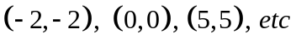
  - x-intercepts become y-intercepts
  - domain become range and range becomes domain
  - To ensure an inverse is a function, you may need to RESTRICT the domain of the original function

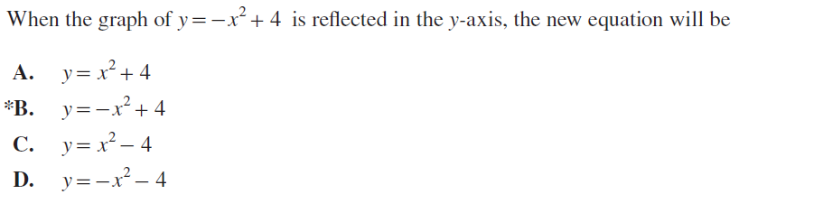
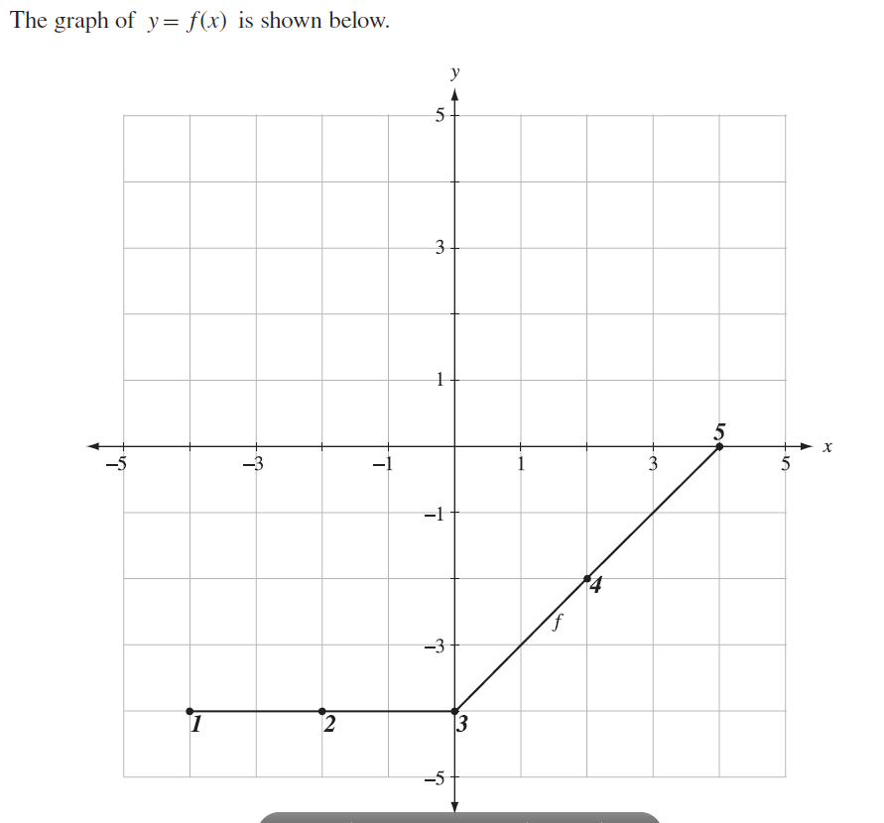
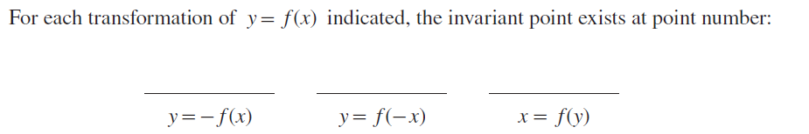
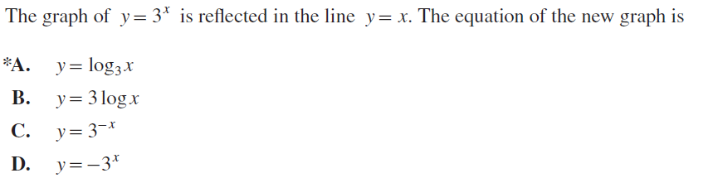

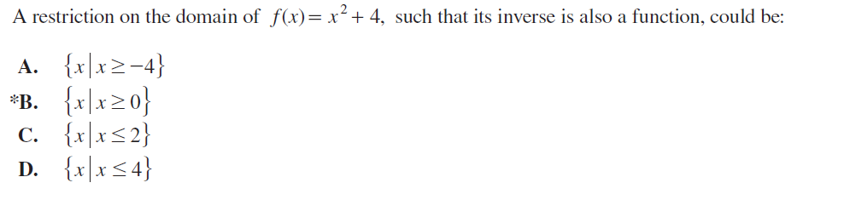

Practice Questions

- Given 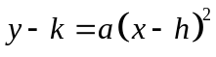, 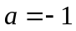, 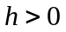, and 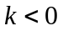, in which quadrant is the vertex?

- The transformation of the function 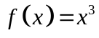 is described by the mapping notation 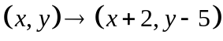. Describe the transformations on 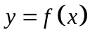.

- The graph of 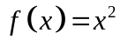 is below left. The function 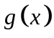, sketched below right, is a translation of . Determine the equation of .
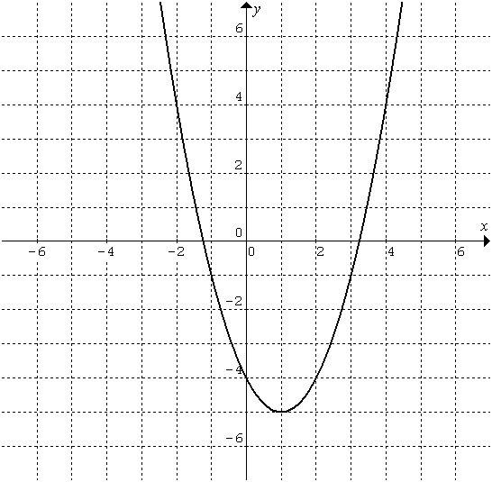
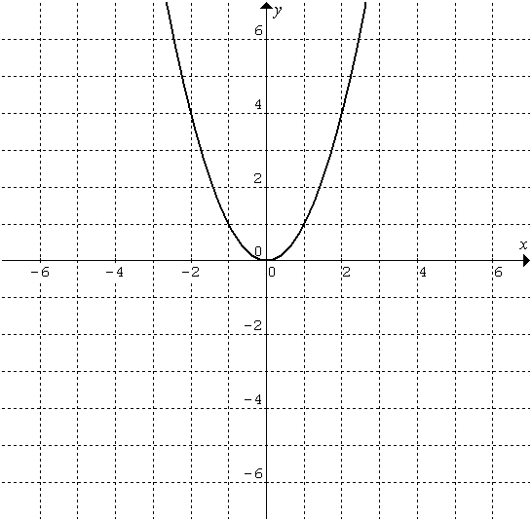

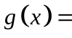______________________

- Given the graph of below left, determine the equation of the graph below right
in the form . (rf2)
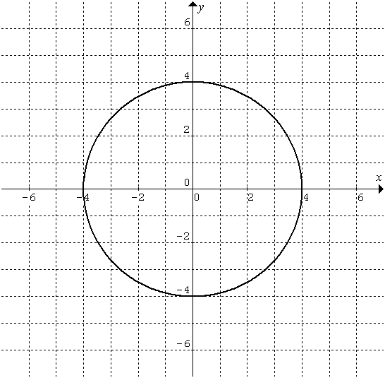
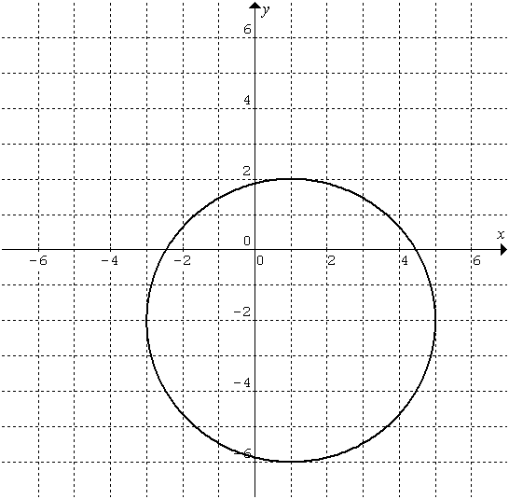

New equation: ______________________
- If you were given the graph of , describe the translations you would need to draw the graph of , given that 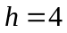 and 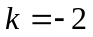.

- The graph of is transformed into the graph of 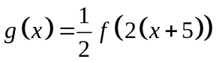. The domain and range of each functions is shown below. Complete the chart by filling in the domain and range for the graph of .
 | Domain | Range
Graph of | 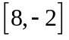 | 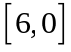
Graph of

- There is an ordered pair, 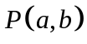 on the graph of the function .

If undergoes the following single transformations, determine the coordinates of the corresponding point P on the new graph.
  - Reflection in the y-axis _______.
  - Reflection in the x-axis _______.
  - Reflection in the line y = x _______.

- The graph of the function 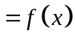 is transformed to produce the graph of the function 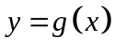 as shown below. Determine an equation for in the form 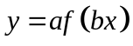.

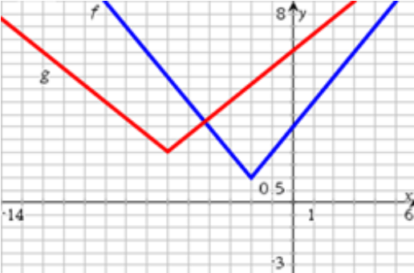

- Given the graph of below, sketch the graph of 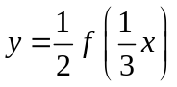.
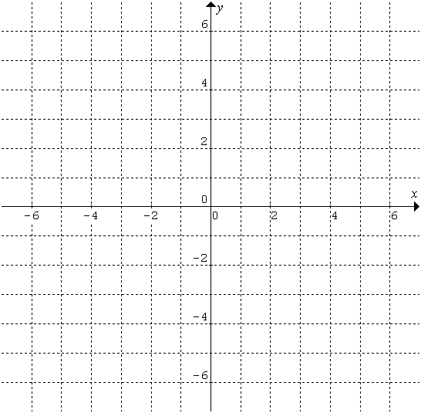

- Given the graph of below, sketch the graph of 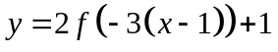.

- The graph of is reflected in the y-axis, vertically translated 3 units down, and stretched horizontally about the y-axis by a factor of to create the graph of . For the point 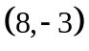 on the graph of , determine the corresponding point on the graph of .

- If the point (-4, 7) is on the graph of , what point will be on the graph of 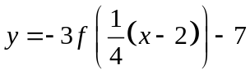?

- Given the graph of below, determine the equation of the graph below right.

New equation: ______________________

- Describe a sequence of transformations required to transform the graph of 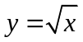 to the graph of 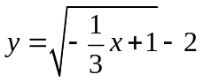.

- Given the graph of 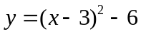below left, determine the equation of the graph below right.
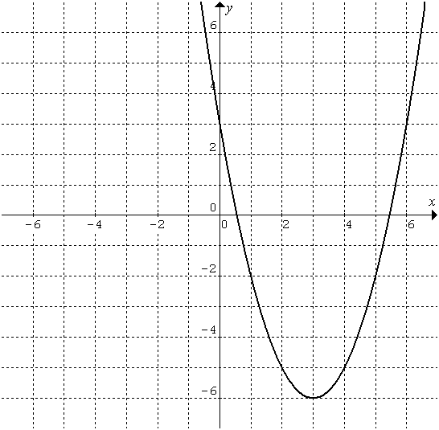
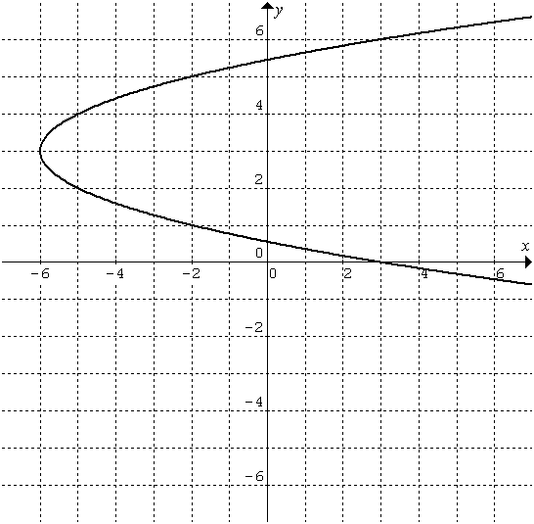

New equation: ______________________

- The graph of 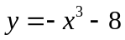 is reflected in the y-axis. Determine the equation of the new graph.

- The graph of is shown below.
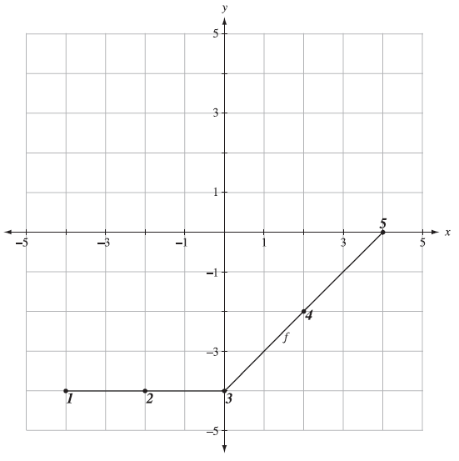

For each transformation of indicated, the invariant point exists at point number:

_______________ _______________ _______________
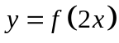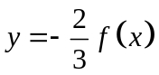

- Given the graph of below, sketch the graph of .

- Determine if the funtions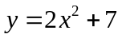 and 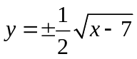 are inverses of each other.

- a) Given that 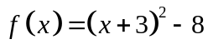, determine the equation of .

  - What restrictions must be put on the domain of so that its inverse is a function?

Multiple Choice Questions

- Which of the following transformations suggest the same resulting function?
- 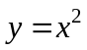stretched vertically by a factor of ; stretched horizontally by a factor of
- stretched vertically by a factor of 2; stretched horizontally by a factor of
- stretched vertically by a factor of 2; stretched horizontally by a factor of
- 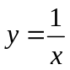stretched vertically by a factor of 2 and 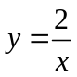 stretched horizontally by a factor of

- A point on the function is given by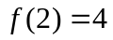. The corresponding point on the function 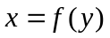 is:

A. (2 , 4) B. (4 , 2) C. (, 4) D. (2 , )

- The function 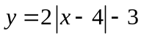 has its vertex in which quadrant?

A. I B. II C. III D. IV

- The function 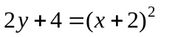has its vertex in which quadrant?

A. I B. II C. III D. IV

- Given the function 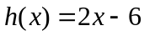. The x-intercept of the function 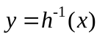is:

A. (2 , 0) B. (3 , 0) C. (6 , 0) D. (-6 , 0)
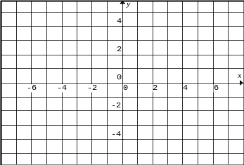
y = h(x)

Use the function shown
for questions 6-8.

- A new x-intercept for the function 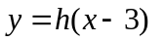is:

A. (0 , 0) B. (-4 , 0) C. (0 , -1) D. (2 , 0)

- The function is sketched. A point that is on both functions is:

A. (-2 , -2) B. (2 , 1) C. (-1 , 0) D. (0 , 2)

- The function 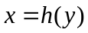is sketched. A point that is on the new function is:
A. (1 , 1) B. (2 , 0) C. (-1 , 0) D. (0 , 2)
- The function 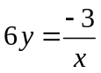 is best described as the function that has been:

A. stretched vertically by a factor of 2 and reflected in the x-axis
B. stretched horizontally by a factor of 2 and reflected in the y-axis
C. stretched vertically by a factor of 6, vertically by a factor of 3 and reflected in the x-axis
D. stretched vertically by a factor of and reflected in the x-axis

- The function is best described as the function 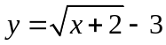 after it has been:

A. shifted 2 units left and 3 units up
B. shifted 2 units right and 3 units up
C. shifted 2 units left and 3 units down
D. shifted 2 units right and 3 units down

Recall: Standard form for the equation of a circle: 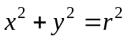 center at the origin (0,0) and r = radius
- The equation 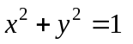is the equation of a circle whose center is at the origin and whose radius equals 1.

- Replacing x with x + 2 would have what effect on the circle?

A. the circle would move to the left 2 units
B. the circle would move to the right 2 units
- the circle would move up 2 units
- the circle would move down 2 units

- Replacing y with y – 4 would have what effect on the circle?

- the circle would move to the left 4 units
- the circle would move to the right 4 units
- the circle would move up 4 units
- the circle would move down 4 units

- The circle (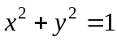) has been moved 3 units to the right and 5 units down. Its new equation is:

- 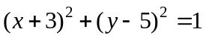 B. 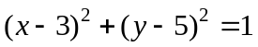
C. 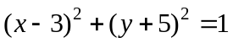 D. 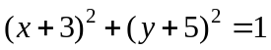

14. The function y = 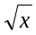 has first been moved to the left 6 units and then stretched horizontally by a factor of . Its new equation is:

A. 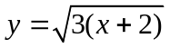 B. 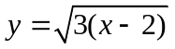 C. 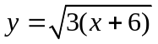 D. 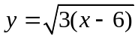

15. The function 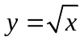 has first been stretched horizontally by a factor of and then moved to the left 6 units. Its new equation is:

A. B. C. D.

16. Which represents the function 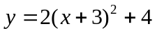stretched vertically by a factor of and moved up 4 units.

A. 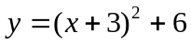 B. 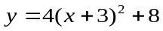 C. 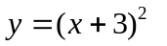 D. 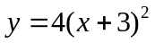
17. Which represents the function 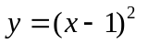stretched horizontally by a factor of 2 and then moved left 2 units.

A. 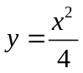 B. 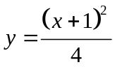 C. 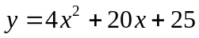 D. 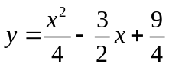

18. The function 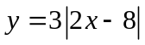 is best described as 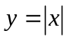 after:

A. a vertical stretch of , a horizontal stretch of 2, and a shift of 8 units to the right.
B. a vertical stretch of 3, a horizontal stretch of , and a shift of 8 units to the right.
C. a vertical stretch of , a horizontal stretch of 2, and a shift of 4 units to the right.
D. a vertical stretch of 3, a horizontal stretch of , and a shift of 4 units to the right.
Short Answer Questions

19. The point 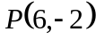 lies on the graph of . Find the image of P on the transformed graph:
(a) 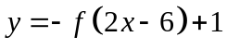 (b) 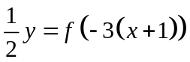

20. Describe the transformations that have taken place from the graph of the first relation to the graph of the second:
(a) 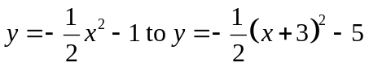 (b) 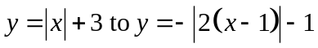

21. Compared to the graph of , describe the transformations of the following graph: 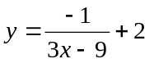
Multiple Choice Answer Key
1. C 2. B 3. D 45. C 5. D 6. D 7. A 8. B 9. D
10. B 11. A 12. C 13. C 14. A 15. C 16. A 17. A 18. D

Short Answer Key

19. (a) 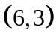 (b) 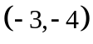
20. (a) horizontally translated 3 units left, vertically translated 4 units down
(b) horizontally stretched about the y-axis by a factor of , reflection in the x-axis, horizontally translated 1 unit right and vertically translated 4 units down.
21. stretched vertically about the x-axis by a factor of , then vertically reflected, and then horizontally
translated 3 units right, vertically translated 2 units up.

