**Math 30-1 Chapters 4, 5 & 6 Review Name ___________________________**

**Trigonometry**

*  questions on last diploma were TRIG; 4 of those questions were standard of excellence (**** of the test is standard of excellence)
* 1 question from outcome 1; 1 question from outcome2; 3 questions from outcome 3; 2 questions from outcome 4; 3 questions from outcome 5; 3 questions from outcome 6

**Outcome 1: Angles in Standard Position, Degrees and Radians, Arc Length**

* Rotate counter-clockwise for positive angle, clockwise for negative
* **CO-TERMINAL** means if the angles were drawn, their terminal arms would overlap
* Reference angles are always POSITIVE and measure ** . . .always relative to the axis**
* Formula involving ARC LENGTH is on formula sheet ** BUT** only works if  is in RADIANS

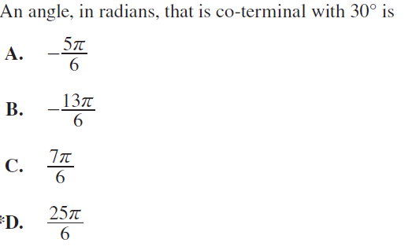



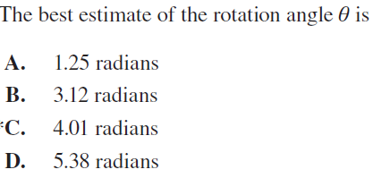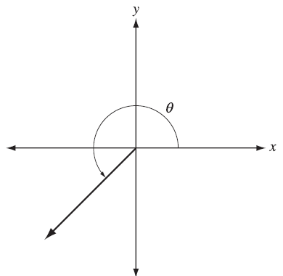

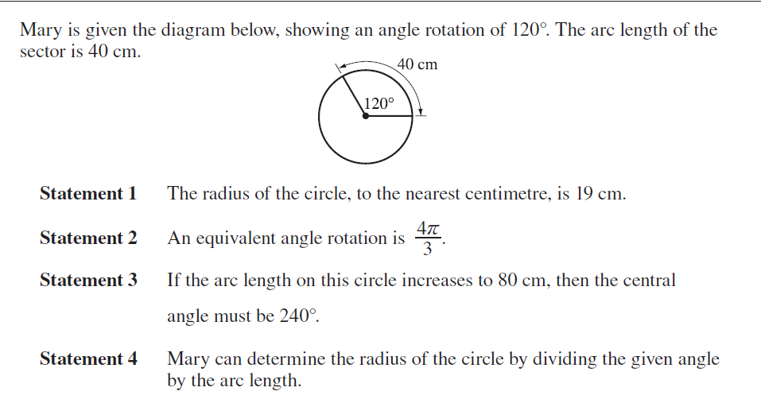



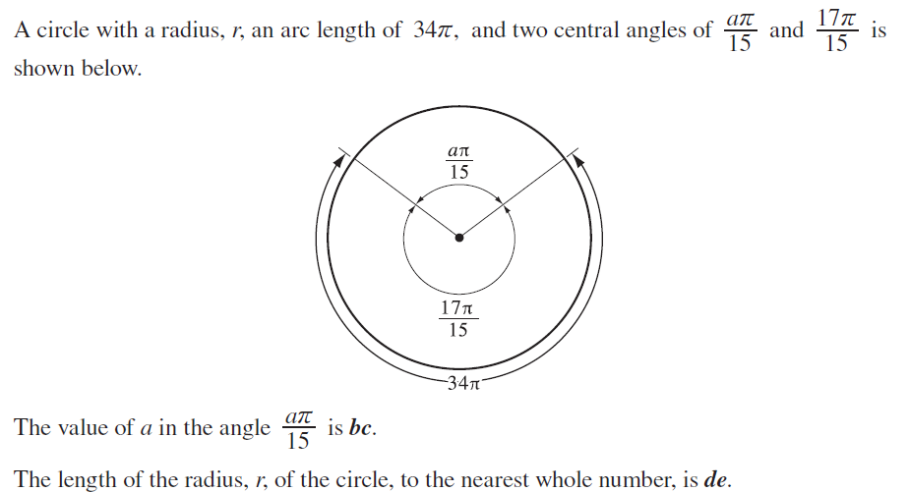

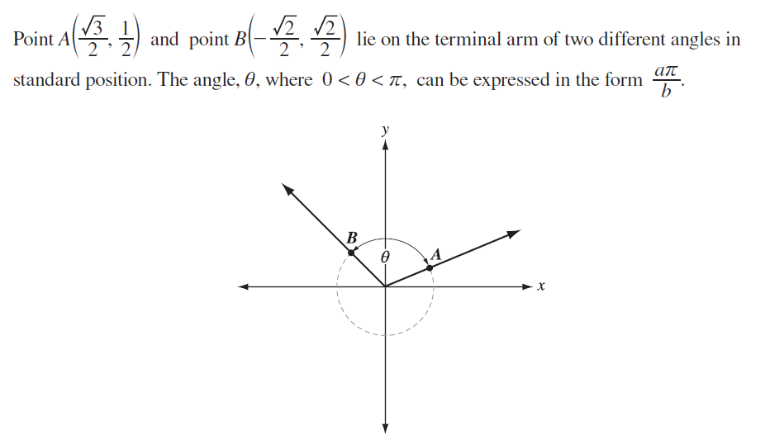

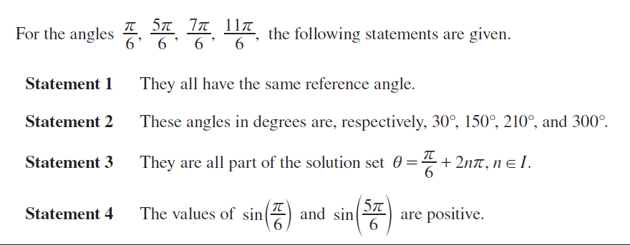



**Outcome 2: Apply Equation of Unit Circle**

* Equation of unit circle is 
* Any point on the unit circle should “satisfy” the equation
  + You can sub in an **-**coordinate to solve for the ****coordinate of a point (or vice versa)
* If you are given the coordinates of a point on the unit circle . ..
  + The **-**coordinate represents the COSINE ratio of the angle
  + The **-**coordinate represents the SINE ratio of the angle

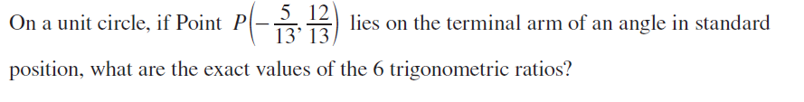

**Outcome 3: Solve Problems involving the SIX trig ratios**

* If given a trig ratio you would know 2 out of 3 sides of a right angle triangle and you can use pythagorean theorem to find the third side
  + Look for restrictions on  that will tell you which QUADRANT to draw the triangle in
* Exact values of trig ratios can be found using EITHER the points on the unit circle OR the special triangles
* Given a trig ratio, you can find an angle using the INVERSE or 2nd button on your calculator
  + Remember, given  there are 2 angles with the same trig ratio
  + Example: ** and **
  + Use your CAST rule to help you find all the angles
* Knowing the coordinates of your QUADRANTALS will help with the **and **ratios of 





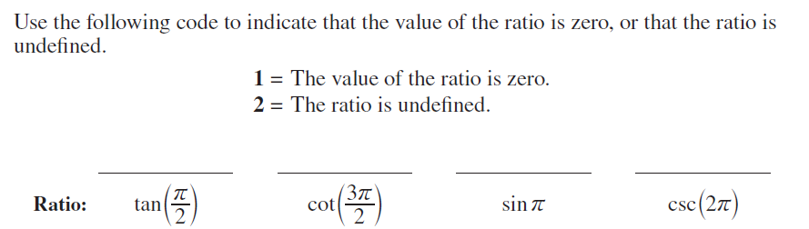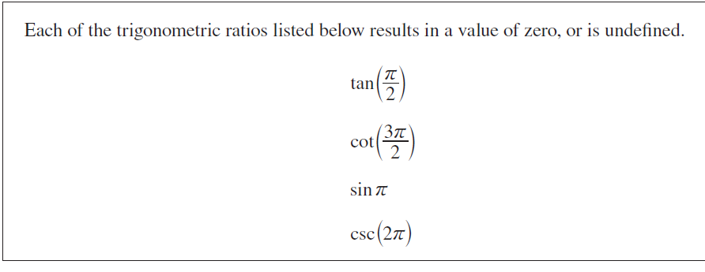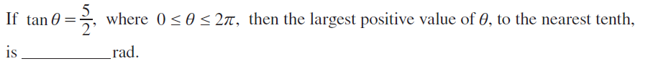

**Outcome 4: Graph and Analyze Trig Functions**

* Given a graph, you may be asked to write the equation in the form ** or **
  + **Recall:**
    -  is the amplitude of the wave 
    -  is the RATIO of the regular period  to the new period 
    -  is the phase shift
    -  is the vertical displacement (the *y-*value of the middle of the wave) 
  + Domain is 
  + Range is 
* Tangent functions
  + Have NO amplitude
  + Have a period of **!!!**
* Ferris Wheel
  + The radius of the wheel = 
  + the time it takes to complete one revolution is the PERIOD . .. 
  +  would be the height of the CENTER of the wheel off the ground.





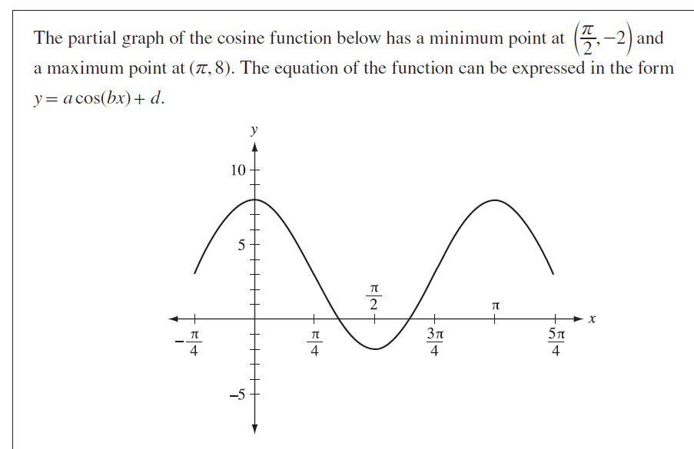



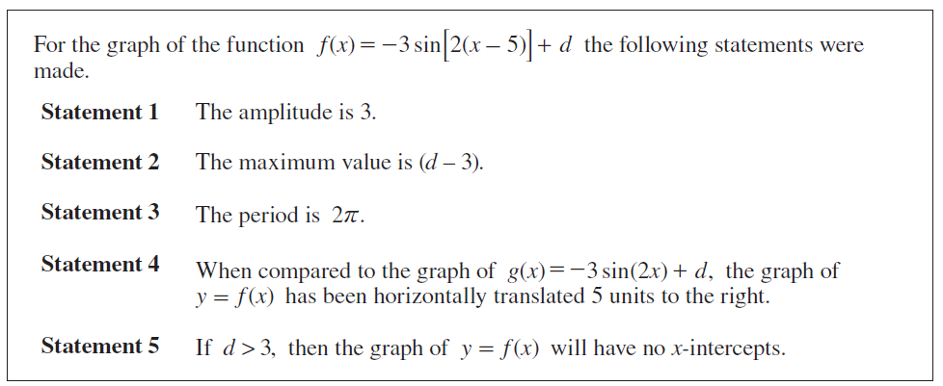

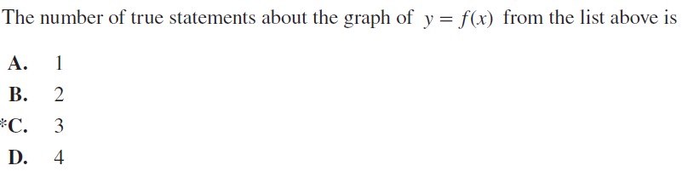

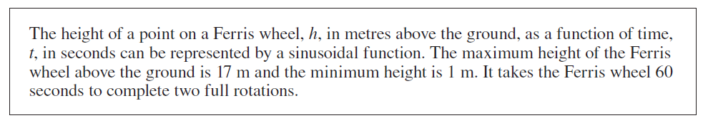

Write the equation in the form  also.

**Outcome 5: Solve Trig Equations**



* FIRST you must use an IDENTITY to replace ** . . . .**
* Then you can factor the new equation and solve
* To address the “domain”
  + Find any solutions from ** to **
  + Find any solutions from ** to **
    - These will be angles in quadrants III and IV
    - You will rotate in a NEGATIVE direction to reach these angles
* This equation can be solved by factoring the equation as a DIFFERENCE OF SQUARES
* Once factored, set each factor to zero and solve 
* There would be 4 solutions if the domain was ** BUT** the domain is really ****so you write all the anlges CO-TERMINAL to each of your solutions
* This equation can be solved by taking out a common factor 
* Once factored, set each factor to zero and solve 
* There would be 4 solutions if the domain was ** BUT** the domain is restricted so there are only 2 solutions.



* The equation is ALREADY in factored form . . . set each factor = 0 , isolate the **,** and reciprocate the ratio to solve for 
* **One equation at a time,** enter left side as  and right side as 
  + ** , **
  + Make sure you’re in DEGREE MODE
  + Find intersection points

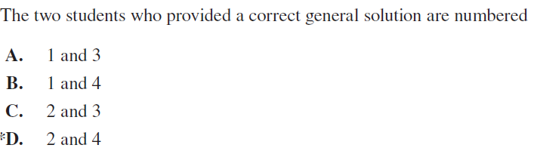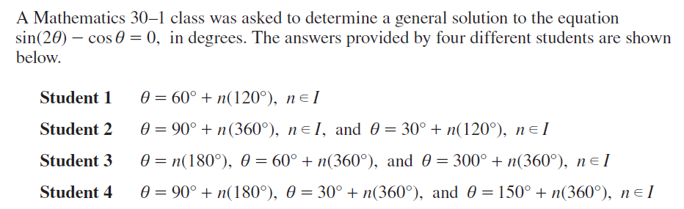

* To solve this graphically, enter 
  + ** , **
  + find intersection points and determine which general solutions match
* To solve this algebraically, use the IDENTITY for **,** factor and solve.

**Outcome 6: Trig Identities**

* All identities can be found on your formula sheet
* VERIFYING – substitute a given value in for  and showing that the LS and RS come out to the same value
* PROVING –use identities involving trig ratios to show that both sides of the equation simplify to the same trig expression
* RESTRICTIONS (NON-PERMISSIBLE VALUES) . . . denominators  0 & there are “hidden restrictions” in  
  + 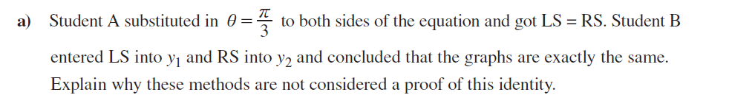Restictions are always written as a GENERAL SOLUTION

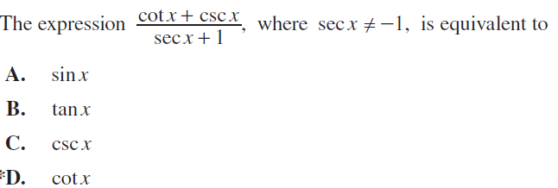

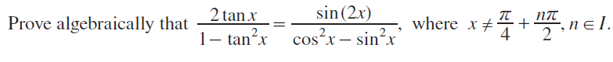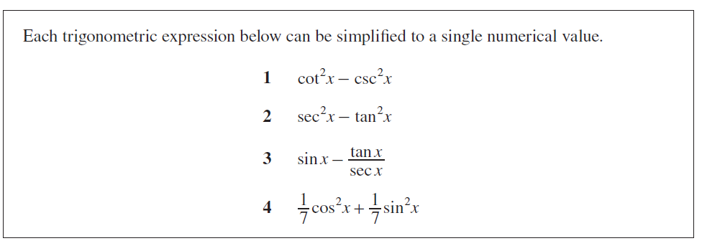

This is an identity . . . expand and use exact values to solve.

These are just the “restictions” . . .not really important to the solving of this question.

* You know the “exact” values for 
* There are SUM or DIFFERENCE identities that will allow you to solve this question