Group Names
Person 1
Person 2
Person 3
Person 4
Relations & Functions Roundtable Review

Part A: Given the equation $y=x^{2}-4$ take turns completing the following questions.
Person 1: Write the equation in function notation. Calculate the x and y intercepts

Person 2 Check and Initial: ________
Person 2: Calculate f(-6) and calculate the value of x if f(x) = 117

Person 3 Check and Initial: ________
Person 3: Create a table of values for the relation and graph it. Is the relation linear?
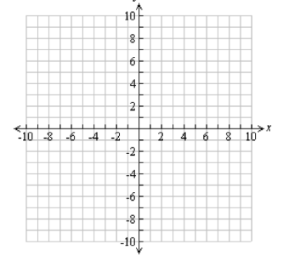
x | y
-2
-1
0
1
2

Person 4 Check and Initial: ________
Person 4: Determine the Domain and Range of the function

Person 1 Check and Initial: ________
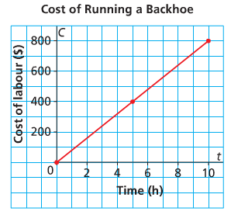
Part B: St. Adolphe, Manitoba is located in the flood plain of the Red River. To help prevent flooding, backhoes were used to build dikes around houses and farms in the town. The graph shows the labour costs of running a backhoe.

Person 1: Determine the rate of change. What does this represent?

Person 2 Check and Initial: ________
Person 2: Write the domain and range.

Person 3 Check and Initial: ________
Person 3: Calculate the cost to run the backhoe for 7h.

Person 4 Check and Initial: ________
Person 4: Calculate how many hours the backhoe would be run when the cost is $360.

Person 1 Check and Initial: ________

Group Names
Person 1
Person 2
Person 3
Person 4
Relations & Functions Roundtable Review

Part A: Given the equation $y=x^{2}-9$ take turns completing the following questions.
Person 1: Write the equation in function notation. Calculate the x and y intercepts

Person 2 Check and Initial: ________
Person 2: Calculate f(-8) and calculate the value of x if f(x) = 40

Person 3 Check and Initial: ________
Person 3: Create a table of values for the relation and graph it. Is the relation linear?
x | y
-2
-1
0
1
2

Person 4 Check and Initial: ________
Person 4: Determine the Domain and Range of the function

Person 1 Check and Initial: ________
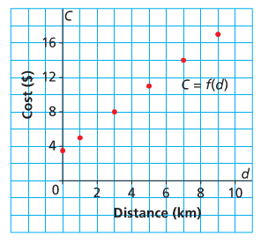
Part B: This graph shows the cost for a cab at Eagle Taxi Cabs. The cost, C dollars, is a function of the distance travelled, d kilometers.

Person 1: Determine the rate of change. What does this represent?

Person 2 Check and Initial: ________
Person 2: Write the domain and range.

Person 3 Check and Initial: ________
Person 3: Calculate the cost to travel 7km

Person 4 Check and Initial: ________
Person 4: Calculate how far you could travel for $9.50.

Person 1 Check and Initial: ________

Group Names
Person 1
Person 2
Person 3
Person 4
Relations & Functions Roundtable Review

Part A: Given the equation $y=-2x^{2}+8$ take turns completing the following questions.
Person 1: Write the equation in function notation. Calculate the x and y intercepts

Person 2 Check and Initial: ________
Person 2: Calculate f(-4) and calculate the value of x if f(x) = -90

Person 3 Check and Initial: ________
Person 3: Create a table of values for the relation and graph it. Is the relation linear?
x | y
-2
-1
0
1
2

Person 4 Check and Initial: ________
Person 4: Determine the Domain and Range of the function

Person 1 Check and Initial: ________
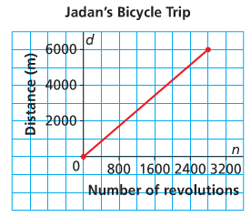
Part B: This graph shows the distance, d metres, travelled by Jadan on her bicycle as a function of the number of wheel revolutions, n, as she rode from Whitehorse to the Grey Mountain Road lookout in the Yukon.

Person 1: Determine the rate of change. What does this represent?

Person 2 Check and Initial: ________
Person 2: Write the domain and range.

Person 3 Check and Initial: ________
Person 3: Use the graph to estimate the distance travelled after 1600 revolutions.

Person 4 Check and Initial: ________
Person 4: Use the graph to estimate the number of revolutions needed to travel 5000m.

Person 1 Check and Initial: ________

Group Names
Person 1
Person 2
Person 3
Person 4
Relations & Functions Roundtable Review

Part A: Given the equation $y={4x}^{2}-1$ take turns completing the following questions.
Person 1: Write the equation in function notation. Calculate the x and y intercepts

Person 2 Check and Initial: ________
Person 2: Calculate f(-6) and calculate the value of x if f(x) = 255

Person 3 Check and Initial: ________
Person 3: Create a table of values for the relation and graph it. Is the relation linear?
x | y
-2
-1
0
1
2

Person 4 Check and Initial: ________
Person 4: Determine the Domain and Range of the function

Person 1 Check and Initial: ________
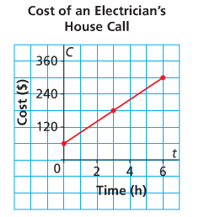
Part B: This graph shows the total cost for a house call by an electrician for up to 6hrs of work.

Person 1: Determine the rate of change. What does this represent?

Person 2 Check and Initial: ________
Person 2: Write the domain and range.

Person 3 Check and Initial: ________
Person 3: Determine the approximate cost for 5 hours of work.

Person 4 Check and Initial: ________
Person 4: Determine the approximate number of hours of work for $240.

Person 1 Check and Initial: ________

