**Math 10 C: Investigating Lines**

Complete the following with a partner.

**Part A**

1. The cost of a private dinner with a set menu at a restaurant is represented by the equation where *n* is the number of people in attendance and *C* is the total cost. Complete the partial table of values below. Then, graph the data on the grid provided. Label the graph L1.

|  |  |
| --- | --- |
| ***n*** | ***C*** |
| 0 |  |
| 1 |  |
| 2 |  |
| 3 |  |
| 4 |  |
| 5 |  |
| 6 |  |

1. The cost of a different menu is represented by the equation  where *n* is the number of people in attendance and *C* is the total cost. Complete the partial table of values below. Then, graph the data on the same grid as number 1. Label the graph L2

|  |  |
| --- | --- |
| ***n*** | ***C*** |
| 0 |  |
| 1 |  |
| 2 |  |
| 3 |  |
| 4 |  |
| 5 |  |
| 6 |  |

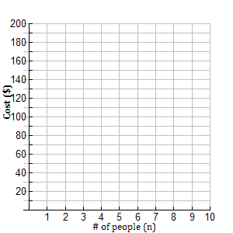

3. Is the function represented by the equations (and graphs) above linear or non-linear?

How do you know?

4. How are L1 and L2 different? How are they similar?

5. What would happen to the **graph** if the equation was ?

6. (a) What does the number in front of the independent variable represent in this problem?

(b) What does the number in front of the independent variable represent in general?

7. Given the graphs below, determine:

(a) The cost/person

(b) The equation of the line.

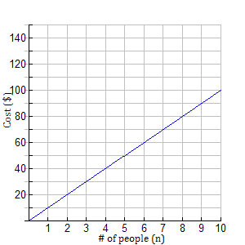 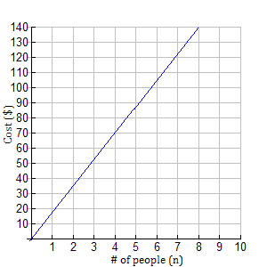

1. (a)
2. (b)

8. How did you find the value in front of the variable in question #7?

9. What if you were told that the cost for 8 people was $96? What would be the equation of the line?

**Part B**

1. The cost of a dinner at another restaurant is represented by the equation where *n* is the number of people in attendance and *C* is the total cost. Complete the table of values below. Then, graph the data on the grid provided. Label the line L1.

|  |  |
| --- | --- |
| ***n*** | ***C*** |
| 0 |  |
| 1 |  |
| 2 |  |
| 3 |  |
| 4 |  |
| 5 |  |
| 6 |  |

1. The cost of a different menu at the same restaurant is represented by the equation  where *n* is the number of people in attendance and *C* is the total cost. Create a table of values below. Then, graph the data on the same grid as number 1. Label the line L2

|  |  |
| --- | --- |
| ***n*** | ***C*** |
| 0 |  |
| 1 |  |
| 2 |  |
| 3 |  |
| 4 |  |
| 5 |  |
| 6 |  |

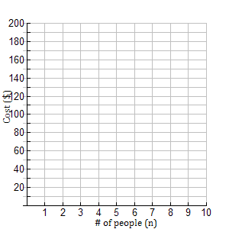

3. How are L1 and L2 different? How are they similar?

4. What would happen to the **graph** if the equation was ?

5. What does the constant number (the number NOT multiplied by a variable) in the equation represent?

6. What is the equation of the line shown below? Explain.

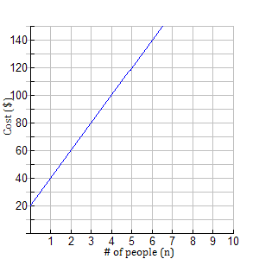

7. What if you were told that the fixed cost of renting a room is $40 and the cost per person is $15. Write the equation of the line.