Jig-Saw Problem - Circles

Sketch a graph of the following quadratic function and complete the table provided.

$$y=x^{2}+2x-8$$
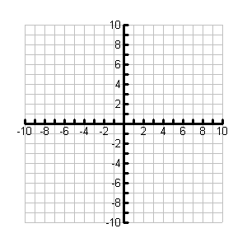

$$y=x^{2}+2x-8$$
Vertex
Maximum or minimum value
y-intercept
x-intercept(s)
Equation of the Axis of Symmetry
Domain
Range
Jig-Saw Problem - Triangles

Sketch a graph of the following quadratic function and complete the table provided.

$$y={(x+1)}^{2}-9$$

$$y={(x+1)}^{2}-9$$
Vertex
Maximum or minimum value
y-intercept
x-intercept(s)
Equation of the Axis of Symmetry
Domain
Range
Jig-Saw Problem - Squares

Sketch a graph of the following quadratic function and complete the table provided.

$$y=\left(x+4\right)(x-2)$$

$$y=\left(x+4\right)(x-2)$$
Vertex
Maximum or minimum value
y-intercept
x-intercept(s)
Equation of the Axis of Symmetry
Domain
Range
Jig-Saw Problem - Stars

Sketch a graph of the following quadratic function and complete the table provided.

x | y
-5 | 7
-4 | 0
-1 | -9
0 | -8
2 | 0
3 | 7

Vertex
Maximum or minimum value
y-intercept
x-intercept(s)
Equation of the Axis of Symmetry
Domain
Range

