Mathematics 20-1: Final Exam
Name: _________________________ Date: _________________
This exam consists of 24 multiple choice questions worth 2 marks each and 8 written response questions worth a total of 26 marks. There is a tear-off formula sheet at the back of the exam.
Multiple Choice Answer Section (48 marks)
Place the letter corresponding to the best answer on the line.

 | - _____  - _____  - _____ | - _____  - _____  - _____ | - _____  - _____  - _____  - _____ |  | - _____  - _____ | - _____  - _____ |  |  | - _____  - _____  - _____ |  | - _____  - _____  - _____  - _____ |  | - _____  - _____  - _____
Scoring Guide: To Be Filled Out By Teacher
Unit |  |  |  | Multiple Choice  Questions |  |  | MC  Score | Written  Questions |  | Written  Score |  | Total  Mark |  | Score on  Final Exam
1: Sequences & Series |  |  |  | 1 – 3 |  |  | /6 | 1 |  | /4 |  | /10
2: Trigonometry |  |  |  | 4 – 6 |  |  | /6 | 2 |  | /3 |  | /9
3: Quadratic Functions |  |  |  | 7 – 10 |  |  | /8 | 3 |  | /3 |  | /11
4: Quadratic Equations |  |  |  | 11 – 12 |  |  | /4 | 4 |  | /3 |  | /7
5: Radical Expressions & Equations |  |  |  | 13 – 14 |  |  | /4 | 5 |  | /3 |  | /7
6: Rational Expressions & Equations |  |  |  | 15 – 17 |  |  | /6 | 6 |  | /3 |  | /9
7: Absolute Value & Reciprocal Functions |  |  |  | 18 – 21 |  |  | /8 | 7 |  | /4 |  | /12
8: Systems of Equations |  |  |  | n/a |  |  | n/a | 8 |  | /3 |  | /3
9: Linear & Quadratic Inequalities |  |  |  | 22 – 24 |  |  | /6 | n/a |  | n/a |  | /6
Totals: |  |  |  |  |  |  | /48 |  |  | /26 |  | /74

Mathematics 20-1 Final Exam

Multiple Choice Questions (2 marks each)
Record your answers on the front cover of the exam.

- What are the missing terms of the arithmetic sequence: __, 3, 9, __, __?
  - 1, 27, 81
  - 9, 3, 9
  - -6, 12, 17
  - -3, 15, 21

- What is the sum of the first five terms of the geometric series 16 807 – 2401 + 343 – ...?
  - 19 607
  - 14 707
  - 16 807.29
  - 14 706.25

- The 20th term of a geometric sequence is 524 288 and the 14th term is 8192. The value of the third term could be
  - 4 only
  - 8 only
  - +4 and -4
  - +8 and -8

- Which angle in standard position has a different reference angle than all the others?
  - 125°
  - 155°
  - 205°
  - 335°

- Which is the exact value of cos 150°?
  - $\frac{1}{2}$
  - $\frac{\sqrt{3}}{2}$
  - $-\frac{\sqrt{3}}{2}$
  - $-\frac{1}{2}$

- The expression that could be used to determine the measure of angle $θ$ in the diagram is:
  - $\frac{\sin{θ}}{70}=\frac{\sin{28}}{34}$
28°
34 cm
70 cm
$$θ$$
  - $θ^{2}={34}^{2}+{70}^{2}-2\left(34\right)\left(70\right)\cos{28°}$
  - $\cos{θ=}$ $\frac{{70}^{2}+{34}^{2}-{28}^{2}}{2\left(70\right)(34)}$
  - $\frac{\sin{θ}}{34}=\frac{\sin{28}}{70}$
- What points on the graph of this quadratic function
represent the locations of the zeros of the function?
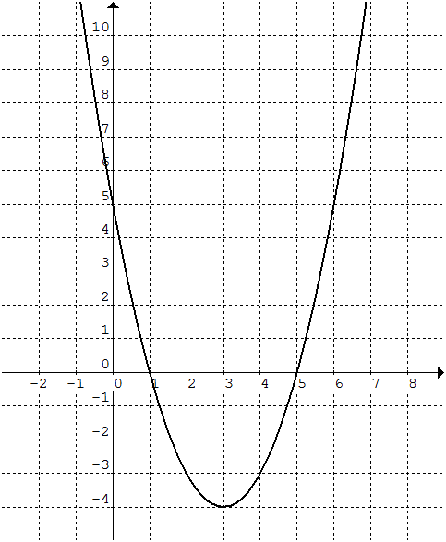
  - (0, 5) and (1, 0)
  - (0, 1) and (0, 5)
  - (1, 0) and (5, 0)
  - (5, 0) and (0, 1)

- Which function is NOT a quadratic function?
  - $f\left(x\right)=2{\left(x+2\right)}^{2}-7$
  - $f\left(x\right)=\left(x-3\right)\left(2x+5\right)$
  - $f\left(x\right)=5x^{2}-20$
  - $f\left(x\right)=3\left(x-9\right)+6$

- Identify the range for the function $y=-6{\left(x-6\right)}^{2}+6$.
  - $\left\{y | y≤6,y∈R\right\}$
  - $\{y│y≥6,y∈R\}$
  - $\left\{y | y≤-6,y∈R\right\}$
  - $\left\{y | y≥-6,y∈R\right\}$

- What conditions on a and q will give the function $f\left(x\right)=a{\left(x-p\right)}^{2}+q$ have no x-intercepts?
  - $a>0$ and $q>0$
  - $a<0$ and $q>0$
  - $a>0$ and $q=0$
  - $a<0$ and $q=0$

- What is one of the factors of $x^{2}-3x-10$?
  - $x-5$
  - $x+5$
  - $x-10$
  - $x+10$

- The roots, to the nearest hundredth, of $-\frac{1}{2}x^{2}+x+\frac{7}{2}$ are
  - 1.83 and 3.83
  - -1.83 and 3.83
  - 1.83 and -3.83
  - -1.83 and -3.83

- What is the entire radical form of $-3\left(\sqrt[3]{2}\right)$?
  - $\sqrt[3]{54}$
  - $\sqrt[3]{18}$
  - $\sqrt[3]{-18}$
  - $\sqrt[3]{-54}$

- What is the simplest form of the expression $-2x\sqrt{6x}+5x\sqrt{6x}, x≥0$?
  - $3\sqrt{6x}$
  - $6\sqrt{12x}$
  - $3x\sqrt{6x}$
  - $6x\sqrt{12}$

- Simplify the rational expression $\frac{x^{2}-7x+6}{x^{2}-2x-24}$ for all permissible values of x.
  - $\frac{x+1}{x-4}$
  - $\frac{x-1}{x+4}$
  - $\frac{x+1}{x+4}$
  - $\frac{x-1}{x-4}$

- Simplify $\frac{8}{3y}+\frac{5y}{4}-\frac{5}{8}$ for all permissible values of y.
  - $\frac{{30y}^{2}-15y+64}{24y}$
  - $\frac{{30y}^{2}+79}{24y}$
  - $\frac{{15y}^{2}+64}{24y}$
  - $\frac{5y+3}{24y}$

- Determine the solution(s) of the equation $\frac{x}{x^{2}+6x+5}=\frac{2}{x^{2}-1}$.
  - $x=-2, x=5$
  - $x=-5, x=-1, x=1$
  - $x=-2, x=3$
  - $x=2$

- The value of the expression $\left|-9-3\right|-\left|5-2^{3}\right|+\left|-7+1-4\right|$ is
  - 13
  - 19
  - 21
  - 25

- The range of the function $f\left(x\right)=\left|x-3\right|$ is
  - $\left\{y | y>3, y∈R\right\}$
  - $\left\{y | y≥3, y∈R\right\}$
  - $\left\{y | y≥0, y∈R\right\}$
  - $\left\{y | y>0, y∈R\right\}$

- The absolute value equation $\left|1-2x\right|=9$ has solution(s):
  - x = -4
  - x = 5
  - x = -5 and x = 4
  - x = -4 and x = 5

- One of the vertical asymptotes of the graph of the reciprocal function $y=$ $\frac{1}{x^{2}-16}$ is:
  - x = 0
  - x = 4
  - x = 8
  - x = 16

- What linear inequality does the graph show?
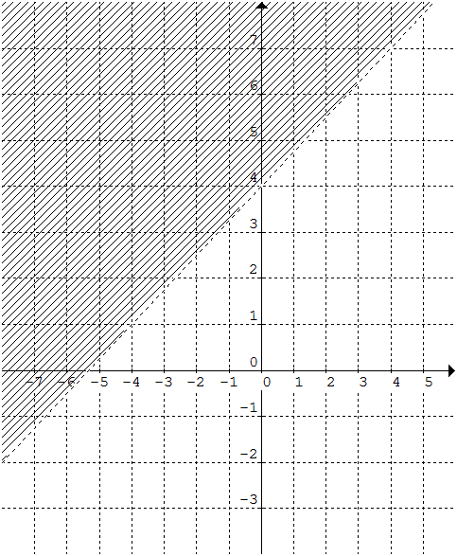
  - $y≤\frac{3}{4}x+4$
  - $y≥\frac{3}{4}x+4$
  - $y<\frac{3}{4}x+4$
  - $y>\frac{3}{4}x+4$

- What is the solution set for the quadratic inequality $6x^{2}-7x-20<0$?
  - $\left\{x | x≤-\frac{4}{3} or x≥\frac{5}{2}, x∈R\right\}$
  - $\left\{x | -\frac{4}{3}≤x≤\frac{5}{2}, x∈R\right\}$
  - $\left\{x | -\frac{4}{3}<x<\frac{5}{2}, x∈R\right\}$
  - $\left\{x | x<-\frac{4}{3} or x>\frac{5}{2}, x∈R\right\}$

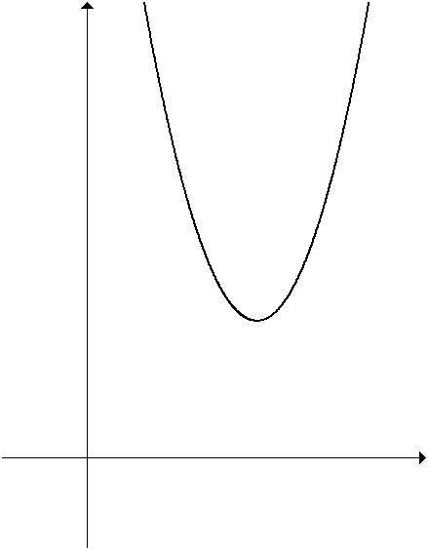
- For the quadratic function q(x) shown in the graph,
which of the following is true?
  - There are no solutions to $q\left(x\right)>0$.
  - All real numbers are solutions to $q\left(x\right)≥0$.
  - All real numbers are solutions to $q\left(x\right)≤0$.
  - All positive real numbers are solutions to $q\left(x\right)<0$.

Written Response (marks as indicated)
Record your answers below. Remember to show all your work.

- Consider the sequence 5, __, __, __, __, 160.
  - Assume the sequence is arithmetic. Determine the unknown terms of the sequence.

  - What is the general term of the arithmetic sequence?

  - Assume the sequence is geometric. Determine the unknown terms of the sequence.

  - What is the general term of the geometric sequence?

/4

- In ΔPQR, ∠P = 56°, p = 10 cm, and q = 12 cm.
  - Sketch a diagram of the triangle.

  - Determine the length of the unknown angles to the nearest degree.

  - Determine the measures of the unknown side to the nearest tenth of a centimetre.

/3

- Write the quadratic function $y=3x^{2}+36x+13$ in the form $y=a{\left(x-p\right)}^{2}+q$ by completing the square.

/3

- Solve the quadratic equation $3x^{2}+5x+1$ using the quadratic formula. Express your answers as exact roots.

/3

- Given the equation $x-4=\sqrt{x+2}$
  - Solve the equation.

  - State any extraneous roots.

  - Identify the values of x for which the radical is defined.

/3

- Given the equation $2-$ $\frac{5}{x^{2}-x-6}=\frac{x+3}{x+2}$,
  - Solve the equation.

  - Identify all non-permissible values.

/3

- Consider the function $f\left(x\right)=\left|2x-7\right|$.
  - Sketch the graph of the function on the grid
to the right.
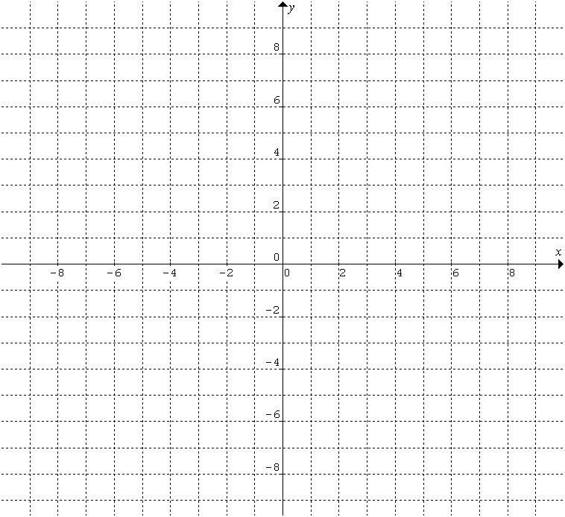

  - Determine all the x- and y-intercepts.

  - State the domain and range.

  - What is the piecewise notation form of the function?

/4

- Solve the following system algebraically.
$$y=7x-11$$
$$5x^{2}-3x-y=6$$

/3

